Chapter No. 20
Removal of contaminants of emerging concern by microalgae-based wastewater treatments and related analytical techniques
A. Agüera¹, P. Plaza-Bolaños¹, F.G Acién Fernández^{1,2}*.
¹ Solar Energy Research Centre (CIESOL), Joint Centre University of Almeria-CIEMAT, University of Almeria, Carretera de Sacramento s/n, 04120, Almeria, Spain.
²Department Chemical Engineering, University of Almeria, 04120 Almeria, Spain

*Corresponding author: facien@ual.es

Abstract
On this chapter, the role of microalgae in wastewater treatment processes, and especially in the removal of contaminants of emerging concern (CECs), is reviewed. Besides, the adequate methodologies needed to evaluate the removal of this type of contaminants are discussed. Microalgae-related processes are a more sustainable alternative to conventional wastewater treatment schemes which allow treating wastewater at a lower cost and energy consumption and recovering nutrients as valuable biomass for different applications, such as the production of biofertilizers, among others. Although the removal of CECs in this type of processes has been scarcely studied, it has been reported that different biotic and abiotic phenomena such as absorption, UV degradation and oxidation are the most relevant. In order to determine the presence of this type of compounds, adequate analytical methods are required, involving the analytical determination by low and high resolution mass spectrometry coupled with gas and liquid chromatography. Additionally, the application of adequate pre-concentration methods is needed to obtain enriched and cleaner extracts suitable for analysis. All these aspects are reviewed on this chapter as a basis for further improvement and scale-up of these processes on an industrial scale.
Keywords: Microalgae, wastewater, contaminants of emerging concerns (CECs), gas and liquid chromatography, mass spectrometry, photobioreactor.
1. Introduction
Wastewater treatment is a major challenge in the sustainability of increasing population worldwide, which is producing higher amounts of wastewater and an enlargement of the amount of water released per person. Therefore, the adequate treatment of wastewater is mandatory to avoid public health and environmental problems such as eutrophication phenomena. Conventional technologies proposed for wastewater treatment usually involve the use of bacteria, both aerobic and anaerobic. However, these systems require a large amount of energy and the installation of expensive infrastructure to remove the contaminants present in the wastewater (mainly organic matter, nitrogen and phosphorous). Thus, the average cost of wastewater treatment is 0.2 €/m³ with energy requirements of up to 0.5 kWh/m³ consumed on this process. As alternative, the utilization of microalgae-based processes has been proposed.
The first work on wastewater treatment with microalgae was carried out in the ‘60s of the last century [1]. Thus, high rate algal ponds (HRAPs) were designed to allow microalgae producing the oxygen required by bacteria to remove organic matter, which is a simpler way that using costly and high energy consumption systems (Figure 1).
**Insert Figure 1**
Despite these advantages, microalgae-based wastewater treatment processes have been scarcely applied. One of the reasons is the large area required for the proposed technology, up to 10 m²/p.e. (person equivalent). Recently, the interest of microalgae related wastewater treatment processes has strongly increased not only because these processes can adequately treat wastewater, but also because the energy consumption is notably lower in comparison with conventional activated sludge processes (up to 0.2 kWh/m³). Furthermore, this type of microalgae-based treatments permits the recovery of nutrients contained into the wastewater (e.g. C, N, P) as valuable microalgae biomass for different non-human related applications, such as feed, biofertilizers or biofuels [1–3]. Thus, the utilization of microalgae related processes for wastewater treatment represents a more sustainable alternative than conventional systems, allowing (i) to reduce the energy consumption, (ii) to strongly reduce the emission of greenhouse gases and (iii) to recover the nutrients contained into wastewater as useful biomass [4]. However, these processes must still be optimized to become industrial. In this sense, the design of HARPs is being reviewed to improve their performance by optimizing the hydraulic on the system, reducing its energy consumption [5,6]. Besides, the mass transfer on this type of reactors must also be optimized to allow the utilization of provided CO₂ and the removal of excess of accumulated oxygen [7,8]. Finally, the management of microalgae-bacteria consortia already existing on these systems must be evaluated [9]. On microalgae related wastewater treatment processes, there is always a consortium of microalgae and bacteria performing the process. The adequate type and proportion of microalgae and bacteria strongly influences the overall performance of the system [10]. The challenge is to optimize all these parameters to achieve processes requiring less surface, from 1 m²/p.e., values to 2 m²/p.e., target which has been already achieved by a private company (FCC Aqualia) at demonstration scale of 10 ha [11].
In addition to conventional pollutants, wastewater also contains relevant amounts of contaminants of emerging concern (CECs), which are primarily synthetic organic chemicals that have been recently detected in natural environments [12]. Emerging contaminants involve a large group of unregulated compounds which can potentially cause deleterious effects in aquatic and human life at environmentally relevant concentrations which are becoming a growing concern [13]. They include pharmaceutical organic contaminants, personal care products (PCPs), endocrine disrupting compounds (EDCs), surfactants, pesticides, flame retardants, and industrial additives, among others (Figure 2). The concentrations of these compounds usually range from a few ng/L to a few hundred mg/L [14]. On this range, these compounds cause ecological risk such as interference with endocrine system of high organisms, microbiological resistance, and accumulation in soil, plants and animals [15]. The major problem is that these compounds are scarcely removed by conventional wastewater treatment processes, and therefore, the application of more intense oxidative processes are needed, such as treatments based on photo-catalysis [16–18].
**Insert Figure 2**
Microalgae related processes have also been reported to reduce the presence of CECs in wastewater, although the information available on this field is still scarce. There is only one study dealing with the HRAPs’ capacity to remove tetracyclines (antibiotics), and it was performed at laboratory-scale with synthetic wastewater [19]. Other studies dealing with the microalgae’s capacity to remove organic contaminants, such as polycyclic aromatic hydrocarbons (PAHs), biocides (e.g. organotin compounds), surfactants and phenolic compounds, suggest that microalgae–based wastewater technologies allows to remove microcontaminants by both abiotic (sorption, volatilization or photodegradation) and biotic (biodegradation, microalgae uptake or metabolization) processes [20,21] .
On this chapter, the relevance of microalgae related wastewater treatments has been reviewed, focusing on the removal of CECs and the required methodologies to determine the presence of this type of compounds. This is a relatively new field on which more research is needed, specially from a multidisciplinary point of view which integrates analytic, biological and engineering aspects.

2. Wastewater treatment with microalgae-based systems
Microalgae are photosynthetic microorganisms capable of growing autotrophically, but also mixotrophically and heterotrophically. They have been reported as the larger producers of oxygen in the planet, this property has also been exploited for the enhancement of wastewater treatment by bacteria. Thus, the degradation of the organic matter contained in wastewater by bacteria requires large amounts of oxygen, which is usually supplied in conventional processes by mechanical systems (blowers and diffusers). The objective of this is to maintain the dissolved oxygen concentration higher than 2 mg/L to maximize the performance of the activated sludge system. Consequently, conventional wastewater treatments by activated sludge technology require up to 0.5 kWh/m³, consuming most of this energy for aeration purposes. The organic matter is then transformed into mineral compounds (mainly CO₂, NH₄⁺ and PO₄⁻³), CO₂ being released into the atmosphere, in addition to N₂ produced by nitrification/denitrification processes, whereas phosphorous compounds are precipitated or just remain in the water. When microalgae are integrated on this process, oxygen is provided through the photosynthesis, microalgae biomass also consume carbon, and nitrogen and phosphorous compounds are released to the media by the bacteria, and transforming it into valuable biomass [22]. To optimize the performance of the process, it is required to achieve an optimum equilibrium between the load of organic matter, its degradation rate by bacteria and the oxygen production rate by microalgae, which is driven by the light availability (Figure 3).
**Insert Figure 3**
The success of microalgae-related processes relies on the equilibrium between bacteria and microalgae performance. The concentration of bacteria is mainly determined by the load of organic matter supplied to the process, which also determines the oxygen consumption rate and the rate of inorganic nutrients released to the culture medium. These rates must be equivalent to those achievable by microalgae: this means that microalgae must be able to provide the oxygen required by bacteria at the same rate and to remove the inorganic nutrients already released by bacteria. The consumption rate of inorganic compounds is a function of the concentration of microalgae and of light availability, which is subsequently a function of geometry of the reactor and optical properties of the culture. Due to the growth rate of microalgae is much lower than that of bacteria (one day vs few hours), the microalgae biomass concentration must be much higher than bacteria concentration to achieve a stable biological system. In this sense, it has been reported that microalgae biomass concentration on these systems is ten times higher than bacteria concentration [2]. For the same reason, the overall biomass production capacity is mainly due to the production of microalgae biomass. Considering a mean composition of wastewater containing 500 mg/L of COD, 60 mg/L of ammonium and 10 mg/L of phosphorous, up to 1 kg of microalgae biomass can be produced per m³ of wastewater. Moreover, the energy required to produce this biomass using open raceway reactors is lower than 5 MJ so if the combustion heat of the biomass (20 MJ/kg) is considered, a net positive energy balance is achieved [2].
The possibility of transforming wastewater treatments into positive processes, which means not consuming resources (energy) but producing valuable biomass and simultaneously recovering nutrients and fixing solar energy, is attracting the interest of large companies involved on this field. For instance, the company FCC Aqualia recently installed a demonstration facility in Chiclana, South of Spain. According to data from this company, up to 2.000 m³/day of wastewater can be treated in 2-ha cultivation area, consuming less than 0.17 kWh/m³ of electricity and 0.22 kWh/m³ of thermal energy, releasing up to 1.840 m³/day of clean water suitable for reuse in agriculture, at the same time that producing more than 65.000 Nm³/year of biomethane (0.93 kWh/m³ of thermal energy) and more than 100 t/year of solids suitable to be used as biofertilizers [23]. This 2-ha facility can provide wastewater treatment service for a 10.000 equivalent population capacity and the amount of produced biomethane is sufficient to run up 40 cars for one year [23].
When using microalgae in wastewater treatment, no pure monoalgal cultures are utilized. Thus, although a large number of publications report the performance of different microalgae strains in wastewater treatment processes [24,25], the reality is that it is not possible to maintain pure cultures at industrial scale [26]. Moreover, it is not desirable. In large scale systems, it has been demonstrated that consortia of naturally occurring microalgae and bacteria are established, and the robustness of these consortia was much higher than that of pure cultures [27]. The main factors determining the species prevailing in the wastewater treatment process are the composition of the wastewater, the environmental conditions and, especially, the operation conditions [28]. In this sense, pH control and water depth, together with dilution rate or hydraulic residence time are the most relevant factors determining the performance of the process.
Concerning pH, wastewater does not contain enough carbon to maximize the performance of microalgae cultures when providing optimal conditions. Thus, the cultures become carbon limited if no additional CO₂ is provided. The major consequence of this phenomena is not the limitation of the biomass productivity but the increase of pH, which results inadequate for bacteria, and in consequence, the microalgae-bacteria consortium becomes unstable [2]. Controversial data has been published at this respect, but the difference relies on the conditions at which the cells are exposed to, the closer to the optimal ones (light availability, nutrients supply, temperature, etc.), the higher is the relevance of the additional CO₂ supply [29,30]. In relation to water depth, it has been recommended to operate wastewater treatment reactors at water depths ranging from 30 to 40 cm, whereas other authors recommended to reduce the water depth to 10-20 cm. Both recommendations are not contradictory but each of them targets a different objective. Thus, in order to maximize the amount of wastewater to be treated, it is recommendable to use larger water depths. In this case the photosynthesis rate is reduced but it is sufficient to provide the oxygen requested by the bacteria to degrade the organic matter [31]. On the contrary, to maximize the nutrient recovery and to ensure that most of the nitrogen is fixed as valuable microalgae biomass, the utilization of low water depth is recommendable [32]. Concerning dilution rate or hydraulic retention time, this parameter must be fitted to the optimal value according to the growth rate of the dominant microalgae strains at the culture conditions prevailing into the reactor. Due to maximal specific growth rate of microalgae ranges at 1 day⁻¹, the optimal dilution rate is in the range 0.4-0.5 day⁻¹, but bearing in mind that the culture conditions outdoor are not optimal, the real dilution rate at which the open raceway reactors are operated ranges from 0.2 to 0.3 day⁻¹, which is equivalent to 5-7 days of retention time [32].

3. Analytical strategies applied in the identification and monitoring of CECs in wastewater treatments
In parallel to the development of new and efficient treatment technologies to improve the quality of urban and industrial wastewater effluents, enhanced analytical techniques capable of guaranteeing the achievement of the required quality levels have also been developed. The improvements in the analytical methods have been focused on solving the main limitations associated with this type of analysis, which requires: (i) a high sensitivity to detect microcontaminants at low concentrations; (ii) a high selectivity that minimizes the interferences of complex matrices; and (iii) a large scope to determine the highest number of compounds in a single analysis (single run). Nowadays, low and high resolution mass spectrometry (MS) are the preferred techniques because they can partially overcome these limitations. They provide at the same time a high identification capability for target analytes and a potential for the elucidation of non-target and unknown (transformation products) contaminants. Their coupling with chromatographic techniques, such as gas chromatography (GC-MS) and liquid chromatography (LC-MS), is undoubtedly the best choice and the developments in analytical strategies and tools have contributed to expand the number of CECs that can be currently determined. In addition, the determination of CECs in water has also to pay attention to sample extraction because the low concentration these contaminants are found, together with matrix complexity, often make sample pre-treatment a crucial step.

3.1. Sample enrichment and clean-up
Before the instrumental determination, analytical methods usually include pre-concentration steps with the aim of providing enriched and cleaner extracts. Selection of an adequate extraction procedure depends on the objective of the analysis (multi- o single-residue analysis) and the physical-chemical properties of the target analytes (polar, non-polar, ionic compounds). A comprehensive analysis of CECs in wastewater is challenging due to the large number of potential contaminants and the great diversity in structures and properties and, unfortunately, there are no multi-residue methods capable of extracting all of them efficiently. The most widely used approach is solid-phase extraction (SPE), because of its capability of extracting compounds in a wide range of polarities when polymeric sorbents, such as Oasis HLB (hydrophilic–lipophilic balance) or Strata-X are used. Other more selective sorbents (MIPs, mixed-mode) or alternative extraction procedures (solid-phase microextraction (SPME), stir-bar sorptive extraction (SBSE)) have been reported [33]. In all cases, the optimization of the extraction conditions is required to get the best recoveries for most of the compounds and analyte losses are assumed as a compromise solution. Alternatively, taking advance of the impressive sensitivity of modern LC-MS instruments, direct injection (DI) of water samples is being considered as a promising and efficient option [34,35]. DI of samples minimizes pre-treatment labour, saves time, increases sample throughput and avoids losses inherent to the extraction procedures, providing good performance and simpler methods. Thus, Campos-Mañas et al. [34] applied a DI LC-MS/MS method to the monitoring of 115 CECs in wastewater effluents from urban WWTPs. A 10μL injection volume was enough to determine the target compounds with LOQs as low as 10 ng L⁻¹ and low (<25%) or medium (<50%) matrix effects in most cases. Oliveira et al. [35] also used a DI (50 μL) approach to investigate the presence of 185 pharmaceuticals and personal care products (PPCPs) in hospital effluents and WWTP influents and effluents. DI is also useful when non-target approaches are used to identify unknown compounds, such as transformation products (TPs), and optimization of extraction procedures is not possible [36,37].

3.2. Quantitative target analysis
LC-MS with electrospray ionization (ESI) is the most commonly used technique because of its wide application scope, which includes compounds of medium/high polarity. Thus, most of the reported multiresidue methods are based on LC-MS while GC-MS is focused on less polar, non-thermolabile and highly volatile compounds. Analytical methods applied in the analysis of CECs in wastewater vary depending on the objective of the analysis (Figure 4).
**Insert Figure 4**
In general, quantitative determination is required, especially if the risk for ecosystems or human health is going to be evaluated. Although Environmental Quality Standards (EQS) are established only for selected Priority Substances [38], adequate exposure evaluation is only possible based on accurate information about the concentration levels of CECs present in the environment. Thus, it is necessary to have validated methods able to provide quality results. Quantitative target analysis is usually performed using hybrid MS analyzers, such as the triple quadrupole (QqQ) or the quadrupole-linear ion trap (QqLIT) analyzers. These instruments permit the development of highly robust and reproducible methods with excellent performance in terms of sensitivity and selectivity when operating in the Selected Reaction Monitoring (SRM) mode [34,39–41]. In this operational mode, characteristic precursor-product ion transitions are selected and optimized for a number of known substances for which analytical standards are available. Retention time matching between samples and standards and the presence of at least two SRM transitions with the correct ion-intensity ratio are recognized as reliable identification criteria (Figure 4). The identification capability can also be improved by using QqLIT analyzers, which can operate in the information-dependent acquisition (IDA) mode. The IDA mode combines sequential SRM and MS/MS experiments in a single run, in such a way that the instrument operates in SRM mode, looking for the target SRM transitions and triggering an ion trap MS/MS scan simultaneously. The result is an enhanced product ion (EPI) spectrum which can be compared with MS/MS spectral libraries containing EPI spectra recorded at different collision energies. This feature contributes to improve identification capabilities.
The wide linear range and excellent precision of these analyzers also contribute to confirm them as the best approach for quantitative analysis and LC-MS/MS is currently considered as the workhorse in target analysis of CECs in water [42,43]. However, the application of SRM or Multiple Reaction Monitoring (MRM) methods shows some limitations, such us (i) the limited number of SRM transitions that can be included in a method without affecting accuracy or sensitivity; (ii) the lack of specificity of some transitions; or (iii) the absence of a confirmatory transition. This last limitation often difficults the adequate confirmation of some compounds resulting in false positives/negatives identification or in an erroneous quantification, especially in presence of co-eluting matrix interferences. In addition, the current needs in the analysis of CECs in natural and wastewater go beyond the objectives of target analysis, which is often insufficient to assess water quality. An analytical alternative that is being implemented with increasing interest to overcome some of these limitations is the use of high-resolution mass spectrometry (HRMS) approaches.

3.3. Suspect screening strategies
Modern HRMS instruments used in Environmental Analysis mainly include time-of-flight (TOF) or Orbitrap mass analyzers. These systems provide mass resolutions in a range from 10.000 to 200.000 full-width at half of the maximum height (FWHM), which enable high levels of selectivity and sensitivity operating in the full scan mode. These features allow the simultaneous analysis of an unlimited number of compounds without individual analyte-specific tuning, expanding the capabilities of the analysis to non-expected (suspect screening) or unknown compounds (non-target analysis), for which standards are not available in the laboratory (Figure 4). Selectivity is directly related to the resolution reached by the instrument, which provides accurate mass measurements and elemental compositions of all ionized compounds in a sample. This permits the differentiation of isobaric compounds (same nominal mass but different elemental composition) and discrimination of co-eluting interferences, providing a great diagnostic and confirmatory value. The availability of hybrid configurations incorporating a quadrupole mass filter (Q-TOF, Q-Orbitrap) enable the simultaneous acquisition of full-scan MS and tandem MS experiments (MS/MS) on all peaks. Thus, these techniques can provide a higher degree of confirmation thanks to the obtained accurate mass MS/MS spectra, where it is possible to obtain information on the elemental composition of the fragment ions.
Suspect screening is becoming a very popular strategy in CECs analysis because of its complementarity with traditional target analysis. It is based on the use of large lists of substances, which are potential candidates to be present in the samples. These lists contain the name, molecular formula and the exact mass of the molecular ions ([M+H]⁺ for ESI+, [M−H]⁻ for ESI−) or their adducts ([M+Na]⁺, [M+NH₄]⁺) and, eventually, of some characteristic product ions when known. Retention time is not included because of the lack of standards a priori, unlike in the target analysis. Suspect lists of contaminants can be found in literature or free-available sources (e.g. NORMAN suspect list exchange [44]), or prepared in-house according to the specific requirements of the analysis. Using these databases, masses fulfilling pre-set intensity and signal-to-noise (S/N) requirements are investigated throughout the chromatograms. The extracted masses are also filtered based on mass accuracy, isotopic pattern and MS/MS spectral interpretation. Tolerances for these parameters usually include ±5 ppm error in accurate mass of the (de)protonated molecule, a 10% of variation in the isotopic profile, and 70%-80% match between mass spectra of the suspect analytes in the sample and the mass library, with presence of at least 2-3 diagnostic ions. When standards are not available, the use of retention time prediction tools are useful to check the plausibility of the chromatographic retention time and disregard false positive peaks or support tentative identification of compounds with higher grade of confidence [45] (Figure 4).
Another very interesting capability of HRMS instruments is the possibility of performing the so-called retrospective analysis, which is the retrospective processing of stored data of previous analyses. In this way, samples can be reprocessed looking for new contaminants that were previously ignored [46]. Retrospective suspect screening has been recently reported for the identification of opioids in surface and wastewaters by LC-QTOF-MS/MS [47]. Samples which had been previously investigated for antidepressants were reprocessed using a database comprising more than 200 opioids and some of their metabolites. Up to ten opioids were identified. Comparison of these data with more recent ones can help to establish trends in opioid use during the last years. Thus, retrospective analysis affords the possibility of exploiting historical data to rapidly and effectively establish the temporal and spatial occurrence of newly identified contaminants [46].
Despite the potential of suspect and retrospective analysis, data processing can be highly time-consuming and reliable identification of analytes still faces several challenges [46]. In addition, tentative identifications are only confirmed by the subsequent analysis of the corresponding analytical standards in order to avoid misidentifications. This is the case of structural isomers that cannot be distinguished in full scan because they have the same exact mass, elemental composition and isotopic pattern. Recording of false negatives is also frequent for low abundant or poorly ionized compounds, for which sensitivity in full scan is insufficient, especially when HRMS operates at high resolution values, since very often an increase in resolution results in a decrease of the sensitivity. The probability of false negative results also increases in the presence of complex matrices, especially when analytes are present at low concentration levels. Low intensity peaks can escape from a proper identification when MS/MS spectra are obtained by data-dependent acquisition (DDA). In this mode, only a limited number of the most abundant ions per scan are isolated and fragmented to obtain the corresponding MS/MS spectra. Therefore, the peaks of compounds present at low intensity can be ignored and the MS/MS spectra cannot be recorded. Re-analysis of the samples is then required using “include lists” or lists of specific precursor ions that force the acquisition of the MS/MS spectrum from those selected precursor ions. Another alternative is the use of data-independent acquisition techniques (DIA) or all-ion fragmentation (AIF) experiments, which record all the product ions generated in the collision cell without previous precursor ion isolation in Q1 [48,49]. A higher number of MS/MS are acquired with DDA and several MS/MS features can be collected from coeluting species without intensity discrimination. This acquisition mode is especially useful for retrospective analysis, where reanalysis of old samples is not always possible.

3.4. Non-target analysis: TP identification
The last approach available in HRMS is non-target analysis. The identification of non-target or unknown compounds entails a great difficulty and sophisticated post-acquisition data-processing tools and supplementary analytical techniques are required [50]. The main challenge is the vast quantity of generated data that must be managed to discriminate useful features which can correspond to potential contaminants. Accurate and efficient data mining is required in order to exclude irrelevant peaks coming from the matrix or the analytical process (blank subtraction), remove instrumental noise or group signals belonging to one unique compound (componentization). Once relevant peaks are extracted, a molecular formula is assigned based on the accurate mass, isotopic profile and MS/MS information. Then, exploration of databases (such as ChemSpider or PubChem) can help in the assignation of a structure. However, elucidation of hundreds or thousands of peaks demands a high amount of time and effort without any guarantee of success. The setting of prioritization criteria such as peak intensity, presence of heteroatoms or presence of common fragment ions in the fragmentation pattern [51,52], as well as meta information such as the environmental context of the samples can reduce the workload.
Another approach to address data treatment in non-target analysis is the application of statistical methods, such as principal component analysis (PCA) or linear discrimination analysis, which can be useful to discriminate peaks of interest from the endogenous matrix components, understand the fate of unknown compounds during wastewater treatments or prioritize features for identification based on intensity profiles. Ponce-Robles et al. [53] describes the use of a PCA method, to explore relationships between samples coming from different stages of a treatment line applied to cork boiling wastewater and spectral features (masses or compounds), which could indicate changes in formation, degradation or polarity, during the treatment. The results revealed that although most of the signal intensities were reduced after the treatment line, new peaks were formed after coagulation/flocculation and photo-Fenton processes. The proposed approach uncovered 48 masses with well-defined behaviour in a pool of over 2700 selected ions showing a great potential for discovering relevant unknown compounds that otherwise would be missed. A similar study was accomplished by Schollee et al. [54] to investigate ozonation TP formation in a wastewater treatment train including different post-treatments and ozone doses. PCA and hierarchical cluster analysis (HCA) were applied to prioritize certain non-target features for further identification and understand their behaviour during ozonation and post-treatment by establishing relevant trends.
Among the applications of non-target screening in Environmental Analysis, the identification of TPs is one of the most reported. The absence of parent contaminants does not guarantee the good quality of treated water and wastewater treatments must consider the formation of TPs in order to minimize the environmental impact of the effluents. Different workflows have been proposed for TP identification [55]. In most cases, simulated experiments under controlled conditions (pure individual compounds, high concentration, distilled water) are carried out to facilitate this task. Identification is usually achieved by structural elucidation based on the MS/MS fragmentation pattern. The use of spectral databases is not useful in most cases, because only mass spectra of parent contaminants are available. However, the information about the elemental composition, the structural relationship with the precursor and the knowledge of the most common transformations taking place in the different treatment processes, are essential to propose the structures. Another interesting approach is based on the use of computational (in silico) prediction tools, such as the EAWAG-BBD Pathway Prediction System [56] or the PathPred software [57], able to predict potential TPs, which can then be searched in the samples using “suspect screening” approaches [58,59]. However, confirmation of tentatively proposed structures can be performed only using reference standards, but in most cases, they are not commercially available. Consequently, the reported TPs remain in most cases not fully identified.

4. Removal of CECs in microalgae-based treatment systems
The analytical strategies described above have been widely applied to evaluate presence and fate of CECs in various environmental compartments, identify sources of contamination, as it is the case of WWTP effluents, and evaluate the efficiency of wastewater treatments. This last aspect is especially relevant if one wants to improve the quality of water resources and guarantee the safety of reclaimed water reuse practices. Thus, numerous studies have evaluated the ability of the active sludge process and other tertiary (e.g. ozonization, chlorination, ultra/nanofiltration) or non-conventional treatments (e.g. advanced oxidation processes, electrochemical treatments) to eliminate CECs. However, while capability of microalgae to remove nutrients, heavy metals and pathogens bacteria from domestic and industrial wastewater (e.g. olive oil mill wastewater, paper industry wastewater) has been widely studied, only a few studies have been focused on the removal of CECs [2,60] (Table 1).
**Insert Table 1**
Some works are based on the study of model contaminants, such as acetonitrile, phenanthrene, phenol or p-nitrophenol and using laboratory experiments [9]. Nevertheless, more recent studies have focused the interest on the removal of CECs, demonstrating that algae-based treatment systems, including algal pond and photobioreactors (PBR) of different configurations, are an interesting alternative for the effective treatment of CECs in wastewater [61]. Efficiency for organic pollutant removal is enhanced using algae-bacteria consortia more than using individual microorganisms, although both have shown great capability in CECs removal. The mechanisms involved in microcontaminant removal by algae-based technologies usually include bioadsorption, bioaccumulation, biodegradation, photodegradation and volatilization [62]. However, the predominance of each of them is related to the physical-chemical properties of the compounds (volatility, hydrophobicity, UV light absorption, biodegradability). Additionally, environmental (temperature, illumination) and operational (hydraulic residence time, treatment system configuration, microbial and algae selection) conditions are also susceptible of affecting the removal efficiency. Consequently, an improvement in the degradation performance can be obtained by deepening the knowledge regarding the processes involved and by performing an adequate optimization of them focused on CEC removal. It is also relevant to consider that contaminants can be toxic to microalgae, which can be adversely affected by CEC concentrations in wastewater or by synergistic effects derived from the simultaneous occurrence of multiple compounds [63]. As an example, eight microalgal species from Northern Sweden have been studied from the point of view of their potential to remove 19 pharmaceuticals from their growth media, observing that the growth of two of them was strongly or completely inhibited in presence of the pharmaceuticals [64]. However, the other ones were able to remove the studied compounds, but with different performance. Caffeine, carbamazepine, oxazepam, tramadol, fluconazole, codeine and trimethoprim were the most persistent compounds, remaining stable in relatively high amounts at the end of the cultivation. In contrast, lipophilic compounds such as hydroxyzine, mirtazapine, diphenhydramine, memantine, orphenadrine, bupropion, biperiden, flecainide, trihexyphenidyl, clomipramine and amitriptyline were fast and efficiently removed, but by different mechanisms depending on the algal species. Thus, Coelastrella sp. 3–4 and Coelastrum astroideum RW10 accumulated certain compounds in their biomass, while Chlorella vulgaris 13-1 and Chlorella saccharophila RNY were highly efficient in removing all 19 pharmaceuticals from the growth medium within 12 days, with accumulation of only small amounts of these compounds in their biomass.
One of the first studies addressing the capability of microalgae-based wastewater treatment systems to remove CECs was published by De Godos et al. [19]. These authors used two pilot HRAPs fed with synthetic wastewater to evaluate the removal efficiency of tetracycline. A removal of around 69 ± 1% was reached for this antibiotic, mainly caused by photodegradation and biosorption, thus evidencing the potential of the process. A later study [65] addressed the removal kinetics of four endocrine disruptor compounds (4-tert-octylphenol, technical-nonylphenol, 4-nonylphenol and bisphenol-A) in batch reactors containing the effluent of an Anaerobic Membrane BioReactor (AnMBR) in the presence of light, oxygen and microalgae. A microalgal culture system was proposed as a post-treatment stage to remove the high nitrogen and phosphorus concentrations present in the AnMBR effluent and the results showed that, under aerated conditions, removal ratios higher than 91% could be achieved for all compounds. Other studies also report the efficient degradation of a limited number of compounds such as the analgesics ketoprofen, paracetamol and aspirin [66], the hormone 17β-estradiol [67], the pharmaceuticals ibuprofen, naproxen, salicylic acid and the personal care products triclosan and propylparaben [68] or the antibiotic tetracycline [69].
Matamoros et al. [70] used HRAPs for treating real urban wastewater and expanded the study to a higher number of compounds (26 compounds including pharmaceuticals and personal care products, fire retardants, surfactants, anticorrosive agents, pesticides and plasticizers, among others). The obtained removal rates ranged from negligible to more than 90% depending on the compound, but the ecotoxicological risk associated with the studied CECs was substantially reduced (90%) with the treatment. Biodegradation and photodegradation were revealed as the most important removal pathways, while volatilization and sorption were solely relevant for hydrophobic and volatile compounds. These results were confirmed by Gentili and Fick [71] that reported photodegradation as an important removal pathway for several pharmaceuticals, finding a close correlation between compound removal and light inside the algae culture. They also propose biosorption and biodegradation of micro-pollutants but considering that it can be influenced by the specific ability of the algal species to adsorb and/or absorb and degrade the pollutants.
The behaviour of larger number of CECs, using a pilot scale microalgal multi-tubular PBR with a consortium of microalgae and bacteria, was investigated [72]. The PBR was fed with real toilet wastewater and 17 pharmaceuticals could be identified. Overall high removals (98%) were achieved for anti-inflammatory drugs (ibuprofen, acetaminophen, salicylic acid, and codeine) and some compounds, such as the diuretics hydrochlorothiazide (84%) and furosemide (total removal) (Figure 5). Lower removals (>48%) were obtained for antibiotics (azithromycin, ciprofloxacin, ofloxacin and erythromycin) and the psychiatric drug lorazepam (30–57%).
**Insert Figure 5**
In a recent work, the efficiency of the microalgae technology using HRAPs has been compared with an activated-sludge based conventional process [73]. Two different HRAP configurations were investigated in the treatment: (i) using the HRAPs as tertiary treatment after an UASB reactor or (ii) directly, combined with an additional treatment using dissolved air flotation (DAF). Up to sixty-four compounds were evaluated in the real wastewater used in the study. It was found that removal efficiencies for these compounds were in average comparable (94 vs 92%) to that used in conventional WWTPs for both treatment lines when comparing total CEC concentrations. However, removal mechanisms were different, yielding effluents with different composition, depending on the chemicals and wastewater treatments considered. HRAP was more efficient eliminating some pharmaceuticals that are of environmental concern such as a diclofenac and antibiotics, showing microalgae technology as an efficient and realistic alternative for wastewater treatment.

5. Conclusions and perspectives
Wastewater treatment processes involving microalgae are currently under revision and optimization, although the performance and reliability of the current technology is already suitable for industrial application. Thus, first demonstration facilities are being developed and, in the near future, commercial systems will be implemented. The main advantage of microalgae-based systems is their larger sustainability which allows to reduce the emission of greenhouse gases and to recover nutrients contained in wastewater as valuable biomass. It has been demonstrated that microalgae related wastewater treatment processes fulfil regulations in terms of water quality, and additionally, microalgae related processes are also capable of removing emerging contaminants from wastewater. Although regulations do not consider the removal of these compounds as mandatory yet, it is expected that changes related to this type of contaminants will occur in the near future. Therefore, research and data about the capacity and mechanisms which take place in the removal of CECs in microalgae related wastewater treatment process are needed. For that aim, reliable, selective and sensitive analytical methods are mandatory, not only detecting the emerging compounds contained into the wastewater but also the possible TPs released when decomposing the initial ones. Moreover, the presence of these compounds in the produced biomass must be also evaluated, determining its potential uses.
In the near future, large efforts must be dedicated to developing analytical methods suitable to detect the presence of CECs in wastewater and microalgae biomass. These methods must be comfortable, fast and accurate. The application of these methods must allow the optimization of microalgae-based wastewater treatment processes, not only for the removal of conventional contaminants (COD, N, P) but also of these CECs. Thus, the capacity of microalgae to “naturally” remove these contaminants can be highly relevant when deciding the different technologies suitable to be installed in whatever wastewater treatment case. To achieve this objective, the integration of different disciplines such as Analytical Chemistry, Biology and Engineering is mandatory.

References:
[1] O. Hammouda, A. Gaber, N. Abdelraouf, Microalgae and Wastewater Treatment, Ecotoxicol. Environ. Saf. 31 (1995) 205–210. doi:10.1006/eesa.1995.1064.
[2] F.G. Acién, C. Gómez-Serrano, M.M. Morales-Amaral, J.M. Fernández-Sevilla, E. Molina-Grima, Wastewater treatment using microalgae: how realistic a contribution might it be to significant urban wastewater treatment?, Appl. Microbiol. Biotechnol. 100 (2016) 9013–9022. doi:10.1007/s00253-016-7835-7.
[3] E.J. Olguín, Phycoremediation: Key issues for cost-effective nutrient removal processes, in: Biotechnol. Adv., 2003: pp. 81–91. doi:10.1016/S0734-9750(03)00130-7.
[4] L.T. Arashiro, N. Montero, I. Ferrer, F.G. Acién, C. Gómez, M. Garfí, Life cycle assessment of high rate algal ponds for wastewater treatment and resource recovery, Sci. Total Environ. 622–623 (2018) 1118–1130. doi:10.1016/j.scitotenv.2017.12.051.
[5] J.L. Mendoza, M.R. Granados, I. de Godos, F.G. Acién, E. Molina, C. Banks, S. Heaven, Fluid-dynamic characterization of real-scale raceway reactors for microalgae production, Biomass and Bioenergy. 54 (2013) 267–275. doi:10.1016/j.biombioe.2013.03.017.
[6] K. Sompech, Y. Chisti, T. Srinophakun, Design of raceway ponds for producing microalgae, Biofuels. 3 (2012) 387–397. doi:10.4155/bfs.12.39.
[7] I. de Godos, J.L. Mendoza, F.G. Acién, E. Molina, C.J. Banks, S. Heaven, F. Rogalla, Evaluation of carbon dioxide mass transfer in raceway reactors for microalgae culture using flue gases, Bioresour. Technol. 153 (2014) 307–314. doi:10.1016/j.biortech.2013.11.087.
[8] J.L. Mendoza, M.R. Granados, I. de Godos, F.G. Acién, E. Molina, S. Heaven, C.J. Banks, Oxygen transfer and evolution in microalgal culture in open raceways, Bioresour. Technol. 137 (2013) 188–195.
[9] R. Muñoz, B. Guieysse, Algal-bacterial processes for the treatment of hazardous contaminants: A review, Water Res. 40 (2006) 2799–2815. doi:10.1016/j.watres.2006.06.011.
[10] D. García, E. Posadas, S. Blanco, G. Acién, P. García-Encina, S. Bolado, R. Muñoz, Evaluation of the dynamics of microalgae population structure and process performance during piggery wastewater treatment in algal-bacterial photobioreactors, Bioresour. Technol. 248 (2018) 120–126. doi:10.1016/j.biortech.2017.06.079.
[11] ALL-GAS, ALL-GAS Newsletter 11/2018, 2018.
[12] M. Grassi, G. Kaykioglu, V. Belgiorno, G. Lofrano, Removal of Emerging Contaminants from Water and Wastewater by Adsorption Process, in: G. Lofrano (Ed.), Emerg. Compd. Remov. from Wastewater, Springer, Dordrecht, 2012: pp. 15–37. doi:10.1007/978-94-007-3916-1_2.
[13] D. Dolar, M. Gros, S. Rodriguez-Mozaz, J. Moreno, J. Comas, I. Rodriguez-Roda, D. Barceló, Removal of emerging contaminants from municipal wastewater with an integrated membrane system, MBR–RO, J. Hazard. Mater. 239–240 (2012) 64–69. doi:10.1016/j.jhazmat.2012.03.029.
[14] L. Prieto-Rodriguez, S. Miralles-Cuevas, I. Oller, A. Agüera, G.L. Puma, S. Malato, Treatment of emerging contaminants in wastewater treatment plants (WWTP) effluents by solar photocatalysis using low TiO2 concentrations, J. Hazard. Mater. 211–212 (2012) 131–137. doi:10.1016/j.jhazmat.2011.09.008.
[15] D. Belhaj, R. Baccar, I. Jaabiri, J. Bouzid, M. Kallel, H. Ayadi, J.L. Zhou, Fate of selected estrogenic hormones in an urban sewage treatment plant in Tunisia (North Africa), Sci. Total Environ. 505 (2015) 154–160. doi:10.1016/j.scitotenv.2014.10.018.
[16] M.B. Ahmed, J.L. Zhou, H.H. Ngo, W. Guo, N.S. Thomaidis, J. Xu, Progress in the biological and chemical treatment technologies for emerging contaminant removal from wastewater: A critical review, J. Hazard. Mater. 323 (2017) 274–298. doi:10.1016/j.jhazmat.2016.04.045.
[17] M.B. Ahmed, J.L. Zhou, H.H. Ngo, W. Guo, Science of the Total Environment Adsorptive removal of antibiotics from water and wastewater : Progress and challenges, Sci. Total Environ. 532 (2015) 112–126. doi:10.1016/j.scitotenv.2015.05.130.
[18] N. De la Cruz, J. Giménez, S. Esplugas, D. Grandjean, L.F. de Alencastro, C. Pulgarín, Degradation of 32 emergent contaminants by UV and neutral photo-fenton in domestic wastewater effluent previously treated by activated sludge, Water Res. 46 (2012) 1947–1957. doi:10.1016/j.watres.2012.01.014.
[19] I. de Godos, R. Muñoz, B. Guieysse, Tetracycline removal during wastewater treatment in high-rate algal ponds, J. Hazard. Mater. 229–230 (2012) 446–449. doi:10.1016/j.jhazmat.2012.05.106.
[20] X. Bai, K. Acharya, Removal of seven endocrine disrupting chemicals ( EDCs ) from municipal wastewater ef fl uents by a freshwater green alga *, Environ. Pollut. 247 (2019) 534–540. doi:10.1016/j.envpol.2019.01.075.
[21] Z.N. Norvill, A. Shilton, B. Guieysse, Emerging contaminant degradation and removal in algal wastewater treatment ponds: Identifying the research gaps, J. Hazard. Mater. 313 (2016) 291–309. doi:10.1016/j.jhazmat.2016.03.085.
[22] E.J. Olguín, Dual purpose microalgae-bacteria-based systems that treat wastewater and produce biodiesel and chemical products within a Biorefinery, Biotechnol. Adv. 30 (2012) 1031–1046.
[23] ALL-GAS EU Project, No Title, Newsl. 11/2018. (2018). http://www.all-gas.eu/documents/1509955/1612092/2018+Press+Clipping+All-gas+ENG.pdf/21d321d2-06cd-f099-f21d-c42ac24f0364.
[24] Z. Arbib, J. Ruiz, P. Álvarez-Díaz, C. Garrido-Pérez, J.A. Perales, Capability of different microalgae species for phytoremediation processes: Wastewater tertiary treatment, CO2 bio-fixation and low cost biofuels production, Water Res. 49 (2014) 465–474. doi:10.1016/j.watres.2013.10.036.
[25] L. Wang, M. Min, Y. Li, P. Chen, Y. Chen, Y. Liu, Y. Wang, R. Ruan, Cultivation of Green Algae Chlorella sp. in Different Wastewaters from Municipal Wastewater Treatment Plant, Appl. Biochem. Biotechnol. 162 (2010) 1174–1186. doi:10.1007/s12010-009-8866-7.
[26] A.L. Gonçalves, J.C.M. Pires, M. Simões, A review on the use of microalgal consortia for wastewater treatment, Algal Res. 24 (2017) 403–415. doi:10.1016/j.algal.2016.11.008.
[27] R. Craggs, D. Sutherland, H. Campbell, Hectare-scale demonstration of high rate algal ponds for enhanced wastewater treatment and biofuel production, J. Appl. Phycol. 24 (2012) 329–337. doi:10.1007/s10811-012-9810-8.
[28] D.L. Sutherland, M.H. Turnbull, R.J. Craggs, Environmental drivers that influence microalgal species in fullscale wastewater treatment high rate algal ponds, Water Res. 124 (2017) 504–512. doi:10.1016/j.watres.2017.08.012.
[29] E. Posadas, M.M. Morales, C. Gomez, F.G. Acién, R. Muñoz, Influence of pH and CO2 source on the performance of microalgae-based secondary domestic wastewater treatment in outdoors pilot raceways, Chem. Eng. J. 265 (2015) 239–248. doi:10.1016/j.cej.2014.12.059.
[30] D.L. Sutherland, C. Howard-Williams, M.H. Turnbull, P.A. Broady, R.J. Craggs, Frequency of CO2 supply affects wastewater microalgal photosynthesis, productivity and nutrient removal efficiency in mesocosms: implications for full-scale high rate algal ponds, J. Appl. Phycol. 27 (2015) 1901–1911. doi:10.1007/s10811-014-0437-9.
[31] D.L. Sutherland, M.H. Turnbull, R.J. Craggs, Increased pond depth improves algal productivity and nutrient removal in wastewater treatment high rate algal ponds, Water Res. 53 (2014) 271–281. doi:10.1016/j.watres.2014.01.025.
[32] M. del M. Morales-Amaral, C. Gómez-Serrano, F.G. Acién, J.M. Fernández-Sevilla, E. Molina-Grima, Outdoor production of Scenedesmus sp. in thin-layer and raceway reactors using centrate from anaerobic digestion as the sole nutrient source, Algal Res. 12 (2015) 99–108. doi:10.1016/j.algal.2015.08.020.
[33] A. Agüera, D. Lambropoulou, New Challenges for the Analytical Evaluation of Reclaimed Water and Reuse Applications, in: Springer, Cham, 2015: pp. 7–47. doi:10.1007/698_2015_364.
[34] M.C. Campos-Mañas, P. Plaza-Bolaños, J.A. Sánchez-Pérez, S. Malato, A. Agüera, Fast determination of pesticides and other contaminants of emerging concern in treated wastewater using direct injection coupled to highly sensitive ultra-high performance liquid chromatography-tandem mass spectrometry, J. Chromatogr. A. 1507 (2017) 84–94. doi:10.1016/j.chroma.2017.05.053.
[35] T.S. Oliveira, M. Murphy, N. Mendola, V. Wong, D. Carlson, L. Waring, Characterization of Pharmaceuticals and Personal Care products in hospital effluent and waste water influent/effluent by direct-injection LC-MS-MS, Sci. Total Environ. 518–519 (2015) 459–478. doi:10.1016/j.scitotenv.2015.02.104.
[36] G. Nürenberg, M. Schulz, U. Kunkel, T.A. Ternes, Development and validation of a generic nontarget method based on liquid chromatography - high resolution mass spectrometry analysis for the evaluation of different wastewater treatment options, J. Chromatogr. A. 1426 (2015) 77–90. doi:10.1016/j.chroma.2015.11.014.
[37] J.A. Sánchez Peréz, I. Carra, C. Sirtori, A. Agüera, B. Esteban, Fate of thiabendazole through the treatment of a simulated agro-food industrial effluent by combined MBR/Fenton processes at μg/L scale, Water Res. 51 (2014). doi:10.1016/j.watres.2013.07.039.
[38] European Parliament and the Council of the European Union, Directive 2008/105/EC of 16 December 2008 on environmental quality standards in the field of water policy, amending and subsequently repealing Council Directives 82/176/EEC, 83/513/EEC, 84/156/EEC, 84/491/ECC, 86/280/ECC and amending Directive 2000/60/EC, Off. J. Eur. Union. L348 (2008) 84–97.
[39] A. Agüera, M.J. Martínez Bueno, A.R. Fernández-Alba, New trends in the analytical determination of emerging contaminants and their transformation products in environmental waters, Environ. Sci. Pollut. Res. 20 (2013). doi:10.1007/s11356-013-1586-0.
[40] N. Barco-Bonilla, R. Romero-González, P. Plaza-Bolaños, J.L. Martínez Vidal, A. Garrido Frenich, Systematic study of the contamination of wastewater treatment plant effluents by organic priority compounds in Almeria province (SE Spain), Sci. Total Environ. 447 (2013) 381–389. doi:10.1016/j.scitotenv.2013.01.027.
[41] N. Barco-Bonilla, R. Romero-González, P. Plaza-Bolaños, A. Garrido Frenich, J.L. Martínez Vidal, Analysis and study of the distribution of polar and non-polar pesticides in wastewater effluents from modern and conventional treatments, J. Chromatogr. A. 1217 (2010) 7817–7825. doi:10.1016/j.chroma.2010.10.011.
[42] N. Hermes, K.S. Jewell, A. Wick, T.A. Ternes, Quantification of more than 150 micropollutants including transformation products in aqueous samples by liquid chromatography-tandem mass spectrometry using scheduled multiple reaction monitoring, J. Chromatogr. A. 1531 (2018) 64–73. doi:10.1016/j.chroma.2017.11.020.
[43] S. Huntscha, H.P. Singer, C.S. McArdell, C.E. Frank, J. Hollender, Multiresidue analysis of 88 polar organic micropollutants in ground, surface and wastewater using online mixed-bed multilayer solid-phase extraction coupled to high performance liquid chromatography-tandem mass spectrometry, J. Chromatogr. A. 1268 (2012) 74–83. doi:10.1016/j.chroma.2012.10.032.
[44] NORMAN Network, NORMAN Suspect List Exchange, (2018). https://www.norman-network.com/?q=node/236 (accessed May 15, 2019).
[45] R. Bade, L. Bijlsma, T.H. Miller, L.P. Barron, J.V. Sancho, F. Hernández, Suspect screening of large numbers of emerging contaminants in environmental waters using artificial neural networks for chromatographic retention time prediction and high resolution mass spectrometry data analysis, Sci. Total Environ. 538 (2015) 934–941. doi:10.1016/j.scitotenv.2015.08.078.
[46] N.A. Alygizakis, S. Samanipour, J. Hollender, M. Ibáñez, S. Kaserzon, V. Kokkali, J.A. Van Leerdam, J.F. Mueller, M. Pijnappels, M.J. Reid, E.L. Schymanski, J. Slobodnik, N.S. Thomaidis, K. V. Thomas, Exploring the Potential of a Global Emerging Contaminant Early Warning Network through the Use of Retrospective Suspect Screening with High-Resolution Mass Spectrometry, Environ. Sci. Technol. 52 (2018) 5135–5144. doi:10.1021/acs.est.8b00365.
[47] M.C. Campos-Mañas, I. Ferrer, E.M. Thurman, J.A. Sánchez-Pérez, A. Agüera, Identification of opioids in surface and wastewaters by LC/QTOF-MS using retrospective data analysis, Sci. Total Environ. 664 (2019) 874–884. doi:10.1016/j.scitotenv.2019.01.389.
[48] A.T. Roemmelt, A.E. Steuer, M. Poetzsch, T. Kraemer, Liquid chromatography, in combination with a quadrupole time-of-flight instrument (LC QTOF), with sequential window acquisition of all theoretical fragment-ion spectra (SWATH) acquisition: Systematic studies on its use for screenings in clinical and foren, Anal. Chem. 86 (2014) 11742–11749. doi:10.1021/ac503144p.
[49] R. Bade, J.M. White, C. Gerber, Qualitative and quantitative temporal analysis of licit and illicit drugs in wastewater in Australia using liquid chromatography coupled to mass spectrometry, Anal. Bioanal. Chem. 410 (2018) 529–542. doi:10.1007/s00216-017-0747-2.
[50] J. Hollender, E.L. Schymanski, H.P. Singer, P.L. Ferguson, Nontarget Screening with High Resolution Mass Spectrometry in the Environment: Ready to Go?, Environ. Sci. Technol. 51 (2017) 11505–11512. doi:10.1021/acs.est.7b02184.
[51] E.L. Schymanski, H.P. Singer, P. Longrée, M. Loos, M. Ruff, M.A. Stravs, C. Ripollés Vidal, J. Hollender, Strategies to characterize polar organic contamination in wastewater: Exploring the capability of high resolution mass spectrometry, Environ. Sci. Technol. 48 (2014) 1811–1818. doi:10.1021/es4044374.
[52] M.J. Gómez, M.M. Gómez-Ramos, O. Malato, M. Mezcua, A.R. Férnandez-Alba, Rapid automated screening, identification and quantification of organic micro-contaminants and their main transformation products in wastewater and river waters using liquid chromatography–quadrupole-time-of-flight mass spectrometry with an accurate-mass, J. Chromatogr. A. 1217 (2010) 7038–7054. doi:10.1016/j.chroma.2010.08.070.
[53] L. Ponce-Robles, I. Oller, A. Agüera, M.J. Trinidad-Lozano, F.J. Yuste, S. Malato, L.A. Perez-Estrada, Application of a multivariate analysis method for non-target screening detection of persistent transformation products during the cork boiling wastewater treatment, Sci. Total Environ. 633 (2018) 508–517. doi:10.1016/j.scitotenv.2018.03.179.
[54] J.E. Schollée, M. Bourgin, U. von Gunten, C.S. McArdell, J. Hollender, Non-target screening to trace ozonation transformation products in a wastewater treatment train including different post-treatments, Water Res. 142 (2018) 267–278. doi:10.1016/j.watres.2018.05.045.
[55] A.A. Bletsou, J. Jeon, J. Hollender, E. Archontaki, N.S. Thomaidis, Targeted and non-targeted liquid chromatography-mass spectrometric workflows for identification of transformation products of emerging pollutants in the aquatic environment, TrAC - Trends Anal. Chem. 66 (2015) 32–44. doi:10.1016/j.trac.2014.11.009.
[56] EAWAG, EAWAG-BBD pathway prediction system, (2018). http://eawag-bbd.ethz.ch/predict/ (accessed May 15, 2019).
[57] Kyoto University, Pathpred: Pathway Prediction server, (2018). https://www.genome.jp/tools/pathpred/ (accessed May 15, 2019).
[58] A.B. Martínez-Piernas, S. Nahim-Granados, G. Mascolo, P. Fernández-Ibáñez, M.I. Polo-López, A. Agüera, S. Murgolo, Identification of transformation products of carbamazepine in lettuce crops irrigated with Ultraviolet-C treated water, Environ. Pollut. 247 (2019). doi:10.1016/j.envpol.2019.02.001.
[59] M.C. Campos-Mañas, P. Plaza-Bolaños, A.B. Martínez-Piernas, J.A. Sánchez-Pérez, A. Agüera, Determination of pesticide levels in wastewater from an agro-food industry: Target, suspect and transformation product analysis., Chemosphere. (2019). doi:10.1016/j.chemosphere.2019.05.147.
[60] J. Umamaheswari, S. Shanthakumar, Efficacy of microalgae for industrial wastewater treatment: a review on operating conditions, treatment efficiency and biomass productivity, Rev. Environ. Sci. Bio/Technology. 15 (2016) 265–284. doi:10.1007/s11157-016-9397-7.
[61] J.Q. Xiong, M.B. Kurade, B.H. Jeon, Can Microalgae Remove Pharmaceutical Contaminants from Water?, Trends Biotechnol. 36 (2018) 30–44. doi:10.1016/j.tibtech.2017.09.003.
[62] Y. Wang, J. Liu, D. Kang, C. Wu, Y. Wu, Removal of pharmaceuticals and personal care products from wastewater using algae-based technologies: a review, Rev. Environ. Sci. Bio/Technology. 16 (2017) 717–735. doi:10.1007/s11157-017-9446-x.
[63] E. Geiger, R. Hornek-Gausterer, M.T. Saçan, Single and mixture toxicity of pharmaceuticals and chlorophenols to freshwater algae Chlorella vulgaris, Ecotoxicol. Environ. Saf. 129 (2016) 189–198. doi:10.1016/j.ecoenv.2016.03.032.
[64] Z. Gojkovic, R.H. Lindberg, M. Tysklind, C. Funk, Northern green algae have the capacity to remove active pharmaceutical ingredients, Ecotoxicol. Environ. Saf. 170 (2019) 644–656. doi:10.1016/j.ecoenv.2018.12.032.
[65] M.R. Abargues, J. Ferrer, A. Bouzas, A. Seco, Removal and fate of endocrine disruptors chemicals under lab-scale postreatment stage. Removal assessment using light, oxygen and microalgae, Bioresour. Technol. 149 (2013) 142–148. doi:10.1016/j.biortech.2013.09.051.
[66] M.M. Ismail, T.M. Essam, Y.M. Ragab, A.E.B. El-Sayed, F.E. Mourad, Remediation of a mixture of analgesics in a stirred-tank photobioreactor using microalgal-bacterial consortium coupled with attempt to valorise the harvested biomass, Bioresour. Technol. 232 (2017) 364–371. doi:10.1016/j.biortech.2017.02.062.
[67] E. Parladé, A. Hom-Diaz, P. Blánquez, M. Martínez-Alonso, T. Vicent, N. Gaju, Effect of cultivation conditions on β-estradiol removal in laboratory and pilot-plant photobioreactors by an algal-bacterial consortium treating urban wastewater, Water Res. 137 (2018) 86–96. doi:10.1016/j.watres.2018.02.060.
[68] R. López-Serna, E. Posadas, P.A. García-Encina, R. Muñoz, Removal of contaminants of emerging concern from urban wastewater in novel algal-bacterial photobioreactors, Sci. Total Environ. 662 (2019) 32–40. doi:10.1016/j.scitotenv.2019.01.206.
[69] Z.N. Norvill, A. Toledo-Cervantes, S. Blanco, A. Shilton, B. Guieysse, R. Muñoz, Photodegradation and sorption govern tetracycline removal during wastewater treatment in algal ponds, Bioresour. Technol. 232 (2017) 35–43. doi:10.1016/j.biortech.2017.02.011.
[70] V. Matamoros, R. Gutiérrez, I. Ferrer, J. García, J.M. Bayona, Capability of microalgae-based wastewater treatment systems to remove emerging organic contaminants: A pilot-scale study, J. Hazard. Mater. 288 (2015) 34–42. doi:10.1016/j.jhazmat.2015.02.002.
[71] F.G. Gentili, J. Fick, Algal cultivation in urban wastewater: an efficient way to reduce pharmaceutical pollutants, J. Appl. Phycol. 29 (2017) 255–262. doi:10.1007/s10811-016-0950-0.
[72] A. Hom-Diaz, A. Jaén-Gil, I. Bello-Laserna, S. Rodríguez-Mozaz, T. Vicent, D. Barceló, P. Blánquez, Performance of a microalgal photobioreactor treating toilet wastewater: Pharmaceutically active compound removal and biomass harvesting, Sci. Total Environ. 592 (2017) 1–11. doi:10.1016/j.scitotenv.2017.02.224.
[73] E. Villar-Navarro, R.M. Baena-Nogueras, M. Paniw, J.A. Perales, P.A. Lara-Martín, Removal of pharmaceuticals in urban wastewater: High rate algae pond (HRAP) based technologies as an alternative to activated sludge based processes, Water Res. 139 (2018) 19–29. doi:10.1016/j.watres.2018.03.072.

Figure Captions
Figure 1. Examples of HARP reactors used for the treatment of wastewater with microalgae.
Figure 2. Example of the typical families of CECs which can be detected in municipal wastewater effluents and their concentrations and frequency of detection. Reprinted from [34], copyright 2017, with permission from Elsevier.
Figure 3. Scheme of main processes taking place in microalgae-related wastewater treatment processes.
Figure 4. Scheme of methodologies used for the analysis of contaminants of emerging concerns in wastewater.
Figure 5. Occurrence and removal of CECs in a microalgae-based photobioreactor. Reprinted from [72], copyright 2017, with permission from Elsevier.

Table 1.- Applications of microalgae-based systems for micro-contaminants removal from wastewater
Contaminants | Matrix | Treatment | Analysis | Average removal efficiencies | Reference
Tetracycline | Synthetic WW | HRAPs  (Chlorella vulgaris and other microorganisms) | Direct injection in HPLC-UV (378 nm) | 69 ± 1% | [19]
CECs (26 compounds: fire retardants, surfactants, anticorrosive agents, pesticides, plasticizers, PPCPs) | Urban WW | HRAPs (non-axenic Chlorella vulgaris) | SPE (Strata X) and derivatization with TMSH before GC-QqQ-MS/MS | >90% for 5; 60%-90% for 10; 40-60% for 10 and <40% for 3 compounds | [70]
Pharmaceuticals (81 compounds) | Urban WW | UASB-HRAP, HRAP-DAF | SPE (Oasis HLB) and UPLC-QqQ-MS/MS | 94% (UASB-HRAP); 92% (HRAP-DAF) | [73]
4-Tert-octylphenol, t-nonylphenol, 4-nonylphenol, bisphenol-A | WW effluent from a SAnMBR pilot plant | Batch reactors system | SPME (Polyacrylate fibre) and GC-SIM-MS | > 91% | [65]
Ketoprofen, paracetamol, aspirin | Artificial WW | Stirred-tank PBR using microalgae-bacteria consortium. | HPLC-UV | Acetaminophen 80–100%, Aspirin 100%, Ketoprofen 20–98%, Salicylic acid 80–100% | [66]
Pharmaceuticals (81 compounds) | Toilet WW | Multitubular PBR Microalgae-bacteria consortium. | SPE (Oasis HLB) and UPLC-QqLIT-MS/MS | Anti-inflammatory drugs >98%, diuretics >84%, antibiotics >48%, psychiatric drug 30–57% | [72]
Pharmaceuticals (79 compounds) | Urban WW | Open photobioreactor with a mix of freshwater green algae | On-line SPE (Oasis HLB) and LC-MS/MS | Very high ([90%) for 9, moderate (50–90%) for 14, low (10–50%) for 11, and very low or non- quantifiable (\10%) for 18 pharmaceuticals. | [71]
17-β-Estradiol | Toilet WW | Pilot-scale PBR with a consortium of microalgae and bacteria | HPLC-UV (220 nm) | (>93.75%) | [67]
Ibuprofen, naproxen, salicylic acid, triclosan, propylparaben | Synthetic domestic WW | AX-HRAP and ANA-AX-HRAP PBRs | Online direct immersion SPME on-fibre derivatization – GC-MS | ibuprofen, naproxen, salicylic acid, triclosan and propylparaben (94 ± 1%, 52 ± 43%, 98 ± 2%, 100 ± 0%, 100 ± 0%, respectively) | [68]
Tetracycline | Real domestic WW | HRAP algal-bacterial | SPE (Oasis HLB) and HPLC-UV (360 nm) | > 93% | [69]
Pharmaceuticals (19 compounds) | Algae growth medium | PBR with Wild Swedish microalgae strains | Online SPE (Oasis HLB) and LC-MS/MS | Caffeine, Carbamazepin, Oxazepam, Tramadol, Fluconazole, Codeine and Trimetoprim, 40%; Hydroxyzine, Mirtazapine, Diphenhydramine, Memantine, Orphenadrine, Bupropion, Biperiden, Flecainide, Trihexyphenidyl, Clomipramine and Amitriptyline > 70% | [64]
Abbreviations: SPE: Solid Phase Extraction; SPME: Solid Phase Microextraction; WW: Wastewater; HRAP: High-Rate Algae Ponds; PBR: Photo Bioreactor; UASB: Upflow Anaerobic Sludge Blanket reactor; DAF: Dissolved Air Flotation; SAnMBR: Submerged Anaerobic Membrane BioReactor

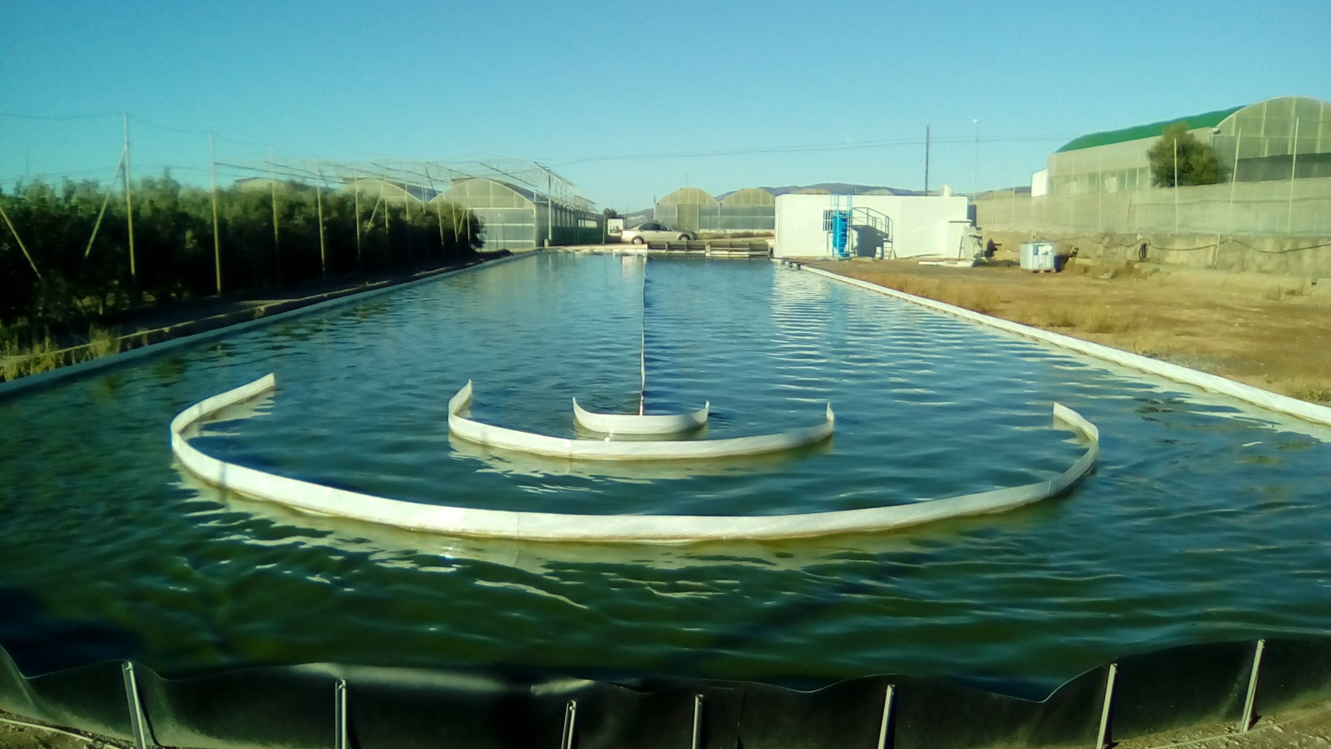
Figure 1. Examples of HARP reactors used for wastewater treatment with microalgae.
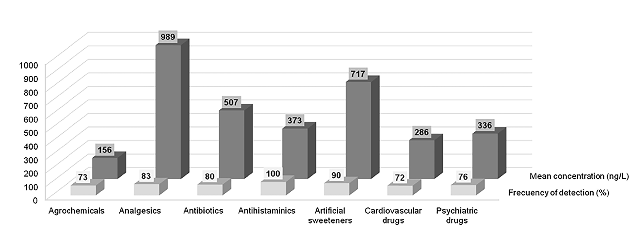
Figure 2. Example of the typical families of CECs which can be detected in municipal wastewater effluents and their concentrations and frequency of detection. Reprinted from [34], copyright 2017, with permission from Elsevier.
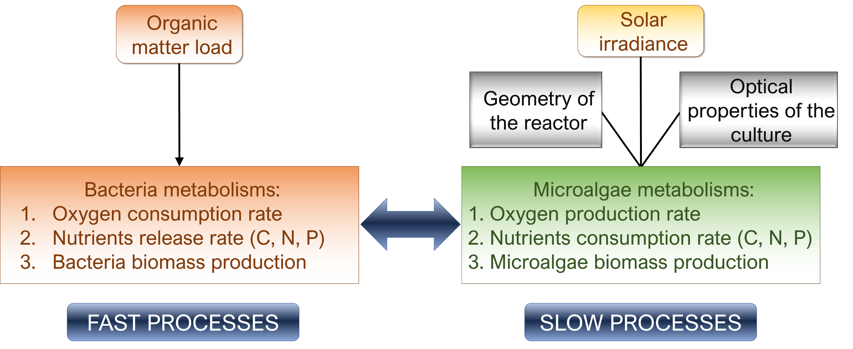
Figure 3. Scheme of main processes taking place in microalgae-related wastewater treatment processes.

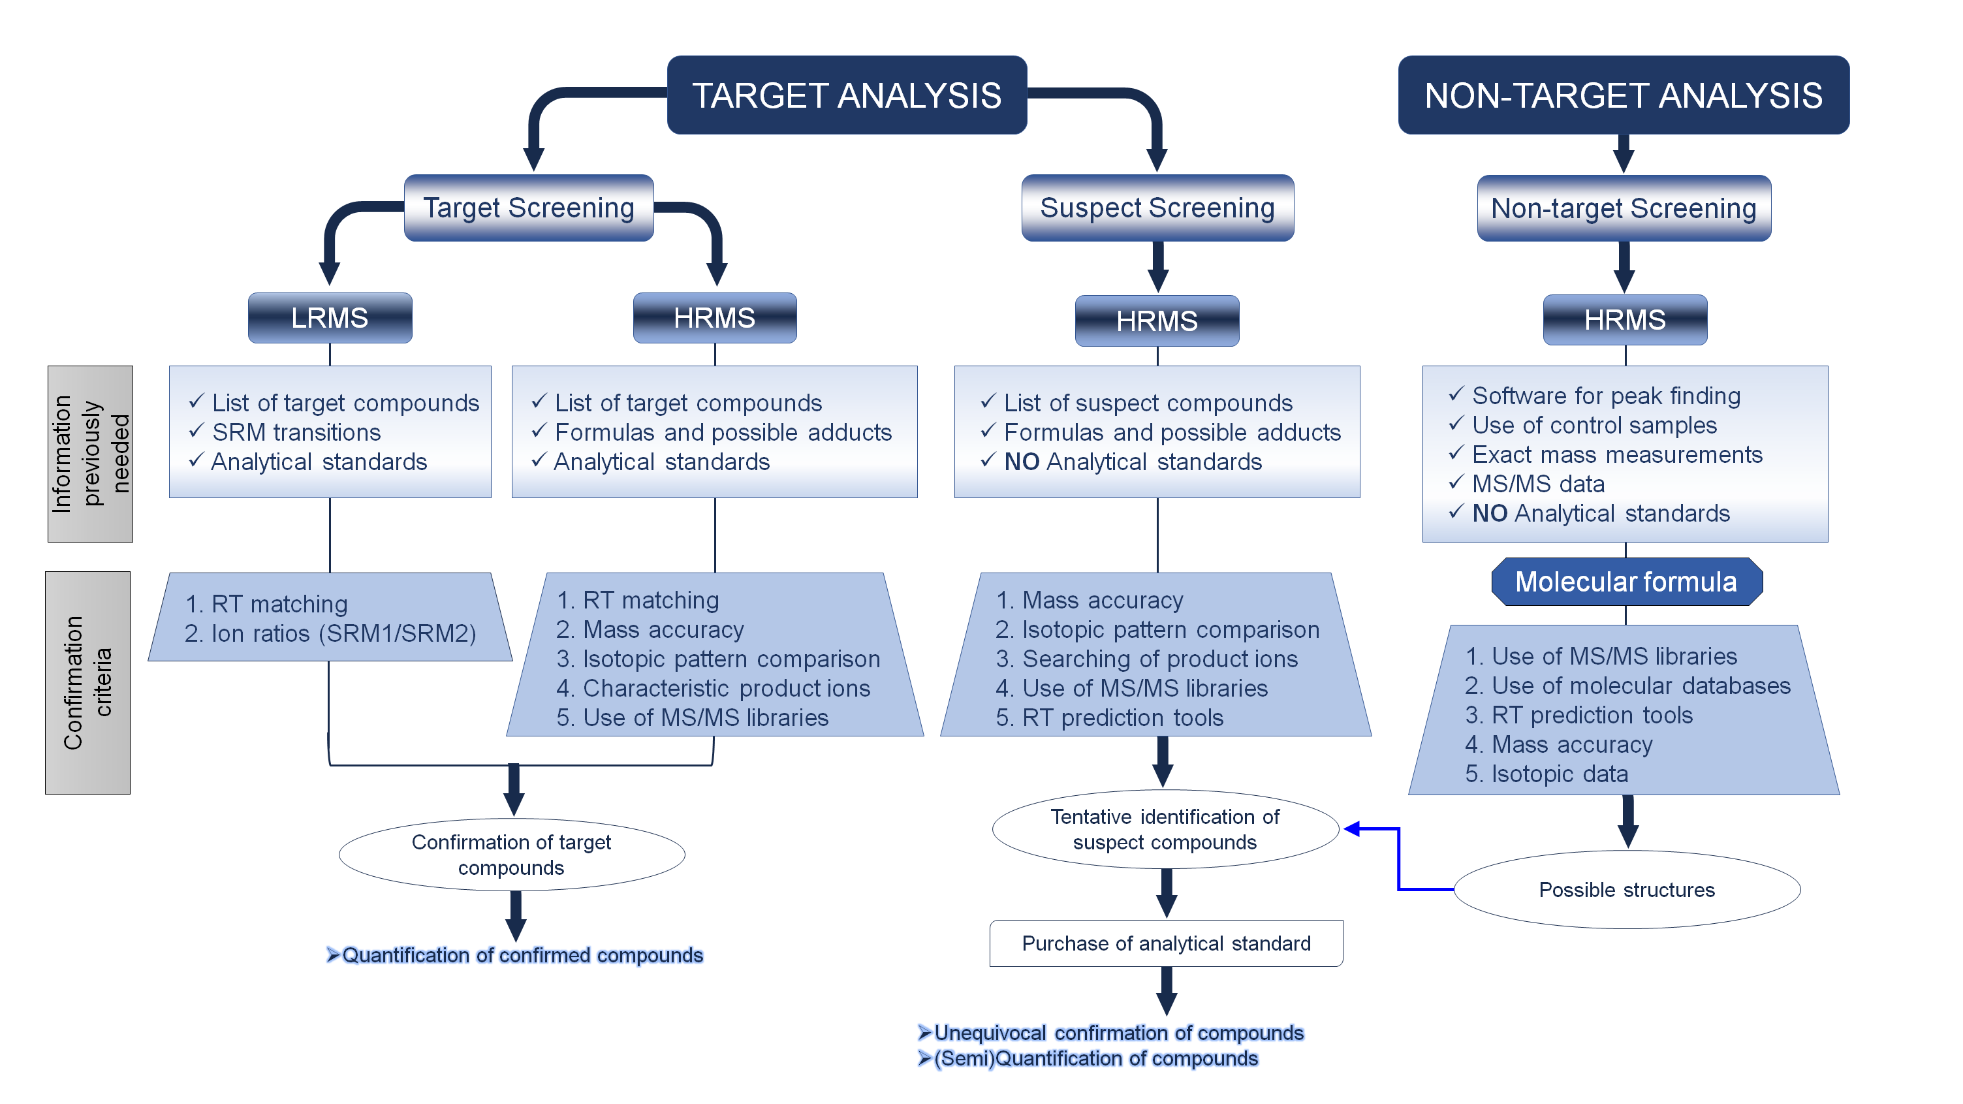Figure 4. Scheme of methodologies used for the analysis of contaminants of emerging concerns in wastewater.

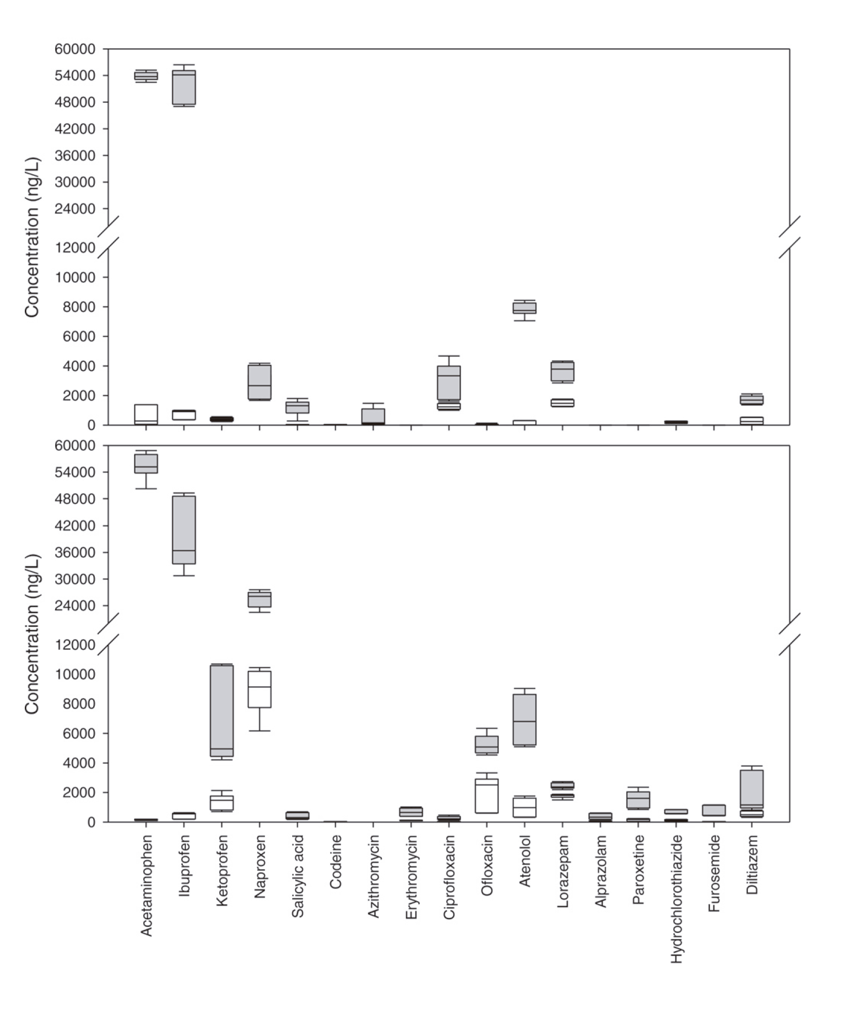
Figure 5. Occurrence and removal of CECs in a microalgae-based photobioreactor. Reprinted from [72], copyright 2017, with permission from Elsevier.

