RESPIROMETRIC ASSESSMENT OF BACTERIAL KINETICS IN ALGAE-BACTERIA AND ACTIVATED SLUDGE PROCESSES

A. Sánchez-Zurano^{*,1}, S. Rossi^{**,1}, J.M. Fernández-Sevilla*, G. Acién-Fernández*, E. Molina-Grima*, E. Ficara**

* Department of Chemical Engineering, Universidad de Almería, E04120 Almería, Spain (E-mail: asz563@ual.es; jfernand@ual.es; facien@ual.es; emolina@ual.es)
** Politecnico di Milano, Dept. of Civil and Environmental Engineering, P.zza L. da Vinci, 32, 20133 Milan, Italy (E-mail: elena.ficara@polimi.it; simone.rossi@polimi.it)
¹ These authors equally contributed to this study

KEYWORDS
Wastewater treatment; Microalgae-bacteria consortia; Activated sludge; Respirometry; Mathematical modelling; Kinetics.

ABSTRACT
Algae-bacteria consortia can be successfully exploited for effective wastewater treatment, based on the algal photosynthetic oxygen production, which allows reducing energy requirements for oxygenation. Kinetic models and parameters for bacterial populations grown in the conventional activated sludge process are well known but their effectiveness in describing bacterial kinetics in algae-bacteria consortia have not been yet validated. In this work, a respirometric procedure was applied to estimate bacterial kinetics at different conditions of temperature, pH, dissolved oxygen and substrates concentrations in activated sludge and algae-bacteria consortia, highlighting important differences. Results showed that bacterial activities were influenced by process operation and environmental conditions in the two systems. Bacteria in algae-bacteria consortia were adapted to a wider range of conditions compared to activated sludge bacteria, suggesting that calibrating algae-bacteria kinetic models is essential for an effective modelling, and respirometry was proven to be a powerful tool to this purpose.

ABBREVIATIONS
AB: Algae-bacteria; AOB: ammonia-oxidizing bacteria; AS: activated sludge; BBM: Bold’s basal medium; COD: chemical oxygen demand; CPM: cardinal pH model; CTMI: cardinal temperature model with inflection; DO: dissolved oxygen; HB: heterotrophic bacteria; HRT: hydraulic retention time; NOB: nitrite-oxidizing bacteria; OUR: oxygen uptake rate; OTR: oxygen transfer rate; SOUR: specific oxygen uptake rate; WWTP: wastewater treatment plant.

TABLE OF CONTENTS
1. INTRODUCTION 3
2. MATERIALS AND METHODS 5
2.1. WASTEWATER CHARACTERISTICS, TREATMENT SYSTEMS AND CLIMATE 5
2.2. RESPIROMETRIC DEVICE 6
2.3. RESPIROMETRIC PROCEDURES 6
2.4. EXPERIMENTAL DESIGN 7
2.5. NUMERICAL METHODS 8
2.6. STATISTICAL METHODS AND SOFTWARE 11
2.7. ANALYTICAL METHODS AND REAGENTS USED 11
3. RESULTS AND DISCUSSION 11
3.1. EFFECT OF TEMPERATURE 15
3.2. EFFECT OF pH VALUES 18
3.3. EFFECT OF DISSOLVED OXYGEN 20
3.4. EFFECT OF SUBSTRATES 22
4. CONCLUSIONS 25
ACKNOWLEDGMENTES 25
REFERENCES 26

INTRODUCTION
Biological secondary treatment is traditionally employed in wastewater treatment plants (WWTPs) to remove the dissolved nutrients (i.e., C, N and P compounds), the most widely applied system being the activated sludge (AS) process (Hreiz et al., 2015; Orhon, 2015). In this bioremediation process, diverse groups of microorganisms are responsible for wastewater treatment, the main actors being heterotrophic bacteria (HB), and autotrophic nitrifying bacteria, i.e., ammonia-oxidizing Bacteria (AOB), and nitrite-oxidizing bacteria (NOB). Despite the high COD, N and P removal efficiencies obtained by AS processes, high energy demands and operating costs are caused by aeration, mixing, and reagents required to properly operate the process (Crini & Lichtfouse, 2019). Nutrient losses and greenhouse gas emissions are also reported as major disadvantages of conventional bioremediation systems (Campos et al., 2016; Capodaglio & Olsson, 2019). To overcome these drawbacks, algae-bacteria (AB) consortia has been proposed as a sustainable alternative, as this biotechnology exploits renewable sunlight, consumes atmospheric CO₂, and allows for N and P removal and recovery, while generating valuable bio-products from the algal biomass (Craggs et al., 2014; Do et al., 2022; Mantovani et al., 2020; Mennaa et al., 2019).
Large-scale AB systems for wastewater treatment are generally implemented in outdoor raceway ponds (RWPs), that are exposed to continuous variations in the environmental conditions (mainly: temperature, irradiance, and evaporation rates), driving the algal and bacterial growth kinetics to follow both daily and seasonal patterns. As a result, other key parameters such as pH and dissolved oxygen (DO) noticeably vary during the day, further influencing the water chemistry and growth kinetics (Casagli, Rossi, et al., 2021; Robles et al., 2020). The availability of nutrients in low amounts, or in large excess, introduce other limitation or inhibition factors for both the algal and bacterial biomass (Aparicio et al., 2022; Klausmeier et al., 2004; Rossi, Díez-Montero, et al., 2020). This makes microalgae-bacteria modelling especially challenging, and imposes the calibration of many kinetic parameters, for which few experimental guidelines have been released (Shoener et al., 2019). Within this context, respirometry have been widely applied as a rapid tool for the assessment of kinetic parameters of AS, aimed at the calibration of Activated Sludge Models (ASM) (Ellis et al., 1996; Henze et al., 2006; Mainardis et al., 2021; Petersen et al., 2003; Sin & Vanrolleghem, 2007). On the other hand, photo-respirometry can be successfully applied to assess the activity of AB consortia treating municipal and industrial wastewaters (Flores-Salgado et al., 2021; Petrini et al., 2020; Rossi et al., 2018; Sánchez-Zurano et al., 2020). Respirometric data have been profitably used to calibrate mathematical models describing AB systems for wastewater treatment (Casagli, Zuccaro, et al., 2021; Manhaeghe et al., 2021; Sánchez-Zurano, Rodríguez-Miranda, et al., 2021; Zambrano et al., 2016). However, only a few studies proposed specific protocols to assess bacterial activities in AB systems (Flores-Salgado et al., 2021; Sánchez-Zurano et al., 2020), these experiments being generally conducted on the algal biomass alone, which has more inter-species variability than bacteria (Rossi, Sforza, et al., 2020). In AB modelling, it is generally assumed that the bacterial populations can be modelled by using parameters that are conventionally adopted in ASMs. However, adaptation phenomena in the AB unit can be expected, driven by continuous environmental perturbations and nutrient/substrates competition with algal species (Fallahi et al., 2021; González-Camejo, Montero, et al., 2020; Ramanan et al., 2016).
In this work, a comprehensive respirometric study of the dependence of bacterial activities on environmental conditions (temperature, pH and DO) and substrates concentrations (COD, N-NH₄⁺, and N-NO₂⁻) was carried out. The procedure was developed and applied to samples collected from a full scale conventional activated sludge tank (fed on municipal wastewater), and from a pilot-scale algae-bacteria raceway pond (fed on the liquid fraction of anaerobic digestate), both in operation at the same WWTP. The respirometric study allowed to model the behaviour of aerobic bacteria (namely, HB, AOB, and NOB) in the two systems, and to identify the most relevant kinetic parameters describing the effect of the above-mentioned conditions. Parameter identification using experimental data made it possible to compare these effects on each bacterial population, aimed at providing a useful methodology, and an extensive dataset, to calibrate existing AB growth models with the final aim of developing control and optimization strategies.

MATERIALS AND METHODS

WASTEWATER CHARACTERISTICS, TREATMENT SYSTEMS AND CLIMATE
The biomass used for respirometric tests was sampled from two wastewater treatment systems, both located in the WWTP of Bresso-Niguarda (Milan, Italy): (i) a full-scale AS tank receiving pre-treated (screening, sand/grit removal, primary settling) municipal wastewater, and (ii) a pilot-scale AB RWP, treating the liquid fraction of centrifuged digestate originated from the anaerobic digestion of excess activated sludge.
The AS tank (6100 m³) was operated continuously with an average HRT of 17 h. The tank was located outdoor, and it was subject to weather conditions and low temperatures during winter. However, the large volume and the fact that it was built underground, made it possible to maintain relatively high temperatures throughout the year (13 – 22°C). The influent wastewater had average total COD, NH₄⁺, and total P concentrations of 307 mg COD·L⁻¹, 22.9 mg N-NH₄⁺·L⁻¹, and 4.6 mg P·L⁻¹, respectively. Under typical operational conditions, the average pH and DO values in the AS tank were 6.9 pH units and 0.3 mg DO·L⁻¹.
The AB cultivation unit was a 0.87 m³ RWP, that was fed in continuous to maintain an HRT of 6 d. The reactor had a 0.15 m liquid height and a total surface of 5.8 m². The RWP was located into a greenhouse, to mitigate the cold winter conditions of Northern Lombardy. More details about the AB unit are available in a previous work (Mantovani et al., 2020). The AB culture was periodically examined for identifying algal species and other microorganisms. During the experimentation, the dominant algae species were Scenedesmus sp. and Chlorella sp. (1.6 ± 1.9 and 1.1 ± 1.3 Mcells·mL⁻¹, respectively, on average). The temperature range and the maximum solar radiation to which the algal culture was exposed in the RWP were 5 – 32°C and 1010 W·m⁻², respectively. The pH was maintained within 6 – 8 by temporized bubbling of pure CO₂ coming from the full-scale biogas upgrading unit . The DO was measured online, reaching minimum and maximum values of 0.3 – 20.8 mg DO·L⁻¹, respectively. The influent digestate had average concentrations of 220 mg N-NH₄⁺·L⁻¹, 177 mg COD·L⁻¹, and 9 mg P-PO₄³⁻·L⁻¹, respectively. Nitrite was almost absent in both the WW and influent digestate (< 0.3 mg N-NO₂⁻·L⁻¹), however partial nitrification occurred in the RWP, with NO₂⁻ accumulation peaks up to 144 mg N-NO₂⁻·L⁻¹. The main characteristics of the influent wastewater and treatment systems are reported in Table 1.

Table 1. Comparison of the main wastewater characteristics and reactor conditions in the two treatment systems. Results are reported as average ± standard deviation. N.a.: not available.
PARAMETER | UNIT | ACTIVATED SLUDGE (AS) |  | ALGAE-BACTERIA (AB)
 |  | Influent | Reactor | Influent | Reactor
N-NH₄⁺ | mg N·L⁻¹ | 29.4 ± 10.9 | 1.0 ± 0.9 | 219 ± 51 | 34.5 ± 21.1
N-NO₂⁻ | mg N·L⁻¹ | - | n.a. | 0.31 ± 0.08 | 75.5 ± 50.9
N-NO₃⁻ | mg N·L⁻¹ | - | 10.1 ± 3.1 | 0.32 ± 0.75 | 58.3 ± 57.2
Total N | mg N·L⁻¹ | 32.1 ± 10.3 | 6.4 ± 3.6 | 220 ± 52 | 168 ± 71
P-PO₄³⁻ | mg P·L⁻¹ | n.a. | 0.74 ± 0.30 | 9.2 ± 2.4 | 6.3 ± 2.5
Total P | mg P·L⁻¹ | 4.6 ± 2.2 | 0.8 ± 0.4 | 13.1 ± 1.1 | 12.4 ± 1.5
COD_{S} | mg COD·L⁻¹ | n.a. | n.a. | 164 ± 60 | 205 ± 154
COD_{TOT} | mg COD·L⁻¹ | 308 ± 128 | 17.9 ± 8.7 | 301 ± 40 | 669 ± 103
BOD_{TOT,5}·COD_{TOT}⁻¹ | - | 0.57 ± 0.09 | n.a. | 0.30 ± 0.08 | 0.09 ± 0.01
TSS | g TSS·L⁻¹ | 0.15 ± 0.08 | 7.3 ± 1.3 | 0.21 ± 0.09 | 0.47 ± 0.24
OD₆₈₀ | - | n.a. | n.a. | 0.10 ± 0.06 | 0.42 ± 0.21
HRT | d | n.a. | 0.7 ± 0.1 | n.a. | 15.0 ± 0.0
Temperature | °C | n.a. | 18.3 ± 4.6 | n.a. | 20.2 ± 6.0
Temperature range | °C | n.a. | 13.0 – 21.9 | n.a. | 4.7 – 32.4
pH | - | 7.5 ± 0.3 | 6.9 ± 0.1 | 8.6 ± 0.2 | 7.1 ± 0.3
pH range | - | n.a. | 6.7 – 7.1 | n.a. | 5.9 – 7.9
DO | mg DO·L⁻¹ | n.a. | 0.27 ± 0.43 | n.a. | 8.1 ± 3.1
DO range | mg DO·L⁻¹ | n.a. | 0.0 – 3.4 | n.a. | 0.3 – 20.8

RESPIROMETRIC DEVICE
The respirometer used to evaluate respiration rates was composed of two 500 mL glass bottles filled to 300 mL with biomass suspensions. The device was equipped with temperature, DO and pH probes, collecting and communicating data to the control units every 3 s. Tests were conducted in a thermostatic chamber to maintain the desired temperatures. The pH was controlled at the desired levels by automatic titration of concentrated HCl or NaOH solutions (0.1 – 0.5 M), while the DO concentration was controlled by on-demand aeration. A more detailed description of the respirometric apparatus is available elsewhere (Rossi, Casagli, et al., 2020; Rossi et al., 2021).

RESPIROMETRIC PROCEDURES AND EXPERIMENTAL DESIGN
The experimental procedure was inspired by typical respirometric protocols available for the AS process (Vanrolleghem et al., 1999) and for AB consortia (Rossi, Casagli, et al., 2020; Sánchez-Zurano et al., 2020). For each parameter tested (i.e., temperature, pH, DO, and substrate concentrations), a different respirometric protocol was applied for each bacterial population (AOB, NOB, HB).
In order to remove residual culture nutrients and to adjust the biomass concentration, AB samples were concentrated 10 times by centrifugation at 10000 g (Filtermaxx VWO, USA), and immediately resuspended in fresh Bold’s Basal Medium (BBM) to avoid stress on the algal populations, which could have resulted in the release of organic matter (González-Camejo, Pachés, et al., 2020). The composition of the BBM used to resuspend the biomass was previously described (Rossi et al., 2021). AS samples were left in the dark for 24 h, bubbling unfiltered ambient air to reach substrate depletion and endogenous conditions.
After pre-treatments, the environmental conditions were modified according to the experimental design (see Table 2), and the tests started. Respirometric protocols were constituted by a series of three re-aeration cycles. The environmental parameter under investigation was later varied, and the re-aeration cycles were further repeated for all parameters’ combination. When a certain parameter was varied, all other parameters were kept at reference levels (T = 20°C, pH = 7.5, DO = 5 – 6 mg DO·L⁻¹), and the substrate concentrations were maintained to non-limiting concentrations. The control was reactor A (with substrate availability), and the limited reactor was reactor B (with no substrates or with inhibitors). For tests performed on AOB, NH₄⁺ (100 mg N·L⁻¹) was added in both respirometric vessels, while reactor B was supplemented with 10 mg·L⁻¹ of ATU to stop ammonia oxidation (Rossi et al., 2018). For NOB and HB, reactor A was maintained under endogenous and substrate-limited conditions, while the reactor B was supplemented with the relevant substrate (NO₂⁻ and COD at concentrations of 25 mg N·L⁻¹ and 100 mg COD·L⁻¹, respectively (Sánchez-Zurano et al., 2020). In nutrients tests, substrates were added by successive spikes, aimed at increasing the nutrient availability up to the desired concentrations (see also Section 2.4). The tests were divided into four series, targeting temperature, pH, dissolved oxygen, and substrate concentrations. The values of the parameters to be tested were chosen to cover the their range in outdoor AS and AB systems (see Table 1), as summarised in Table 2.

Table 2. Experimental design describing the environmental conditions and nutrient concentrations maintained during respirometric tests.
PARAMETER | UNIT | TARGET POPULATIONS | RANGE TESTED
Temperature | °C | HB, AOB, NOB | 5 – 45
pH | - | HB, AOB, NOB | 4 – 11
Dissolved oxygen | mg DO·L⁻¹ (%DO_{SAT}) | HB, AOB, NOB | 0 – 25 (0 – 275%)
COD | mg COD·L⁻¹ | HB | 0 – 500
NH₄⁺ | mg N·L⁻¹ | AOB | 0 – 300
NO₂⁻ | mg N·L⁻¹ | NOB | 0 – 200

NUMERICAL METHODS
A detailed description of numerical methods to calculate the OURs is reported in previous studies (Rossi, Casagli, et al., 2020; Sánchez-Zurano et al., 2020). Briefly, a DO mass balance was applied to the respirometric bottles (Eq. 1), allowing to define relevant rates affecting the dynamic evolution of the DO during each phase, i.e.: the oxygen uptake rate (OUR) and the oxygen transfer rate (OTR).

$$\frac{\text{d (DO)}}{\text{d (t)}}\text{=OU}{\text{R}}_{\text{i}}\text{+OTR, (}\text{i}\text{ = 1, …, 3)}$$ | Eq. 1

Where: OUR_{i} is the oxygen uptake rate for the considered phase i [mg DO·L⁻¹·h⁻¹], and OTR is the oxygen transfer rate for the given respirometer characteristics [mg DO·L⁻¹·h⁻¹].

To describe the oxygen mass transfer, the following equation was used (Eq. 2):

$$\text{OTR=}{\text{θ}}^{\text{(T-}{\text{T}}_{\text{REF}}\text{)}}\text{·}{\text{k}}_{\text{L}}{\text{a}}_{\text{20}}\text{·(D}{\text{O}}_{\text{SAT}}\text{-DO)}$$ | Eq. 2

Where: θ = 1.024 [-] is the temperature correction coefficient according to previous guidelines (ASCE, 1993), T_{REF} = 20°C is the reference temperature, k_{L}a₂₀ = 1.06 [h⁻¹] is the volumetric gas-liquid mass transfer coefficient, estimated through dedicated reaeration tests in clean water at 20°C (see also Section SI.1), DO_{SAT} [mg DO·L⁻¹] is the oxygen saturation at the considered temperature, calculated from the appropriate Henry constant (Rossi et al., 2021).

Given that the DO dynamics were recorded online, and the OTR was calculated by knowing the volumetric mass transfer coefficient k_{L}a, the OUR could be estimated for each phase. Specific oxygen uptake rates (SOUR_{i}, [mg DO·g TSS⁻¹·h⁻¹]) were calculated for each phase, by dividing the obtained OUR_{i} values by the TSS concentration expressed in [g TSS·L⁻¹] (Eq. 3).

$$\text{SOU}{\text{R}}_{\text{i}}\text{=}\frac{\text{OU}{\text{R}}_{\text{i}}}{\text{TSS}}\text{, (}\text{i}\text{ = 1, …, 3)}$$ | Eq. 3

The bacterial activity of each population (SOUR_{X} in Eq. 4 , where X = HB, AOB, or NOB) was determined by difference among the activity recorded in the control reactor A and the limited reactor B.

$$\text{SOU}{\text{R}}_{\text{X,i}}\text{=SOU}{\text{R}}_{\text{A,i}}\text{-SOU}{\text{R}}_{\text{B,i}}\text{ (X = HB, AOB, NOB; }\text{i}\text{ = 1, …, 3)}$$ | Eq. 4

To compare test results among different conditions, OUR data were finally normalized by the maximum experimental value recorded, i.e., SOUR_{MAX} (SOUR_{NORM,X,i}, Eq. 5).

$$\text{SOU}{\text{R}}_{\text{NORM,X,i}}\text{=}\frac{\text{SOU}{\text{R}}_{\text{X,i}}}{\text{SOU}{\text{R}}_{\text{MAX}}}\text{ (X = HB, AOB, NOB; }\text{i}\text{ = 1, …, 3)}$$ | Eq. 5

To model the respiration dependence from each tested condition, commonly applied models were used (Casagli, Zuccaro, et al., 2021; Sánchez-Zurano, Rodríguez-Miranda, et al., 2021; Solimeno et al., 2019).

The temperature dependence was modelled using the cardinal temperature model with inflection (CTMI), shown in Eq. 6 (Rosso et al., 1995);

$$\frac{\text{SOUR}}{\text{SOU}{\text{R}}_{\text{MAX}}}\text{=}\left\{\begin{matrix}\text{0, if T<}{\text{T}}_{\text{MIN}} \\ \frac{\left(\text{T-}{\text{T}}_{\text{MAX}}\right){\text{·}\left(\text{T-}{\text{T}}_{\text{MIN}}\right)}^{\text{2}}}{\left({\text{T}}_{\text{OPT}}\text{-}{\text{T}}_{\text{MIN}}\right)\text{·}\left(\left({\text{T}}_{\text{OPT}}\text{-}{\text{T}}_{\text{MIN}}\right)\text{·}\left(\text{T-}{\text{T}}_{\text{OPT}}\right)\text{-}\left({\text{T}}_{\text{OPT}}\text{-}{\text{T}}_{\text{MAX}}\right)\text{·}\left({\text{T}}_{\text{OPT}}\text{+}{\text{T}}_{\text{MIN}}\text{- 2·T}\right)\right)}\text{, if }{\text{T}}_{\text{MIN}}\text{<T<}{\text{T}}_{\text{MAX}} \\ \text{0, if T>}{\text{T}}_{\text{MAX}}\end{matrix}\right.$$ | Eq. 6

Where: T_{MIN} is the minimum cardinal temperature below which the respiration rate is zero [°C], T_{OPT} is the optimal temperature for which the respiration rate is maximum [°C], T_{MAX} is the maximum cardinal temperature above which the respiration rate is zero [°C].

To evaluate the dependence on the pH value, the cardinal pH model (CPM) in Eq. 7 (Rosso et al., 1995) was fitted to experimental data:

$$\frac{\text{SOUR}}{\text{SOU}{\text{R}}_{\text{MAX}}}\text{=}\left\{\begin{matrix}\text{0, if pH<}{\text{pH}}_{\text{MIN}} \\ \frac{\text{(pH-p}{\text{H}}_{\text{MIN}}\text{)·(pH-p}{\text{H}}_{\text{MAX}}\text{)}}{\left(\text{pH-p}{\text{H}}_{\text{MIN}}\right)·\left(\text{pH-p}{\text{H}}_{\text{MAX}}\right)\text{-}{\left(\text{pH-p}{\text{H}}_{\text{OPT}}\right)}^{\text{2}}}\text{, if }{\text{pH}}_{\text{MIN}}\text{<pH<}{\text{pH}}_{\text{MAX}} \\ \text{0, if pH>}{\text{pH}}_{\text{MAX}}\end{matrix}\right.$$ | Eq. 7

Where: pH_{MIN} is the minimum cardinal pH value below which the respiration rate is zero [-], pH_{OPT} is the optimal pH value for which the respiration rate is maximum [-], pH_{MAX} is the maximum cardinal pH value above which the respiration rate is zero [-].

The dependence on DO and nutrients (NH₄⁺, NO₂⁻, COD) was expressed as either the Monod function with nutrient limitation in Eq. 8 (Monod, 1942), or Andrews kinetics, if inhibition at high substrate concentrations occurred, as shown in Eq. 9 (Turon et al., 2015).

$$\frac{\text{SOUR}}{\text{SOU}{\text{R}}_{\text{MAX}}}\text{=}\frac{\text{S}}{\text{S+}{\text{K}}_{\text{S}}}$$ | Eq. 8

Where: S represents either the concentration of DO or the relevant substrate (NH₄⁺ for AOB, NO₂⁻ for NOB, and COD for HB) [mg·L⁻¹], K_{S} is the half-saturation constant for DO or for the substrate [mg·L⁻¹];

$$\frac{\text{SOUR}}{\text{SOU}{\text{R}}_{\text{MAX}}}\text{=}\frac{\text{S}}{\text{S+}\frac{\text{SOU}{\text{R}}_{\text{MAX}}}{\text{α}}\text{·}{\left(\frac{\text{S}}{{\text{S}}_{\text{OPT}}}\text{-1}\right)}^{\text{2}}}$$ | Eq. 9

Where: α [L·d·mg⁻¹] is the initial slope coefficient; S_{OPT} [mg·L⁻¹] is the optimum concentration of DO or of the considered substrate, for which the respiration rate is maximum.

STATISTICAL METHODS AND SOFTWARE
Raw data were exported in the software Excel 365 (Microsoft) and organized as input tables for subsequent elaborations. Data were then imported in MATLAB R2021b (The Mathworks) and the SOUR values were estimated from raw data using the Optimization Toolbox (function: lsqcurvefit). Further elaborations, and plotting, was performed using OriginPro 2020b (OriginLab Corporation), including SOUR data normalization, nonlinear curve fitting, and model statistics. To express the goodness of fit for the selected models, the following parameters were used: the reduced chi-squared, the residual sum of squares, and the adjusted r-squared. Confidence and prediction intervals were calculated at the significance level of 95% (α = 0.05).

ANALYTICAL METHODS AND REAGENTS USED
The TSS concentrations were measured according to Standard Methods (APHA, AWWA, WEF, 2017). Triplicate measurements of the OD₆₈₀ were assessed using a 1-cm path plastic cuvette and read using a spectrophotometer (Hach Company, Model: DR 3900). For AB, the linear regression among the TSS and OD₆₈₀ was used to rapidly estimate the TSS concentration based on faster OD₆₈₀ measurement (see Section SI.2 for more details on the correlation among the OD₆₈₀ and TSS for the AB suspension). All chemicals used to prepare synthetic media (i.e., the synthetic BBM and the concentrated NH₄, NO₂, COD and ATU solutions) were reagent-grade from Sigma-Aldrich.

RESULTS AND DISCUSSION
The results of the fitting procedures for the AS and AB samples (i.e., the estimated model parameters describing the dependence on temperature, pH, DO and substrates) are given in Table 3 and Table 4, respectively. Detailed residual analyses and model statistics, including the reduced Chi-square, residual sum of squares, and adjusted R-square, are reported in Section SI.3. All models were able to represent the experimental dataset (adjusted R-square values: 0.54 – 0.94), confirming both the adequacy of the equations used in algae-bacteria models, and the versatility of respirometric tests to determine bacterial kinetics rapidly and reliably.
Results can be discussed by considering that AS and AB were sampled from systems subjected to different conditions, potentially impacting on the bacterial community and their kinetic parameters. As the AS and AB conditions significantly differed, bacterial response was expected to reflect certain differences among the two samples. Regarding the distinct conditions experienced by bacteria, the main differences mainly arose from the presence of microalgae, the reactor geometry and scale and the wastewater characteristics, influencing the environmental conditions of the suspension and the composition and activities of the microbial community. In particular, the scale and geometry of reactors mainly had an impact on the thermal properties and thermal inertia of the biomass suspension. Indeed, the AS had a volume of 6100 m³, which is several orders of magnitude higher than the scale of the RWP (0.87 m³). In addition, the AS tank of the Bresso-Niguarda plant was built underground, so that thermal excursions were further buffered, and the AS culture has a more stable temperature throughout the year. On the other hand, the AB pond had higher thermal dispersions, since the pilot plant floor was also in exchange with the surrounding air, being placed on a metal structure at approximately 0.8 m above the ground. The geometry of the reactor was further responsible for emphasizing thermal variations, as RWPs are specifically designed to maximize the surface/volume ratio, and to minimize the liquid height, thus maximizing the light penetration for photosynthesis. Indeed, typical liquid heights for RWPs are in the range of 0.1 – 0.3 m, compared to AS systems in which the tank height can typically reach 3 – 6 m, depending on the type of installed aeration devices. In addition, the pH and DO markedly increased in the algal-bacterial suspension, following the photosynthetic activity. Another major difference among the two systems is that the biomass concentration was kept at very high levels in AS (up to 3.7 g TSS·L⁻¹, through settled sludge recirculation). On the contrary, lower TSS concentrations were reached in AB (up to a maximum value of 0.9 g TSS·L⁻¹), as it is common in these systems, to guarantee a sufficient light penetration.
Regarding nutrient sources, as reported in Table 1, the AS received primary effluent, rich in degradable organic matter, and with moderate concentrations of N and P. On the contrary, the AB was fed on nutrient-rich digestate with low concentrations of biodegradable organic matter (Akhiar et al., 2017). This possibly led to the predominance, in the AB system, of autotrophic microalgae and nitrifying bacteria over HB, as testified by the high NH₄ removal rates (> 84%) and the high NO_{X} effluent concentrations (up to 245 mg N-NO₂⁻+NO₃⁻·L⁻¹), coupled with a negligible soluble COD removal efficiency. It should be finally noticed that the bacterial biomass concentrations in AB systems are generally much lower than the algal concentrations, typically showing a ratio of bacterial to algal TSS lower than 1:10 (Casagli, Rossi, et al., 2021; Sánchez-Zurano, Ciardi, et al., 2021). On the contrary, the biomass in the AS tank is practically constituted only by bacterial biomass and inert particulate material, and the concentration of HB in AS is expected to be much higher than AOB and NOB, due to the larger availability of degradable organics. In the following sections, the results obtained for each parameter are reported and discussed.

Table 3. Results of parameter identification for heterotrophic bacteria (HB), ammonia-oxidizing bacteria (AOB), and nitrite-oxidizing bacteria (NOB) in activated sludge (AS) and algae-bacteria (AB) consortia. Results are expressed as value (standard error). n.a.: not applicable.
VARIABLE | FITTING  FUNCTION | MODEL  PARAMETER | UNIT | HB |  | AOB |  | NOB
 |  |  |  | AS | AB | AS | AB | AS | AB
T | CTMI (Eq. 6) | T_{MIN} | °C | -7.7 (4.3) | -4.3 (4.2) | 1.3 (2.5) | 0.48 (2.88) | -7.8 (5.4) | -4.3 (5.2)
 |  | T_{OPT} | °C | 36.1 (1.1) | 35.59 (0.87) | 30.19 (0.84) | 34.13 (0.80) | 36.0 (1.3) | 34.4 (1.3)
 |  | T_{MAX} | °C | 42.90 (0.14) | 40.52 (0.17) | 41.78 (0.31) | 43.75 (0.26) | 43.43 (0.73) | 41.85 (0.50)
pH | CPM (Eq. 7) | pH_{MIN} | - | 4.19 (0.17) | 2.93 (0.50) | 4.24 (0.21) | 4.43 (0.22) | 4.40 (0.10) | 4.04 (0.13)
 |  | pH_{OPT} | - | 8.02 (0.28) | 8.77 (0.35) | 8.48 (0.26) | 9.45 (0.18) | 7.46 (0.23) | 7.83 (0.23)
 |  | pH_{MAX} | - | 11.06 (0.14) | 11.13 (0.11) | 10.80 (0.08) | 10.82 (0.02) | 11.21 (0.17) | 11.00 (0.13)
DO | Monod (Eq. 8),  Andrews (Eq. 9) | k_{DO} | mg DO·L⁻¹ | 1.25 (0.25) | n.a. | n.a. | n.a. | 2.12 (0.16) | 2.28 (0.41)
 |  | α | L·d·mg DO⁻¹ | n.a. | 8.75 (3.06) | 0.59 (0.15) | 1.45 (0.31) | n.a. | n.a.
 |  | DO_{OPT} | mg DO·L⁻¹ | n.a. | 1.29 (0.21) | 6.64 (0.62) | 3.27 (0.29) | n.a. | n.a.
COD | Monod (Eq. 8) | k_{COD} | mg COD·L⁻¹ | 4.39 (0.83) | 3.46 (0.61) | n.a. | n.a. | n.a. | n.a.
NH₄⁺ | Andrews (Eq. 9) | α | L·d·mg N⁻¹ | n.a. | n.a. | 3.08 (0.60) | 2.38 (0.32) | n.a. | n.a.
 |  | NH_{4OPT} | mg N·L⁻¹ | n.a. | n.a. | 10.55 (3.08) | 10. 86 (0.98) | n.a. | n.a.
NO₂⁻ | Monod (Eq. 8) | k_{NO2} | mg N·L⁻¹ | n.a. | n.a. | n.a. | n.a. | 0.76 (0.12) | 4.58 (0.59)

EFFECT OF TEMPERATURE
The effect of temperature on bacterial populations of AS and AB is reported in Figure 1. As shown, the trend for all populations followed the typical asymmetric curve of algal and bacterial cultures (Rosso et al., 1995), in which the optimal temperature is closer to the maximum than to the minimum temperature. The values of the parameters estimated for the CTMI are reported in Table 3.
Regarding the estimated optimal temperatures, these ranged from 30 to 36°C, which is common for a wide variety of bacterial strains and species (Rosso et al., 1993). For AS, optimal temperatures were 36.1°C for HB, 30.2°C for AOB and 36.0°C for NOB, while in AB samples, the optimum for growth resulted to be 35.6°C for HB, 34.1°C for AOB and 34.5°C for NOB. Since, to the best knowledge of the authors, no studies are available in which the cardinal temperatures were experimentally determined for AS, it is not possible to directly compare these results with other literature experiences. However, previous studies reported that the optimal temperature for nitrifiers is approximately 30°C, even though values close to the maximum activity could be observed in the entire range from 15°C to 35°C (Shammas, 1986), with a strong decrease in the activity below 15°C, and almost no activity could be detected at 5°C. In this work, the optimal temperature for AOB was found to be lower in AS than in AB, while the optimum for NOB was similar in both systems. In most cases, the dependence of AS on temperature is modelled by using Arrhenius-type models, which is only suitable to represent the activity below the optimal temperature, therefore no maximum values are found in the literature.
Regarding bacterial populations in AB, the temperature dependence was recently modelled based on the CTMI (Sánchez Zurano et al., 2021), obtaining very similar results for HB (T_{OPT} = 36°C) and for nitrifying bacteria, that were assessed as a single bacterial group (T_{OPT} = 33.6°C). These results were also used as nominal values for the ABACO model (Sánchez-Zurano, Rodríguez-Miranda, et al., 2021). A further confirmation on the reliability of respirometric estimates comes from the calibrated cardinal temperature models available in recently published AB models. In both the ALBA (Casagli, Zuccaro, et al., 2021) and BIO_ALGAE (Solimeno et al., 2019), calibrated values for bacteria are close to the reported estimations.
As previously reported in other studies, bacteria can survive in a wide range of temperatures (Alisawi, 2020; Rosso et al., 1995). This was also confirmed by the experimental data, for which the thermal niche was of 40 – 50°C. The minimum tolerable temperature among all bacterial populations spanned from -7.7°C to 1.3°C, although with large standard errors, suggesting that the experimental design should be improved to better target this parameter. These results were higher than those reported in a similar AB system (Sánchez Zurano et al., 2021), though in this case the climate conditions at which the AB was operated were much warmer than those described here, possibly suggesting an adaptative behaviour. All the bacterial populations could resist up to more than 40°C, and maximum tolerable temperatures ranged from 40.5°C to 43.8°C, coherently with previous findings (Sánchez Zurano et al., 2021). Maximum temperatures were more precisely identified (i.e., with lower standard errors) compared to minimum temperatures (see Table 3 and Section SI.3 for more details).

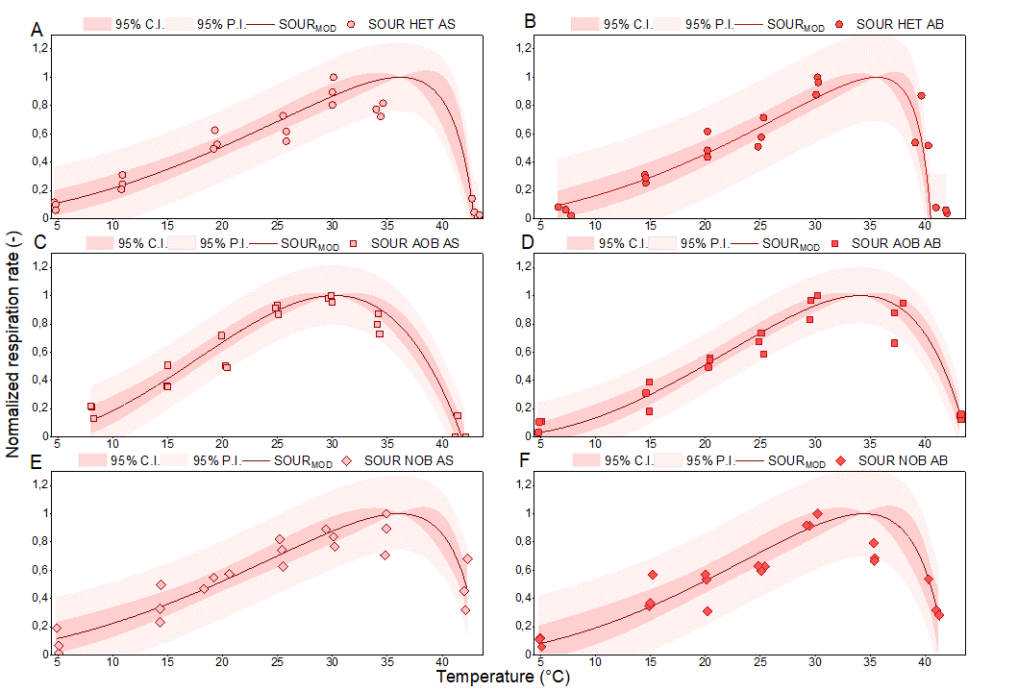
Figure 1. Effect of temperature on bacterial populations in activated sludge (AS) and algae-bacteria (AB) samples: heterotrophic bacteria in AS (A), heterotrophic bacteria in AB (B), ammonia-oxidizing bacteria in AS (C), ammonia-oxidizing bacteria in AB (D), nitrite-oxidizing bacteria in AS (E), nitrite-oxidizing bacteria in AB (F).

EFFECT OF pH VALUES
The effect of different pH values on AS and AB is shown in Figure 2. The CPM described well the respirometric dataset of all bacterial populations, with satisfactory fits and acceptable adjusted R-square values (0.84 – 0.90).
As a general trend, bacteria in both AS and AB systems could resist to quite large intervals of pH, still showing some residual activity at pH 4 – 11. Regarding the optimal pH, estimated values varied among the different populations (between 7.5 and 9.5). For AS, optimal pH values were 8.0 for HB, 8.5 for AOB and 7.5 for NOB, while the estimates for AB were shifted towards higher optima (8.8 for HB, 9.5 for AOB and 7.8 for NOB), suggesting that bacteria adapted in the AB system to more alkaliphilic conditions. These higher pH optima in AB compared to AS can be indeed explained by the higher pH values promoted by photosynthetic CO₂ uptake in algae-based wastewater treatment processes (according to the results reported in Table 1, the pH in the RWP was on average 7.1, with peaks up to 7.9). Previous studies have confirmed that in AS bacterial consortia, a pH ranging from 6.8 to 8.5 resulted in a high microbial activity and rate of biodegradation (Zhou et al., 2019). For HB, high consumption rates could be reached in a wide range of pH values (from 3 to 9), with a very sharp drop at higher pH (Mayo & Noike, 1996). Also, the pH dependence curve for nitrifiers is quite flat-topped, showing similarly high activities at pH values from 7 to 9.5 and with very little activity, or complete inactivation, only below pH 6 and above pH 10 (Antoniou et al., 1990; Painter & Loveless, 1983; Shammas, 1986).
Concerning AB consortia, only a few studies have recently reported the application of the CPM to describe the effect of pH on bacterial populations. Results from Sanchez-Zurano et al.(Sánchez Zurano et al., 2021) were quite consistent with the parameter estimates given in Table 3. Similarly, the ALBA and the BIO_ALGAE models both used calibrated values that are very close to these models (Casagli, Zuccaro, et al., 2021; Solimeno et al., 2019). In these studies describing the pH dependence for bacterial populations in AB, the pH_{MIN}, pH_{OPT}, and pH_{MAX} assumed values in the following ranges: 2.0 – 6.0, 7.0 – 9.0 and 11.0 – 13.4, respectively, further confirming the ability of bacteria to grow in a wide range of pH conditions.

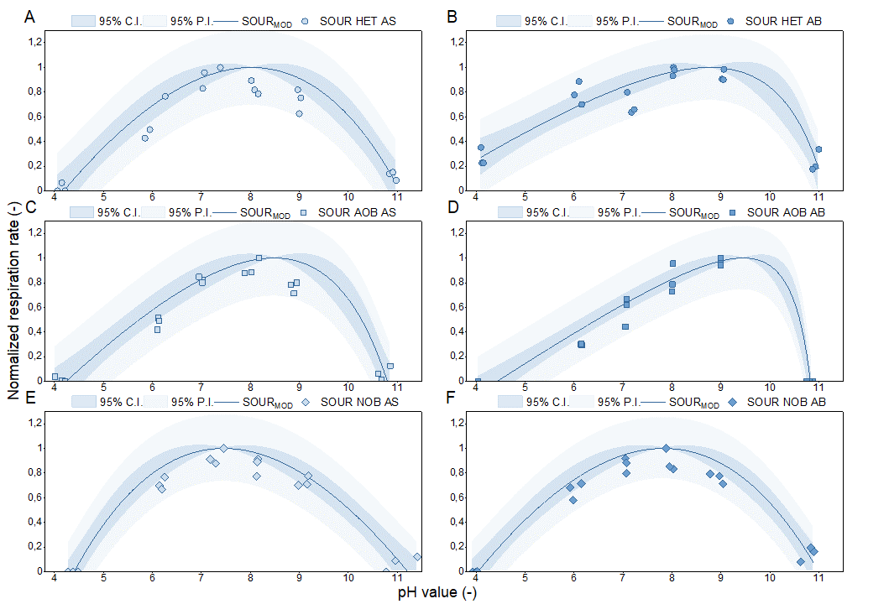
Figure 2. Effect of pH on bacterial populations in activated sludge (AS) and algae-bacteria (AB) samples: heterotrophic bacteria in AS (A), heterotrophic bacteria in AB (B), ammonia-oxidizing bacteria in AS (C), ammonia-oxidizing bacteria in AB (D), nitrite-oxidizing bacteria in AS (E), nitrite-oxidizing bacteria in AB (F).

EFFECT OF DISSOLVED OXYGEN
As depicted in Figure 3, DO had a relevant effect on bacterial respiration rates. DO have an important inhibitory effect on HB and AOB sampled from AB, while almost no inhibition was observed at high DO concentrations for all AS bacterial populations and NOB in both systems. As an explanation for this fact, possible inhibitory effects of DO concentrations far above air saturation were previously reported to occur because of the DO diffusion through the membranes and to cause oxidative stress in cells. However, this inhibitory effect only seems to be related to long-term exposure times to DO oversaturation. Therefore, the differences observed between the two treatment systems could be because in AS, xthe microorganisms are rarely exposed to high DO concentrations, while in AB cultures the frequent exposition to high DO concentrations (caused by the algal photosynthetic activity), could have led to long-term cell stress (Baez & Shiloach, 2014). Estimated half-saturation constants for DO in AS samples were 1.2 and 2.1 mg DO·L⁻¹, respectively, for HB and NOB, and the optimal DO for AOB was 6.6 mg DO·L⁻¹. In AB samples, a similar half-saturation coefficients was found for NOB (2.3 mg DO·L⁻¹), and the optimal DO concentrations for HB and AOB were 1.3 and 3.3 mg DO·L⁻¹, respectively (Table 3). By comparing the DO dependence for the three populations in both AS and AB, it was confirmed, as previously reported for AS samples (Daebel et al., 2007; Hiatt & Grady, 2008), that the affinity for oxygen in HB was generally higher than for nitrifiers. Moreover, the AS had floccular nature, while AB grew as suspended cells. Therefore, a higher diffusion resistance in AS, because of the presence of flocs, can explain the lower affinity for DO that was observed in AS. The lower affinity to oxygen for NOB compared to AOB was also described in several studies, and this fact was often adopted as a selective strategy in partial nitritation reactors, allowing to wash out NOB and to achieve stable accumulation of NO₂⁻ (Blackburne et al., 2008; Rongsayamanont et al., 2010).

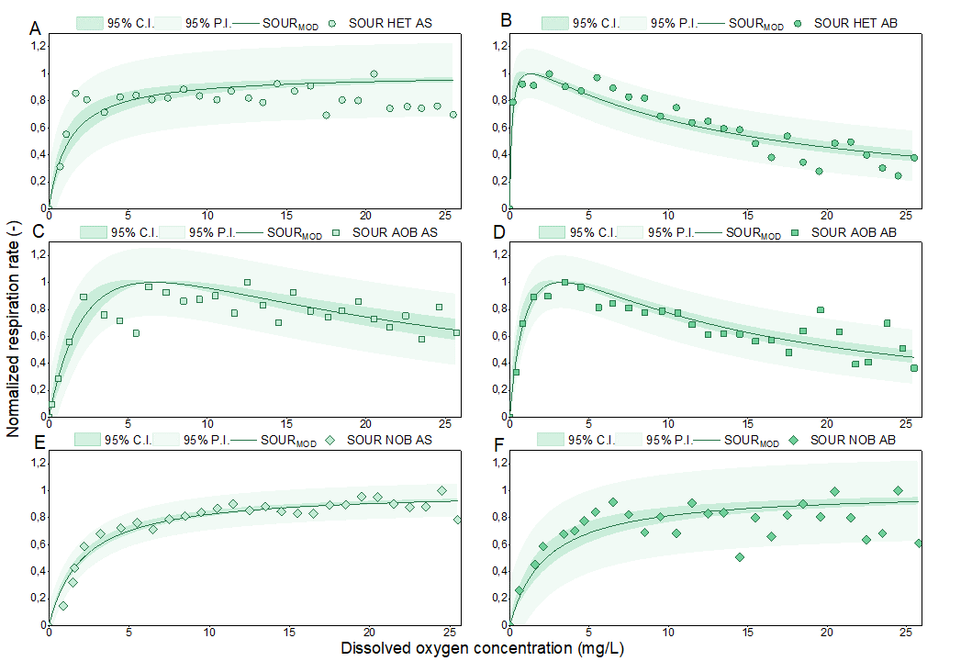
Figure 3. Effect of dissolved oxygen on bacterial populations in activated sludge (AS) and algae-bacteria (AB) samples: heterotrophic bacteria in AS (A), heterotrophic bacteria in AB (B), ammonia-oxidizing bacteria in AS (C), ammonia-oxidizing bacteria in AB (D), nitrite-oxidizing bacteria in AS (E), nitrite-oxidizing bacteria in AB (F).

EFFECT OF SUBSTRATE LIMITATION / INHIBITION
The effects of nutrient concentrations on bacterial populations of AS and AB are reported in Figure 4. For HB, the half-saturation constants for COD were quite similar in both AS and AB (Figure 4A and Figure 4B, respectively), only showing a slightly lower substrate affinity in AS (4.4 mg COD·L⁻¹), compared to AB (3.5 mg COD·L⁻¹). Half-saturation constants found in this study for AS were very close to previous studies (Ellis et al., 1996; Jubany Güell, 2007; Orhon et al., 2009), though a wide range of values is available in the literature, reaching up to one order of magnitude more than those found in this work, i.e. up to 20 – 45 mg COD·L⁻¹, depending on process characteristics (Çığgın et al., 2012; Esquivel-Rios et al., 2014; Kappeler & Gujer, 1992). Regarding AB, as no experimental determination of the half-saturation values is available in the literature for HB, mathematical models describing the growth of AB consortia generally assume the value of 20 mg COD·L⁻¹ from the ASMs (Sánchez-Zurano, Rodríguez-Miranda, et al., 2021; Solimeno et al., 2019), or more similar values to those experimentally found in this study (4 mg COD·L⁻¹), as reported by other sources (Casagli, Zuccaro, et al., 2021).
Regarding the effect of nutrients for nitrifying bacteria, the results for AOB are given in Fig. Figure 4C (for AS) and Figure 4D (for AB), while the results for NOB are reported in Figure 4E (for AS) and Figure 4F (for AB). When looking at the parameter estimates for AOB, inhibitory effects of NH₄⁺ occurred in both AS and AB, as further emphasized by the low optimal ammonia concentrations (NH_{4,OPT} = 10.5 mg N·L⁻¹ and 10.8 mg N·L⁻¹ for AS and AB, respectively). This was coherent with the findings reported in previous studies for AS bacteria (Kim et al., 2006), and might be due to the generation of small amounts of free ammonia (FA), even if the pH was kept at 7.5 to minimize this effect. Indeed, FA is a strong growth/activity inhibitor for several types of microorganisms (Rossi, Díez-Montero, et al., 2020). However, no evidence is directly available for bacterial populations in AB consortia, and the dependence of bacterial growth on ammoniacal nitrogen is generally evaluated in AB models based on a Monod-type function, i.e., not considering substrate inhibition. The findings reported in the present study suggest that a deeper investigation should be conducted, to define whether the inhibitory effect is to be attributed to FA or the ammonium ions. These results were coherent with the experimental determinations of the half-saturation constants for ammoniacal nitrogen in AS: the ASMs and other studies reported values ranging from 0.4 to 5.2 mg N·L⁻¹ (Henze et al., 2000; Iacopozzi et al., 2007; Leyva-Díaz et al., 2020; Wu et al., 2016), though a large variability was again found for this parameter, reaching in some cases values up to 9 – 40 mg N·L⁻¹ (Ficara et al., 2000; Terada et al., 2013; van Dongen et al., 2001). Very similar results were also obtained for AOB in AB consortia Due to the unavailability of experimental studies on bacterial activities, the only possible comparisons can be made with AB models, in which the assumed half-saturation constant for ammoniacal nitrogen range from 0.5 mg N·L⁻¹ (Casagli, Zuccaro, et al., 2021; Reichert et al., 2001; Solimeno et al., 2019), up to 1 mg N·L⁻¹ (Sánchez-Zurano, Rodríguez-Miranda, et al., 2021).
Regarding NOB, a similar effect was observed for the AS and AB samples, since in both ecosystems a Monod-type curve could fit well the experimental values. However, results suggested that NOB populations in AS had a higher substrate affinity (K_{NO2} = 0.8 mg N·L⁻¹) compared to AB (K_{NO2} = 4.6 mg N·L⁻¹). Such values are highly consistent with recent respirometric studies reporting kinetic parameters of NOB for AS samples (Chandran et al., 2008; Iacopozzi et al., 2007; Jiménez et al., 2012; Wu et al., 2016), along with recent AB models considering two-step nitrification (Casagli, Zuccaro, et al., 2021; Solimeno et al., 2019). It should be finally noticed that NO₂⁻ concentrations in the AB cultivation system reached up to 144 mg N·L⁻¹. On the other hand, no relevant NO₂⁻ accumulation was ever recorded in the AS tank, due to the high nitrite-oxidizing activity, that always resulted in complete nitrification, regardless of the operational conditions. However, no explanation regarding the phenomenon of incomplete nitrification in AB reactors could be provided, based on the results of this study. Therefore, it is suggested that further experimental work is conducted, to evaluate other possible factors which could result in limited NOB growth, such as the half-saturation constants for NOB on other nutrients than nitrite (e.g., for inorganic carbon, or phosphorus). Results of kinetic parameter identification for nutrients are reported in Table 3 and Table 4.

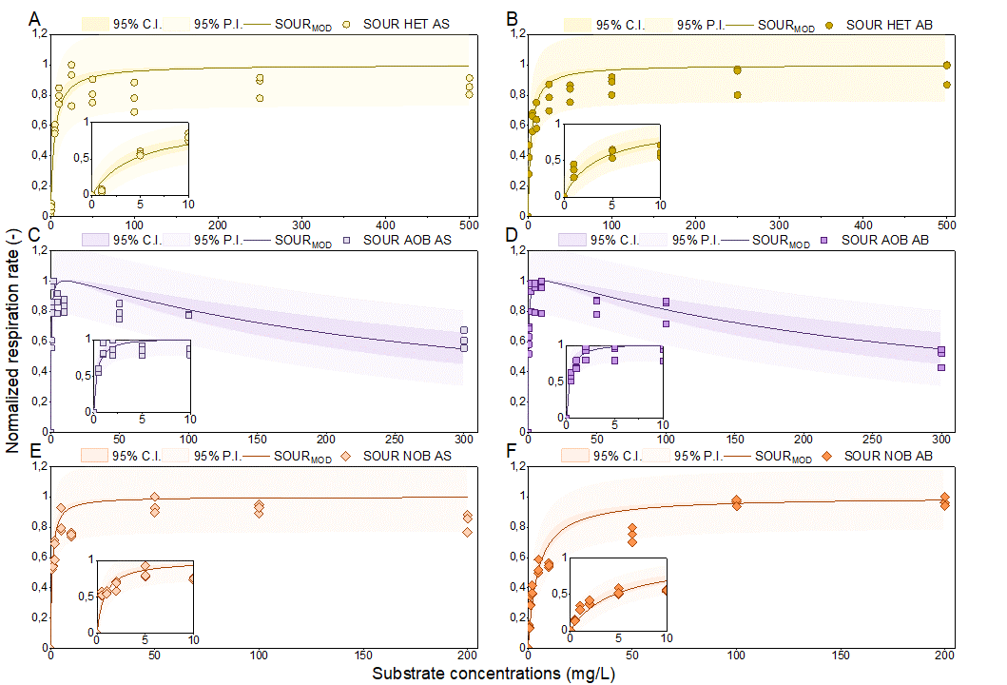
Figure 4. Effect of substrates on bacterial populations in activated sludge (AS) and algae-bacteria (AB) samples: heterotrophic bacteria in AS (A), heterotrophic bacteria in AB (B), ammonia-oxidizing bacteria in AS (C), ammonia-oxidizing bacteria in AB (D), nitrite-oxidizing bacteria in AS (E), nitrite-oxidizing bacteria in AB (F).

CONCLUSIONS
This study demonstrated that the environmental and operational conditions have a decisive impact on the bacterial community. The activity of the main bacterial populations (HB, AOB and NOB) in AS and AB were sensitive to changes in culture conditions, such as temperature, pH and DO. Specifically, bacterial activities were strongly influenced by the pH and DO values, however these parameters can be cost-effectively controlled to target optimal values, while temperature control may be more difficult. Along with environmental variables, the concentration of substrates severely affected the microbial activity, with ammoniacal nitrogen originating a strong inhibitory effect. Moreover, results demonstrated that important differences occurred between microbial populations in AS and AB, suggesting that respirometric protocols must be used to assess bacterial kinetics and that direct translation of available data from AS is inappropriate. The kinetic modelling and parameter estimation using experimental data are crucial to design and properly manage biological wastewater treatment systems based on activated sludge and algae-bacteria consortia, as well as to define control strategies to maximise the treatment efficiency and to guarantee the stability of these processes.

ACKNOWLEDGEMENTS
This research was funded by Fondazione CARIPLO (project: “Il polo delle microalghe”) and by EU H2020 Framework Programme (project: PRODIGIO, 101007006). A. Sánchez-Zurano would like to thank the Spanish Ministry of Education (FPU16/05996).

REFERENCES
Akhiar, A., Battimelli, A., Torrijos, M., & Carrere, H. (2017). Comprehensive characterization of the liquid fraction of digestates from full-scale anaerobic co-digestion. Waste Management, 59, 118–128. https://doi.org/10.1016/j.wasman.2016.11.005
Alisawi, H. A. O. (2020). Performance of wastewater treatment during variable temperature. Applied Water Science, 10(4), 89. https://doi.org/10.1007/s13201-020-1171-x
Antoniou, P., Hamilton, J., Koopman, B., Jain, R., Holloway, B., Lyberatos, G., & Svoronos, S. A. (1990). Effect of temperature and ph on the effective maximum specific growth rate of nitrifying bacteria. Water Research, 24(1), 97–101. https://doi.org/10.1016/0043-1354(90)90070-M
Aparicio, S., Robles, Á., Ferrer, J., Seco, A., & Borrás Falomir, L. (2022). Assessing and modeling nitrite inhibition in microalgae-bacteria consortia for wastewater treatment by means of photo-respirometric and chlorophyll fluorescence techniques. Science of The Total Environment, 808, 152128. https://doi.org/10.1016/j.scitotenv.2021.152128
APHA, AWWA, WEF. (2017). Standard Methods for the Examination of Water and Wastewater, 23rd Edition.
ASCE. (1993). Measurement of Oxygen Transfer in Clean Water. ANSI/ASCE 2-91.
Baez, A., & Shiloach, J. (2014). Effect of elevated oxygen concentration on bacteria, yeasts, and cells propagated for production of biological compounds. Microbial Cell Factories, 13(1), 181. https://doi.org/10.1186/s12934-014-0181-5
Blackburne, R., Yuan, Z., & Keller, J. (2008). Partial nitrification to nitrite using low dissolved oxygen concentration as the main selection factor. Biodegradation, 19(2), 303–312. https://doi.org/10.1007/s10532-007-9136-4
Campos, J. L., Valenzuela-Heredia, D., Pedrouso, A., Val del Río, A., Belmonte, M., & Mosquera-Corral, A. (2016). Greenhouse Gases Emissions from Wastewater Treatment Plants: Minimization, Treatment, and Prevention. Journal of Chemistry, 2016, e3796352. https://doi.org/10.1155/2016/3796352
Capodaglio, A. G., & Olsson, G. (2019). Energy Issues in Sustainable Urban Wastewater Management: Use, Demand Reduction and Recovery in the Urban Water Cycle. Sustainability 2020, Vol. 12, Page 266, 12(1), 266. https://doi.org/10.3390/SU12010266
Casagli, F., Rossi, S., Steyer, J. P., Bernard, O., & Ficara, E. (2021). Balancing Microalgae and Nitrifiers for Wastewater Treatment: Can Inorganic Carbon Limitation Cause an Environmental Threat? Environmental Science & Technology, acs.est.0c05264. https://doi.org/10.1021/acs.est.0c05264
Casagli, F., Zuccaro, G., Bernard, O., Steyer, J. P., & Ficara, E. (2021). ALBA: A comprehensive growth model to optimize algae-bacteria wastewater treatment in raceway ponds. Water Research, 190, 116734. https://doi.org/10.1016/j.watres.2020.116734
Chandran, K., Hu, Z., & Smets, B. F. (2008). A critical comparison of extant batch respirometric and substrate depletion assays for estimation of nitrification biokinetics. Biotechnology and Bioengineering, 101(1), 62–72. https://doi.org/10.1002/bit.21871
Çığgın, A. S., Insel, G., Majone, M., & Orhon, D. (2012). Respirometric evaluation and modelling of acetate utilization in sequencing batch reactor under pulse and continuous feeding. Bioresource Technology, 107, 61–69. https://doi.org/10.1016/j.biortech.2011.12.029
Craggs, R., Park, J., Heubeck, S., & Sutherland, D. (2014). High rate algal pond systems for low-energy wastewater treatment, nutrient recovery and energy production. New Zealand Journal of Botany, 52(1), 60–73. https://doi.org/10.1080/0028825X.2013.861855
Crini, G., & Lichtfouse, E. (2019). Advantages and disadvantages of techniques used for wastewater treatment. Environmental Chemistry Letters, 17(1), 145–155. https://doi.org/10.1007/s10311-018-0785-9
Daebel, H., Manser, R., & Gujer, W. (2007). Exploring temporal variations of oxygen saturation constants of nitrifying bacteria. Water Research, 41(5), 1094–1102. https://doi.org/10.1016/j.watres.2006.11.011
Do, C. V. T., Pham, M. H. T., Pham, T. Y. T., Dinh, C. T., Bui, T. U. T., Tran, T. D., & Nguyen, V. T. (2022). Microalgae and bioremediation of domestic wastewater. Current Opinion in Green and Sustainable Chemistry, 100595. https://doi.org/10.1016/J.COGSC.2022.100595
Ellis, T. G., Barbeau, D. S., Smets, B. F., & Grady, C. P. L. (1996). Respirometric Technique for Determination of Extant Kinetic Parameters Describing Biodegradation. Water Environment Research, 68(5), 917–926.
Esquivel-Rios, I., Ramirez-Vargas, R., Hernandez-Martinez, G. R., Vital-Jacome, M., Ordaz, A., & Thalasso, F. (2014). A microrespirometric method for the determination of stoichiometric and kinetic parameters of heterotrophic and autotrophic cultures. Biochemical Engineering Journal, 83, 70–78. https://doi.org/10.1016/j.bej.2013.12.006
Fallahi, A., Rezvani, F., Asgharnejad, H., Khorshidi Nazloo, E., Hajinajaf, N., & Higgins, B. (2021). Interactions of microalgae-bacteria consortia for nutrient removal from wastewater: A review. Chemosphere, 272, 129878. https://doi.org/10.1016/j.chemosphere.2021.129878
Ficara, E., Musumeci, A., & Rozzi, A. (2000). Comparison and combination of titrimetric and respirometric techniques to estimate nitrification kinetic parameters. Water SA, 26.
Flores-Salgado, G., Thalasso, F., Buitrón, G., Vital-Jácome, M., & Quijano, G. (2021). Kinetic characterization of microalgal-bacterial systems: Contributions of microalgae and heterotrophic bacteria to the oxygen balance in wastewater treatment. Biochemical Engineering Journal, 165, 107819. https://doi.org/10.1016/J.BEJ.2020.107819
González-Camejo, J., Montero, P., Aparicio, S., Ruano, M. V., Borrás, L., Seco, A., & Barat, R. (2020). Nitrite inhibition of microalgae induced by the competition between microalgae and nitrifying bacteria. Water Research, 172, 115499. https://doi.org/10.1016/j.watres.2020.115499
González-Camejo, J., Pachés, M., Marín, A., Jiménez-Benítez, A., Seco, A., & Barat, R. (2020). Production of microalgal external organic matter in a Chlorella -dominated culture: Influence of temperature and stress factors. Environmental Science: Water Research & Technology, 6(7), 1828–1841. https://doi.org/10.1039/D0EW00176G
Henze, M., Gujer, W., Mino, T., & van Loosdrecht, M. (2000). Activated Sludge Models ASM1, ASM2, ASM2D, ASM3. In Water Intelligence Online (Vol. 5). https://doi.org/10.2166/9781780402369
Henze, M., Gujer, W., Mino, T., & van Loosedrecht, M. (2006). Activated Sludge Models ASM1, ASM2, ASM2d and ASM3. https://doi.org/10.2166/9781780402369
Hiatt, W. C., & Grady, C. P. L. (2008). An Updated Process Model for Carbon Oxidation, Nitrification, and Denitrification. Water Environment Research, 80(11), 2145–2156. https://doi.org/10.2175/106143008X304776
Hreiz, R., Latifi, M. A., & Roche, N. (2015). Optimal design and operation of activated sludge processes: State-of-the-art. Chemical Engineering Journal, 281, 900–920. https://doi.org/10.1016/J.CEJ.2015.06.125
Iacopozzi, I., Innocenti, V., Marsili-Libelli, S., & Giusti, E. (2007). A modified Activated Sludge Model No. 3 (ASM3) with two-step nitrification–denitrification. Environmental Modelling & Software, 22(6), 847–861. https://doi.org/10.1016/j.envsoft.2006.05.009
Jiménez, E., Giménez, J. B., Seco, A., Ferrer, J., & Serralta, J. (2012). Effect of pH, substrate and free nitrous acid concentrations on ammonium oxidation rate. Bioresource Technology, 124, 478–484. https://doi.org/10.1016/j.biortech.2012.07.079
Jubany Güell, I. (2007). Operation, modeling and automatic control of complete and partial nitrification of highly concentrated ammonium wastewater. Universitat Autònoma de Barcelona,. https://ddd.uab.cat/record/37074
Kappeler, J., & Gujer, W. (1992). Estimation of Kinetic Parameters of Heterotrophic Biomass under Aerobic Conditions and Characterization of Wastewater for Activated Sludge Modelling. Water Science and Technology, 25(6), 125–139. https://doi.org/10.2166/wst.1992.0118
Kim, D.-J., Lee, D.-I., & Keller, J. (2006). Effect of temperature and free ammonia on nitrification and nitrite accumulation in landfill leachate and analysis of its nitrifying bacterial community by FISH. Bioresource Technology, 97(3), 459–468. https://doi.org/10.1016/j.biortech.2005.03.032
Klausmeier, C. A., Litchman, E., & Levin, S. A. (2004). Phytoplankton growth and stoichiometry under multiple nutrient limitation. Limnology and Oceanography, 49(4part2), 1463–1470. https://doi.org/10.4319/lo.2004.49.4_part_2.1463
Leyva-Díaz, J. C., Muñío, M. del M., Fenice, M., & Poyatos, J. M. (2020). Respirometric method for kinetic modeling of ammonium-oxidizing and nitrite-oxidizing bacteria in a membrane bioreactor. AIChE Journal, 66(8), e16271. https://doi.org/10.1002/aic.16271
Mainardis, M., Buttazzoni, M., Cottes, M., Moretti, A., & Goi, D. (2021). Respirometry tests in wastewater treatment: Why and how? A critical review. Science of The Total Environment, 793, 148607. https://doi.org/10.1016/j.scitotenv.2021.148607
Manhaeghe, D., Allosserie, A., Rousseau, D. P. L., & Van Hulle, S. W. H. (2021). Model based analysis of carbon fluxes within microalgae-bacteria flocs using respirometric-titrimetric data. Science of The Total Environment, 147048. https://doi.org/10.1016/j.scitotenv.2021.147048
Mantovani, M., Marazzi, F., Fornaroli, R., Bellucci, M., Ficara, E., & Mezzanotte, V. (2020). Outdoor pilot-scale raceway as a microalgae-bacteria sidestream treatment in a WWTP. The Science of the Total Environment, 710. https://doi.org/10.1016/J.SCITOTENV.2019.135583
Mayo, A. W., & Noike, T. (1996). Effects of temperature and pH on the growth of heterotrophic bacteria in waste stabilization ponds. Water Research, 30(2), 447–455. https://doi.org/10.1016/0043-1354(95)00150-6
Mennaa, F. Z., Arbib, Z., & Perales, J. A. (2019). Urban wastewater photobiotreatment with microalgae in a continuously operated photobioreactor: Growth, nutrient removal kinetics and biomass coagulation-flocculation. Environmental Technology, 40(3), 342–355. https://doi.org/10.1080/09593330.2017.1393011
Monod, J. (1942). Recherches sur la croissance des cultures bactériennes. Sorbonne Université.
Orhon, D. (2015). Evolution of the activated sludge process: The first 50 years. Journal of Chemical Technology & Biotechnology, 90(4), 608–640. https://doi.org/10.1002/JCTB.4565
Orhon, D., Cokgor, E. U., Insel, G., Karahan, O., & Katipoglu, T. (2009). Validity of Monod kinetics at different sludge ages – Peptone biodegradation under aerobic conditions. Bioresource Technology, 100(23), 5678–5686. https://doi.org/10.1016/j.biortech.2009.06.046
Painter, H. A., & Loveless, J. E. (1983). Effect of temperature and pH value on the growth-rate constants of nitrifying bacteria in the activated-sludge process. Water Research, 17(3), 237–248. https://doi.org/10.1016/0043-1354(83)90176-8
Petersen, B., Gernaey, K., Henze, M., & Vanrolleghem, P. A. (2003). Calibration of Activated Sludge Models: A Critical Review of Experimental Designs. In S. N. Agathos & W. Reineke (Eds.), Biotechnology for the Environment: Wastewater Treatment and Modeling, Waste Gas Handling (pp. 101–186). Springer Netherlands. https://doi.org/10.1007/978-94-017-0932-3_5
Petrini, S., Foladori, P., Donati, L., & Andreottola, G. (2020). Comprehensive respirometric approach to assess photosynthetic, heterotrophic and nitrifying activity in microalgal-bacterial consortia treating real municipal wastewater. Biochemical Engineering Journal, 161, 107697. https://doi.org/10.1016/j.bej.2020.107697
Ramanan, R., Kim, B.-H., Cho, D.-H., Oh, H.-M., & Kim, H.-S. (2016). Algae–bacteria interactions: Evolution, ecology and emerging applications. Biotechnology Advances, 34(1), 14–29. https://doi.org/10.1016/j.biotechadv.2015.12.003
Reichert, P., Borchardt, D., Henze, M., Rauch, W., Shanahan, P., Somlyódy, L., & Vanrolleghem, P. (2001). River Water Quality Model no. 1 (RWQM1): II. Biochemical process equations. Water Science and Technology: A Journal of the International Association on Water Pollution Research, 43(5), 11–30.
Robles, Á., Capson-Tojo, G., Galès, A., Ruano, M. V., Sialve, B., Ferrer, J., & Steyer, J.-P. (2020). Microalgae-bacteria consortia in high-rate ponds for treating urban wastewater: Elucidating the key state indicators under dynamic conditions. Journal of Environmental Management, 261, 110244. https://doi.org/10.1016/j.jenvman.2020.110244
Rongsayamanont, C., Limpiyakorn, T., Law, B., & Khan, E. (2010). Relationship between respirometric activity and community of entrapped nitrifying bacteria: Implications for partial nitrification. Enzyme and Microbial Technology, 46(3), 229–236. https://doi.org/10.1016/j.enzmictec.2009.10.014
Rossi, S., Bellucci, M., Marazzi, F., Mezzanotte, V., & Ficara, E. (2018). Activity assessment of microalgal-bacterial consortia based on respirometric tests. Water Science and Technology, 78(1), 207–215. https://doi.org/10.2166/wst.2018.078
Rossi, S., Casagli, F., Mantovani, M., Mezzanotte, V., & Ficara, E. (2020). Selection of photosynthesis and respiration models to assess the effect of environmental conditions on mixed microalgae consortia grown on wastewater. Bioresource Technology, 305, 122995. https://doi.org/10.1016/j.biortech.2020.122995
Rossi, S., Díez-Montero, R., Rueda, E., Castillo Cascino, F., Parati, K., García, J., & Ficara, E. (2020). Free ammonia inhibition in microalgae and cyanobacteria grown in wastewaters: Photo-respirometric evaluation and modelling. Bioresource Technology, 305, 123046. https://doi.org/10.1016/j.biortech.2020.123046
Rossi, S., Sforza, E., Pastore, M., Bellucci, M., Casagli, F., Marazzi, F., & Ficara, E. (2020). Photo-respirometry to shed light on microalgae-bacteria consortia—A review. In Reviews in Environmental Science and Biotechnology (Vol. 19, Issue 1, pp. 43–72). Springer. https://doi.org/10.1007/s11157-020-09524-2
Rossi, S., Visigalli, S., Castillo Cascino, F., Mantovani, M., Mezzanotte, V., Parati, K., Canziani, R., Turolla, A., & Ficara, E. (2021). Metal-based flocculation to harvest microalgae: A look beyond separation efficiency. Science of The Total Environment, 799, 149395. https://doi.org/10.1016/j.scitotenv.2021.149395
Rosso, L., Lobry, J. R., Bajard, S., & Flandrois, J. P. (1995). Convenient model to describe the combined effects of temperature and pH on microbial growth. Applied and Environmental Microbiology, 61(2), 610–616. https://doi.org/10.1128/AEM.61.2.610-616.1995
Rosso, L., Lobry, J. R., & Flandrois, J. P. (1993). An Unexpected Correlation between Cardinal Temperatures of Microbial Growth Highlighted by a New Model. Journal of Theoretical Biology, 162(4), 447–463. https://doi.org/10.1006/jtbi.1993.1099
Sánchez Zurano, A., Gómez Serrano, C., Acién-Fernández, F. G., Fernández-Sevilla, J. M., & Molina-Grima, E. (2021). Modeling of photosynthesis and respiration rate for microalgae-bacteria consortia. Biotechnology and Bioengineering, 118(2), 952–962. https://doi.org/10.1002/bit.27625
Sánchez-Zurano, A., Ciardi, M., Lafarga, T., Fernández-Sevilla, J. M., Bermejo, R., & Molina-Grima, E. (2021). Role of Microalgae in the Recovery of Nutrients from Pig Manure. Processes, 9(2), 203. https://doi.org/10.3390/pr9020203
Sánchez-Zurano, A., Gómez-Serrano, C., Acién-Fernández, F. G., Fernández-Sevilla, J. M., & Molina-Grima, E. (2020). A novel photo-respirometry method to characterize consortia in microalgae-related wastewater treatment processes. Algal Research, 47, 101858. https://doi.org/10.1016/j.algal.2020.101858
Sánchez-Zurano, A., Rodríguez-Miranda, E., Guzmán, J. L., Acién-Fernández, F. G., Fernández-Sevilla, J. M., & Molina Grima, E. (2021). ABACO: A New Model of Microalgae-Bacteria Consortia for Biological Treatment of Wastewaters. Applied Sciences, 11(3), 998. https://doi.org/10.3390/app11030998
Shammas, N. Kh. (1986). Interactions of Temperature, pH, and Biomass on the Nitrification Process. Journal (Water Pollution Control Federation), 58(1), 52–59.
Shoener, B. D., Schramm, S. M., Béline, F., Bernard, O., Martínez, C., Plósz, B. G., Snowling, S., Steyer, J.-P., Valverde-Pérez, B., Wágner, D., & Guest, J. S. (2019). Microalgae and cyanobacteria modeling in water resource recovery facilities: A critical review. Water Research X, 2, 100024. https://doi.org/10.1016/j.wroa.2018.100024
Sin, G., & Vanrolleghem, P. A. (2007). Extensions to modeling aerobic carbon degradation using combined respirometric–titrimetric measurements in view of activated sludge model calibration. Water Research, 41(15), 3345–3358. https://doi.org/10.1016/j.watres.2007.03.029
Solimeno, A., Gómez-Serrano, C., & Acién, F. G. (2019). BIO_ALGAE 2: Improved model of microalgae and bacteria consortia for wastewater treatment. Environmental Science and Pollution Research, 26(25), 25855–25868. https://doi.org/10.1007/s11356-019-05824-5
Terada, A., Sugawara, S., Yamamoto, T., Zhou, S., Koba, K., & Hosomi, M. (2013). Physiological characteristics of predominant ammonia-oxidizing bacteria enriched from bioreactors with different influent supply regimes. Biochemical Engineering Journal, 79, 153–161. https://doi.org/10.1016/j.bej.2013.07.012
Turon, V., Baroukh, C., Trably, E., Latrille, E., Fouilland, E., & Steyer, J.-P. (2015). Use of fermentative metabolites for heterotrophic microalgae growth: Yields and kinetics. Bioresource Technology, 175, 342–349. https://doi.org/10.1016/j.biortech.2014.10.114
van Dongen, U., Jetten, M. S. M., & van Loosdrecht, M. C. M. (2001). The SHARON®-Anammox® process for treatment of ammonium rich wastewater. Water Science and Technology, 44(1), 153–160. https://doi.org/10.2166/wst.2001.0037
Vanrolleghem, P. A., Spanjers, H., Petersen, B., Ginestet, P., & Takacs, I. (1999). Estimating (combinations of) activated sludge model no. 1 parameters and components by respirometry. Water Science and Technology, 39(1), 195–214. https://doi.org/10.2166/wst.1999.0042
Wu, J., He, C., van Loosdrecht, M. C. M., & Pérez, J. (2016). Selection of ammonium oxidizing bacteria (AOB) over nitrite oxidizing bacteria (NOB) based on conversion rates. Chemical Engineering Journal, 304, 953–961. https://doi.org/10.1016/j.cej.2016.07.019
Zambrano, J., Krustok, I., Nehrenheim, E., & Carlsson, B. (2016). A simple model for algae-bacteria interaction in photo-bioreactors. Algal Research, 19, 155–161. https://doi.org/10.1016/j.algal.2016.07.022
Zhou, Y., Zhang, J., Zhang, Z., Wang, P., & Xia, S. (2019). PH dependent of the waste activated sludge reduction by short-time aerobic digestion (STAD) process. Science of The Total Environment, 649, 1307–1313. https://doi.org/10.1016/j.scitotenv.2018.08.411

