"This is the peer reviewed version of the following article: FULL CITE, which has been published in final form at DOI: 10.1002/ejic.201501357. This article may be used for non-commercial purposes in accordance With Wiley-VCH Terms and Conditions for self-archiving".

Ruthenium complexes containing 2,2'-bipyridine and PTA (PTA = 1,3,5-triaza-7-phosphaadamantane)
Franco Scalambra,^{[a]} Manuel Serrano-Ruiz,^{[a]} Samira Nahim-Granados,^{[a]} and Antonio Romerosa*^{[a]}
[a] F. Scalambra, M. Serrano-Ruiz, S. Nahim-Granados, A. Romerosa
Área de Química Inorgánica-CIESOL
Universidad de Almeria
Carretera Sacramento s/n, 04120, La Cañada de San Urbano, Spain
E-mail: romerosa@ual.es

Supporting information for this article is given in ....

Abstract: The water soluble complexes cis-[Ru(bpy)₂(PTA)₂]Cl₂ (1Cl₂), cis-[Ru(bpy)₂(PTA)₂](PF₆)₂ (1(PF₆)₂), trans-[Ru(bpy)₂(PTA)₂](CF₃SO₃)₂ (2(CF₃SO₃)₂), cis-[Ru(bpy)₂(PTA)(H₂O)](CF₃SO₃)₂ (3(CF₃SO₃)₂), cis-[Ru(bpy)₂(PTAH)(H₂O)](CF₃SO₃)₃·2CF₃SO₃H (4(CF₃SO₃)₃·2CF₃SO₃H), cis-[Ru(bpy)₂(PTAH)₂](CF₃SO₃)₄·4CF₃SO₃H (5(CF₃SO₃)₄·4CF₃SO₃H) and trans-[Ru(bpy)₂(PTAH)₂](CF₃SO₃)₄·4CF₃SO₃H (6(CF₃SO₃)₄·4CF₃SO₃H) have been synthesized and characterized by elemental analysis, NMR and IR spectroscopy. The crystal structures of 1(PF₆)₂, 2(CF₃SO₃)₂, 3(CF₃SO₃)₂ were obtained by single-crystal X-ray diffraction. Both experimental and computational techniques were utilized to perform a thorough analysis of the structural and electronic properties of the complexes 1 and 2 in water in both the deprotonated and protonated state and under N₂ and air. UV/Visible absorbance spectroscopy revealed the sensitiveness of complex 1 and 2 to the pH. Both Ligand-to-Metal Charge Transfer (LMCT) and Metal-to-Ligand/Ligand-to-Ligand Charge Transfer (MLCT/LLCT) transitions were observed in the absorption spectrum. Luminescence studies showed that these complexes are active fluorescence compounds, despite the presence of monophosphines in their structure. The pH sensitiveness of the emission band of both complexes was studied. The photohydrolisis of 1 and 2 in acid water solution was also studied, showing that both complexes release a PTA molecule under selective irradiation in acidic water to give rise to the complex 4. Cyclic voltammetry showed that, in water, irreversible anodic oxidation corresponding to the Ru(II)/Ru(III) redox process occurs for 1, whereas for 2 the process is quasi-reversible. In DMF the redox Ru(II)/Ru(III) wave for both complexes are irreversible and occur at lower potential than in water.
Introduction
Complexes containing the {Ru(bpy)_{n}}²⁺ (n=1,2,3) (bpy = 2,2'-iidyl) moiety have been widely used as sensitizers, photocatalysts, light harvesting materials and photo-activated anticancer prodrugs.^{[1]} In general, Ru(II)-polypyridyl complexes are relatively inert. Ligand dissociation can however occur in an excited state.^{[2]} An innovative and growing area of interest is the synthesis of tunable complexes to be used as catalysts and molecular switches, utilizing ligands that are activated by changing the protonation state.^{[3]} The close coupling of electrons and protons can provide a mechanism to tune the reactivity, through simple modifications of the surrounding environment.^{[4]} Interesting examples are new methods for imaging obtained by using ligands with multiple protonation states, which effectively alter the photophysical properties of their complexes.^{[5]} Attempts to tune the properties of this family of complexes have led to the synthesis of a large number of polypyridyl derivatives, but this strategy has been only partially successful because of the occurrence of irreversible ligand photodissociation and subsequent photosubstitution reactions. ^{[6]}
Extensive work on the photochemical activity of metal complexes^{[7]} has provided many examples of photoactive metal complexes containing phosphines, particularly with ruthenium, ^{[8]} although a few example of photochemically active ruthenium complexes containing water soluble phosphines have been presented.^{[9]} One of the most widely used water soluble phosphines is the easy obtainble PTA (PTA = 1,3,5-triaza-7-phosphaadamantane), which is stable, cheap, soluble in organic solvents and which has one soft coordination position constituted by one P atom and three hard coordinative N atoms, which can be protonated. Inorganic and organometallic complexes containing PTA have found applications in coordination chemistry,^{[10]} medicine,^{[11]} aqueous/biphasic catalysis, ^{[12]} and as new polymeric materials.^{[13]} During the last years we have paid special attention to the synthesis and study of ruthenium complexes containing PTA, which display interesting properties such as anticancer activity, ^{[14]} catalytic properties, ^{[15]} photochemical activity,^{[9]} etc.
The synthesis of bpy derivatives has been found to be complicated and expensive. Ligands like PTA could provide alternatives to the synthesis of new bpy derivatives containing pH-sensitive groups. In 2014 J. J. Huang et al. presented the interesting ruthenium complex [Ru(H)(bpy)₂(PTA)]PF₆ (bpy= 2,2’-bipyridine), which exhibits a very low water solubility.^{[16]} This complex quantitatively reacts with CO₂ and CS₂ to give the [Ru(η¹-OC(H)=O)(bpy)₂(PTA)]PF₆ and [Ru(η¹-SC(H)=S)(bpy)₂(PTA)]PF₆ respectively. Reactions in water have not been reported and therefore the effects of water molecules and pH in the reaction have not been investigated.
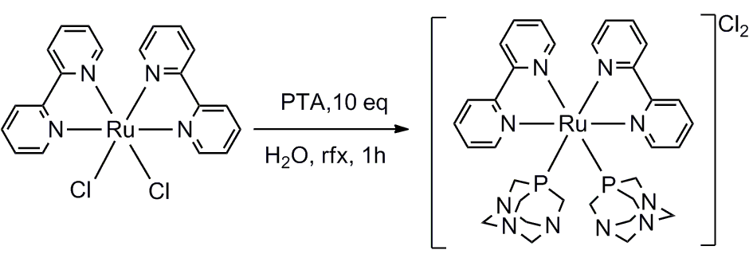
A ruthenium complex containing bpy and PTA ligands could combine large water solubility, new electronic and luminescent properties and pH-tunability. In this paper we present new water soluble ruthenium complexes containing the bpy and PTA ligands and we examine how protonation on the PTA affects their optical properties in water solution.
Scheme 1 Synthesis of 1Cl₂.
Results and Discussion
Synthetic and spectral aspects of 1 and 2
The air stable complex 1Cl₂ was synthesized by reaction of cis-[Ru(bpy)₂Cl₂]·2H₂O with 10 equivalents of PTA in water at refluxing temperature (Scheme 1). The elemental analysis, IR and NMR spectra support the proposed structure for 1, in which a ruthenium atom is coordinated to two bpy cis to each other and two PTA bonded by the P atom. The ¹H NMR spectrum of 1Cl₂ in D₂O displays characteristic signals for one PTA (from 3.77 ppm to 4.35 ppm) and one bpy ligand (from 7.29 ppm to 8.73 ppm). The ¹³C{¹H} NMR also confirmed the coordination of the bpy and PTA ligands to the metal. The ³¹P{¹H} NMR displays a singlet at -38.83 ppm that is in agreement with two PTA cis to each other^{9,} although this could not be verified directly through X-ray crystallography because of the difficulty to obtain good crystalline samples. The complex containing PF₆⁻ counter anions 1(PF₆)₂ was obtained by reaction of 1Cl₂ with NaPF₆ in water. Its NMR spectrum is indistinguishable from the starting complex 1Cl₂, confirming that the cationic complex 1 remains unaltered. The crystal structure obtained for 1(PF₆)₂ confirms the cis-disposition of the ligands (Fig. 7). The trans-isomer complex 2(CF₃SO₃)₂ was synthesized (Scheme 2) by reaction of trans-[Ru(bpy)₂(H₂O)₂](CF₃SO₃)₂ with 10 eq. of PTA in water.
The slow evaporation of the resulting solution provided crystals of sufficient quality for determining its crystal structure by single crystal X-ray diffraction. The crystal structure of 2 showed the trans-disposition of the PTA around the metal, which completes its coordination octahedral-geometry with two bpy molecules (Fig. 7). The observed ¹H, ³¹P{¹H} and ¹³C{¹H} NMR of 2 display the signals for PTA and bpy at chemical shift ranges different from those of 1. The most evident difference between the ¹H and ¹³C{¹H} NMR spectra of both complexes is the notable simplification of the signals. For 2, the NMR spectra shows half of the bipyridyl signals in 1. The singlet observed in the ³¹P{¹H} NMR spectrum of 2 (-42.39 ppm) is shifted to higher fields than in 1 (-38.83 ppm) and agrees with the known trans-PTA complexes. ^{[9]} This complex is also air stable in the solid state and in water solution under air for days.

DFT and TDDFT calculations.
The crystal structure of the complexes 1 and 2 were used as starting point for calculating the electronic distribution in both complexes in water. In both complexes the disposition of the ligands around the metal was not altered with the optimization (Fig. S1 and S24 in Supporting Information). Nevertheless, for both calculated complexes their bond lengths are longer than those found in their crystal structures, being the largest deviations for the Ru-P bonds (1: 9%; 2: 8%) and Ru-N (1, 2: 4%) (Table S2 and S8 in Supporting Information). The optimized bpy rings are less distorted than in the crystal structures and the ligands PTA are rotated around the Ru-P axis (1: 51° for PTA-1, 9° for PTA-2; 2: 15° for PTA-1, 19° for PTA-2).
The analysis of the frontier orbitals revealed that in both complexes the HOMO is constituted mainly by the PTA non-bonding N(p) orbitals and in minor proportion by Ru(d) with the distribution: PTA:Ru = 71:24 for 1 and PTA:Ru 70:30 for 2. Also, for both complexes the compositions of the orbitals from HOMO to HOMO-3 are similar and the LUMO is strongly localized on the bpy ligands (Fig. 1). The most energetically stable HOMO orbital in 1 with the largest metallic character is the HOMO-5 (Ru(d): 73%) while in 2 is the HOMO-4 (Ru(d): 91%). The calculated LUMO/HOMO gap is 3.44 eV for 1 and 3.30 eV for 2 (Fig. 1. See Supporting Information for the Composition Table S6 and S12).

Electronic Absorption Spectrum of 1 and 2 in water and versus pH.
The UV-vis spectra of both complexes in water are shown in Fig. 2. The nature of the electronic transitions of 1 and 2 has been investigated using TD-DFT and results are listed in Table S5 and S11 of the Supporting Information.
The lowest energy vertical excitations for 1 and 2 are constituted by a metal to ligand/ligand to ligand charge transfers (MLCT/LLCT) respectively from HOMO/LUMO+1 and HOMO-1/LUMO. The LLCT and MLCT/LLCT in ligands in which there is not electronic delocalization are quite unusual for octahedral complexes and they are mostly found in tetrahedral or square planar complex of Be, Zn, Re and Pt in inert oxidation states. ^{[17]} During the last years, the use of metal complexes featuring LLCT and MLCT/LLCT in the design of suitable molecules for dye solar cells has attracted attention because in LLCTs the inertia of the metal orbitals during the electron transfer is overcame by an improvement in the electron injection. ^{[18]}
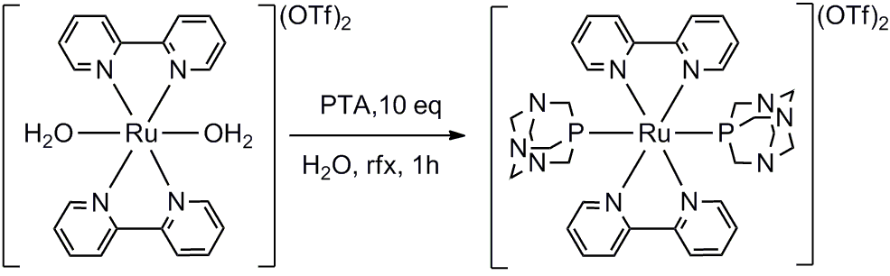
It is important to point out that for both complexes the ground state orbitals involved in the transitions are mainly constituted by the electron donor PTA ligands. Lone pairs on the N_{PTA} in both complexes contribute to the HOMO to HOMO-3 orbitals from 22% to 99%. The calculated vertical excitations are in reasonably good agreement with experimental data and the oscillator strengths of MLCT/LLCT and MLCT bands are in agreement with their respective absorbance bands (Fig. S3 and S26 Supplementary Information). An important hyperchromism is found between the calculated and experimental electronic spectra for the bands below 270 nm, where the LMCT transitions involve HOMO orbitals centred mostly on the bpy and PTA ligands. This hyperchromism found in the calculated data could derive from an underestimation of the hydrogen bonding that is not reproduced by the solvent model.^{[19]} A recent report about the effect of water on the electronic spectrum of complex [RuCp(PTA)₂-μ-CN-1κC:2κ²N-RuCp(PTA)₂](CF₃SO₃) showed how explicit water affects it. The results obtained by neutron diffraction indicates that water molecules interact through hydrogen bonding with N_{PTA} and also with the hydrophobic cyclopentadienyl (Cp) rings. The electronic spectrum of the dimeric-ruthenium complex was correctly modelled by including explicitly the non-isotropic interactions among water molecules and the Cp.^{[20]} Therefore a more accurate study of the solvation structure of the ligands in complexes 1 and 2 in water is required to obtain a more precise theoretical estimation of their electronic spectra.
Scheme 2 Synthesis 2(CF₃SO₃)₂
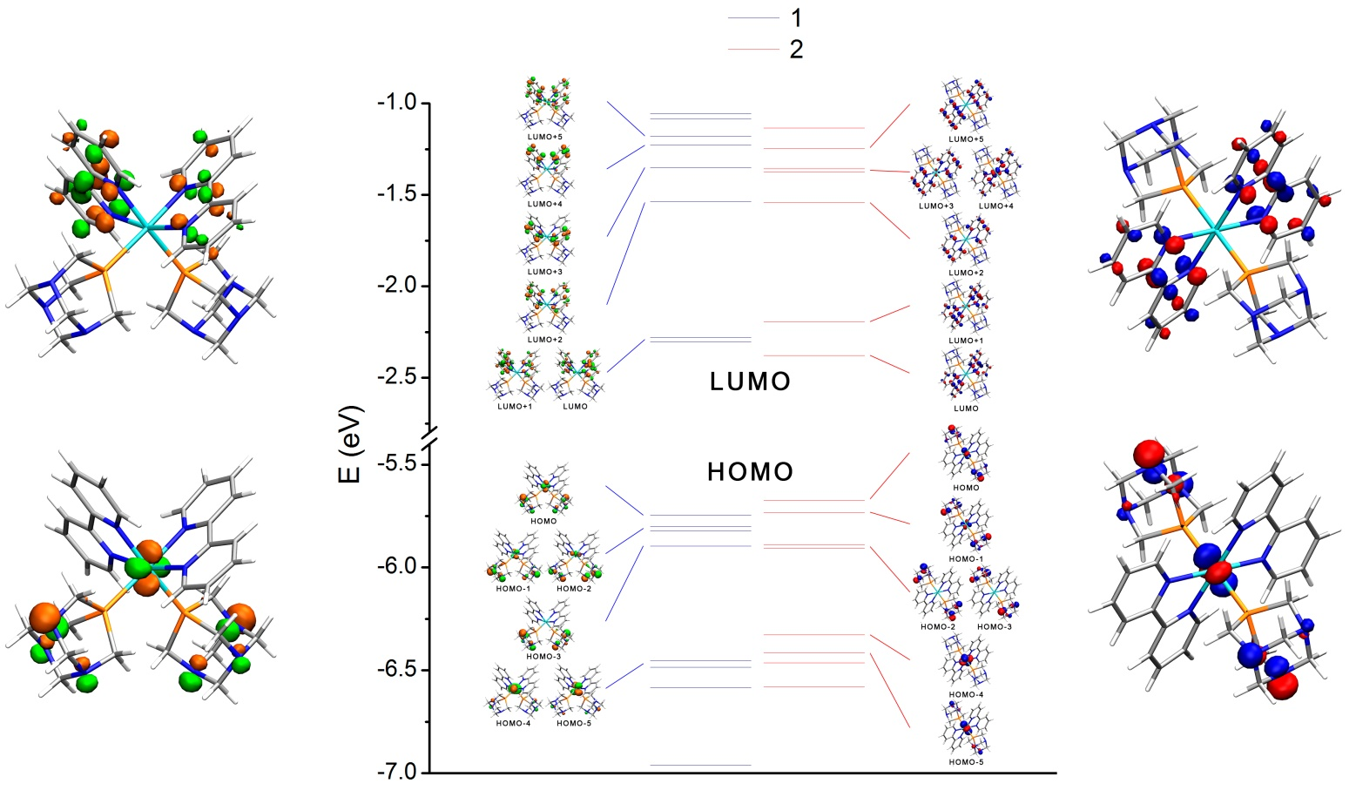
The most intense absorption band is found around 211 nm for both complexes and is related to the LMCT-PTA-Ru and the bpy-π-π* electronic transitions. The observed absorption at 245 nm is due to MLCT/LLCTs, mainly from the HOMO-6 to LUMO+2 for both 1 and 2. Up to 285 nm the bands are mostly composed by MLCT/LLCTs, which in both complexes are observed at the same frequencies. An almost pure MLCT is observed at 316 nm. The contribution of the PTA ligands to the respective HOMO orbitals becomes more important in the lowest frequency bands. The MLCT/LLCT absorption at 385 nm in complex 1 is due mainly to a transition from HOMO-1 (80% of PTA) to LUMO while in 2 is produced by the transition from HOMO (71% of PTA) to LUMO+1, arising at 426 nm. The UV-vis spectra at pH 0, 2, 4, 6, 8, 10 and 12 show the sensitiveness of complex 1 and 2 to the pH (Fig. 2). It has not been possible to determine the individual pK_{b}’s for each N_{PTA} in the complex due to the fact that individual protonations could not be distinguished in titration experiments. The LMCT bands associated with the PTA in both ruthenium complexes arise at similar frequencies as the pH varies. In complex 1 this band moves from 195 nm (pH=2) to 213 nm (pH=12) while in 2 the red shift is from 209 nm (pH=0, 2) to 211 nm (pH=12). Additionally in complex 1 this band exhibits hyperchromism when the pH decreases while in 2 a slight hypochromism is observed (Fig. 2). Electronic delocalisation between the ruthenium and N_{PTA} atoms is not observed, and the observed pH effect on the electronic spectrum of 1 can therefore be explained in terms of a geometrical distortion produced by the repulsion between positive charges created when the N_{PTA} atoms are protonated, which is expected to be stronger in the cis-isomer 1. The MLCT/LLCT bands of both complexes, which were described previously, have the same pH dependency: hypochromism from pH 2 to 6 and hyperchromism from 6 to 12. These bands are found at 366 nm at pH=0, 2 and at 382 nm at pH≥4 in 1 while in 2 it is found at 403 nm at pH=0, 2 and at 425 nm at pH≥4.
Figure. 1 Centre: molecular orbital diagrams and selected orbitals representations of 1 and 2. Sides: HOMO and LUMO orbitals of 1 (left)and 2 (right) (isovalue=0.065).
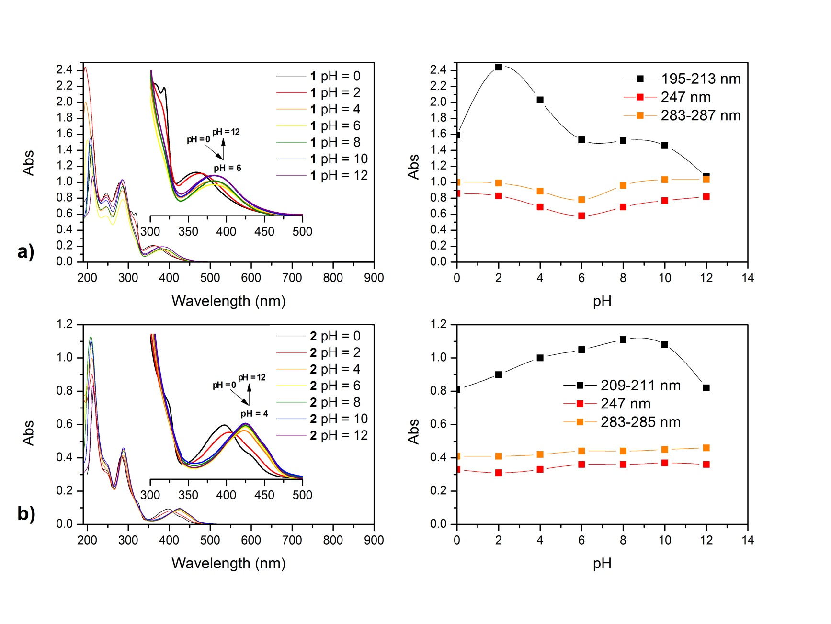
It is important to stress that the sensitiveness of the UV-vis absorption to the pH of the cis-isomer is larger than for the trans-isomer, which indicates that the observed pH dependence is the result of the repulsion between positive charges on the PTA ligands at acid pH, while the hypochromism at basic pH is likely to be a consequence of the stabilization of the ground state by OH⁻ anions in the solvent.^{[21]}
Figure 2 UV-vis spectra of 1 (a) and 2 (b) in water (10⁻⁵ M) and absorption of the bands at 211 nm, 247 nm and 285 nm versus the pH.

Luminescence of 1 and 2 versus pH.
In a concentrated water solution at room temperature and under inert atmosphere of N₂ both complexes are fluorescent (Fig. 3) but interestingly they display also fluorescence in air. The intensity of the fluorescence under inert conditions is larger than in air, as expected. The well-known active MLCT absorption band in bpy metal complexes is at low frequency. For this reason, the electronic transition of 1 and 2 that is excited is at 308 nm, which gives rise to a low-intensity unstructured emission band. It has not been possible to obtain quantum yields for the luminescence processes, as at the standard-quality quantum yield determination (A_{λex} < 0.1) is insufficient for a satisfactory correction of the scattering associated with the measurements. The excitation and emission spectra of both metal complexes in water at pH 0, 2, 4, 6, 8, 10 and 12 is shown in Fig. 3. The excitation and emission bands have similar frequencies for both complexes (1: λ_{Ex}= 308±5 nm, λ_{Em}= 451±1 nm; 2: λ_{Ex}= 308±5 nm, λ_{Em}= 474±1 nm). In air, the largest and smallest emission intensities were observed at pH 4 and 2 for 1 and 2 respectively.
The pH sensitiveness of 1 is in this case larger than that for 2 (Fig. 4). It is important to point out that the emission intensity of 1 at pH 10 is close to the largest one observed at pH 4. Luminescence studies carried out with both complexes showed that the signal intensity cannot be explained using the energy gap law. Contacts with the solvent molecules are the best known quenching processes for the luminescence of a compound in solution. The solvent quenching is particularly intense in water, where it largely derives from hydrogen bonding interactions between ligands and water molecules.^{[2c]} Luminescence in solution depends significantly on the structure of the first and second solvation shell, on the geometry of the complexes and on how the ligands are arranged around the metal ion. Therefore, sequential protonations of PTA is likely to lead to the modification of the complex solvation shell, which affects the luminescence of both complexes, as observed.
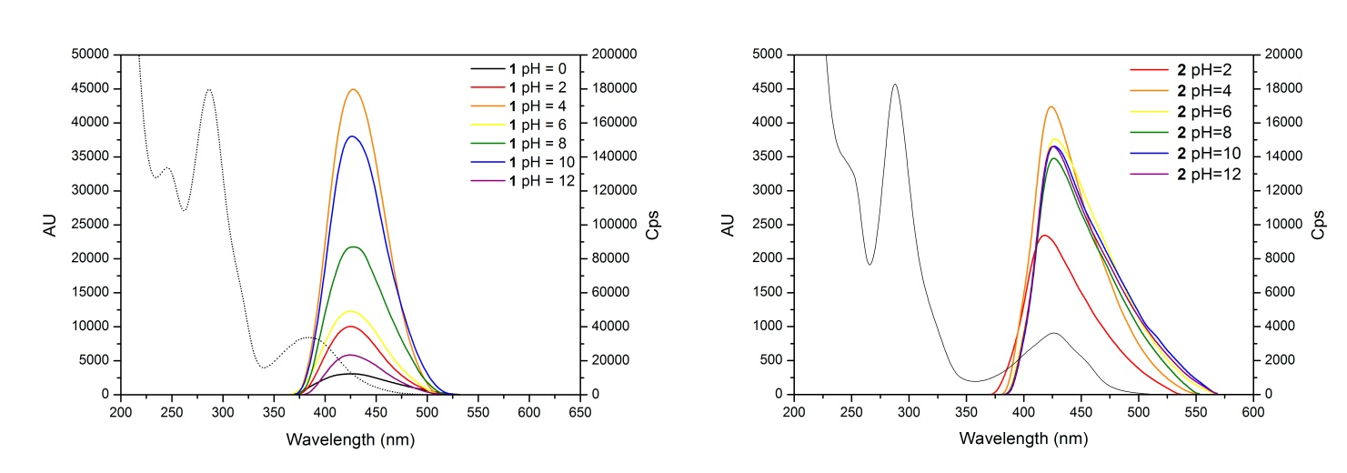
Nevertheless a more accurate study of the distribution of the water molecules around the complexes is required in order to understand the details of the quenching process, and therefore the luminescence dependency on the pH for both complexes.
Figure. 3 Emission (solid line) of 1 (left) and 2 (right) versus pH. and absorption spectra (pH = 7, dotted line)

Photohydrolysis of 1 and 2 in water
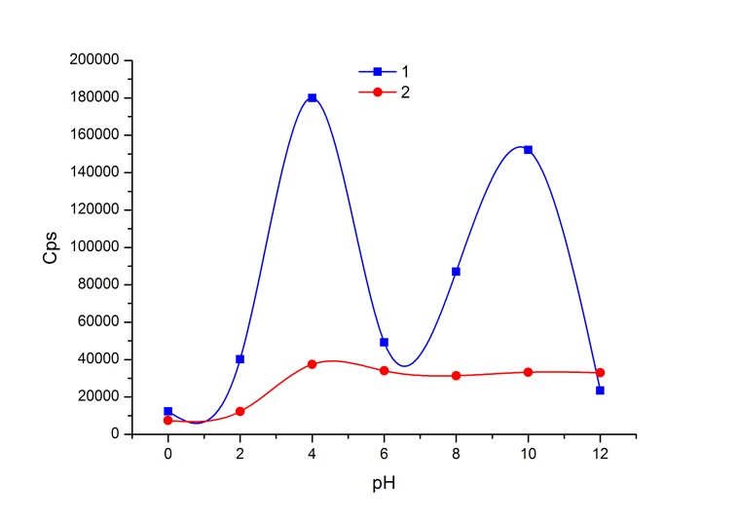
As described previously, the MLCT/LLCT bands of both complexes exhibit similar pH dependency, but the corresponding absorption bands are found to be notably different at pH=0, 2 (1: 366 nm; 2: 403 nm) and at pH≥4 (1: 382 nm; 2: 425 nm). To understand the reasons of this behaviour, solutions of both complexes at pH = 7, 2 and 0 under visible light and in the dark were studied.
Figure 4 Emission intensity of 1 and 2 as a function of the pH.
We initially studied the behaviour of 1Cl₂ and 2(CF₃SO₃)₂ by irradiating with a halogen lamp their water (pH = 7) and acid aqueous solutions (pH = 2, 0). In clean water no reaction was observed, but at pH = 2 and 0 a clear transformation of the starting complexes into a similar compound was produced. The reaction at pH = 0 was found to be faster than that at pH = 2. For this reason we decided to investigate the photochemical properties of complex 1 and 2 more thoroughly at pH = 0, which was obtained by using a 1 M aqueous solution of CF₃SO₃H. This preliminary observation was confirmed by irradiation of (5∙10⁻⁴ M) solutions of 1Cl₂ and 2(CF₃SO₃)₂ at pH = 0 with λ ≥ 320 (Scheme 4). Complexes 1 and 2 reacted completely after 18 and 36 h respectively, to give the new compound, which was characterized by elemental analysis and NMR and IR spectroscopy. The most interesting information is that signals for one PTA and two bpy are now observed, which confirms that the photochemical process only involves one equivalent of PTA. These results suggest that, during the reaction, a PTA is substituted with one water molecule. Nevertheless its chemical shift (-18.69 ppm) in the ³¹P{¹H} NMR in 1 M CF₃SO₃H (D₂O) is still close to the one of PTA trans to the OH₂ ligand in the complex [Ru(H₂O)₂(PTA)₄]²⁺.^{[22]} This fact indicates that in the new complex the water molecule is likely to be in a trans arrangement relative to the remaining PTA, but the different compositions and, especially, the protonation of the PTA suggest that the real disposition of the PTA can be cis to the water molecule. Normally, the protonation of the PTA shifts the PTA signal to a low field by more than 10 ppm.^{[15d]} The crystals obtained were of insufficient quality for single crystal X-ray diffraction experiments and the disorder in the counter CF₃SO₃⁻ anion positions precluded a satisfactory resolution of the structure. For this reason we prepared the equivalent non-protonated complex by reaction of [Ru(bpy)₂(CO₃)] with two CF₃SO₃H and one PTA in water. The resulting complex was found to crystallize easily, but again the quality of the crystals was insufficient for full crystal-structure refinement. However X-ray data was in this case sufficient to verify that the complex structure is cis-[Ru(bpy)₂(PTA)(H₂O)](CF₃SO₃)₂ (3(CF₃SO₃)₂). In this complex, the ruthenium is octahedrally coordinated to two bpy molecules and one PTA ligand cis to one H₂O molecule (Figure 5). This complex shows a singlet at -31.73 ppm in its ³¹P{¹H} NMR, which replaces the triplet signal observed in the PTA cis to the water molecule (-51.8 ppm) in complex [Ru(H₂O)₂(PTA)₄]²⁺.^{[22]} Finally, dissolution of complex 3(CF₃SO₃)₂ in 0.5 mL of D₂O solution of CF₃SO₃H (1 M) led to the same ¹H and ³¹P{¹H] NMR spectra as for the compound obtained by irradiation of 1 and 2 in aqueous CF₃SO₃H (1 M). Previously published PTA containing ruthenium complexes dissolved in water solutions at pH 0-1 were only monoprotonated on the PTA.^{[23]} This experimental fact was supported theoretically by Dyson et al. ^{[24]} who showed that the poly-protonation of free PTA and coordinated PTA in ruthenium complexes containing phosphines and arenes is not thermodynamically favourable. It is reasonable to suppose that the dissolution of PTA-bpy-ruthenium complexes in water at pH 0-1 should lead only to the monoprotonation of the PTA. Nevertheless, the elemental analysis of the product obtained by dissolution of 3(CF₃SO₃)₂ in CF₃SO₃H 1M suggested that the PTA is three protonated. To match this experimental result with those published the most reasonable assumption is to consider that molecules of CF₃SO₃H co-crystalize with the monoprotonated complex, instead of the three protonation of the PTA. Therefore, the product obtained by dissolution of 3(CF₃SO₃)₂ in CF₃SO₃H 1M is most probably the monoprotanted complex cis-[Ru(bpy)₂(PTAH)(H₂O)](CF₃SO₃)₃·2CF₃SO₃H (4(CF₃SO₃)₃·2CF₃SO₃H). Co-crystallization molecules of CF₃SO₃H are not strange there have being found in crystal packing of complexes such as [(cyclen)₄Ru₄(4,4’-bpy)₄](CF₃SO₃)₈·2CF₃SO₃H·5MeOH.^{[25]}
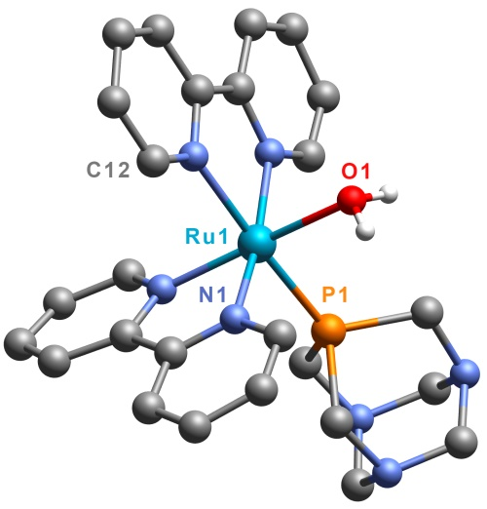
A dissociative mechanism is the most common process in low spin d⁶ octahedral complexes. Therefore, the observed photo-substitution of ligands by water molecules in the complexes 1 and 2 is likely to proceed via a dissociative mechanism. No transformation of 1 and 2 is observed in acid solution in the dark at room temperature, but PTA ligands are protonated, remaining the solution unchanged in the dark for days. However, by irradiation with near-UV light in water, the selective transformation of 1 and 2 into 4 occurs. The charge on protonated PTA is localised far from the P atom. It is therefore unlikely that the elimination of PTAH in complexes 1 and 2 results from electronic (orbital) effects alone. This process is instead likely to be favoured by electrostatic repulsion between the positive charges on different PTAH ligands, which favours their release. The slower reaction rate found for 2 where the two PTAH are trans to each other is consistent with this hypothesis. The five-coordinate intermediate resulting from the cis-complex 1 retains its configuration, but the intermediate from 2 isomerizes to a cis-bpy configuration. Finally, an H₂O molecule occupies the vacant coordination position, to produce complex 4 (Scheme 4).
Scheme 3 Photohydrolysis of 1 and 2 to give 4 and synthesis without irradiaton of 3 and 4.
Figure. 5 Crystal structure of cationic complex 3(CF₃SO₃)_{2,} including the atomic labelling scheme. The anion and hydrogen atoms are not included for clarity.
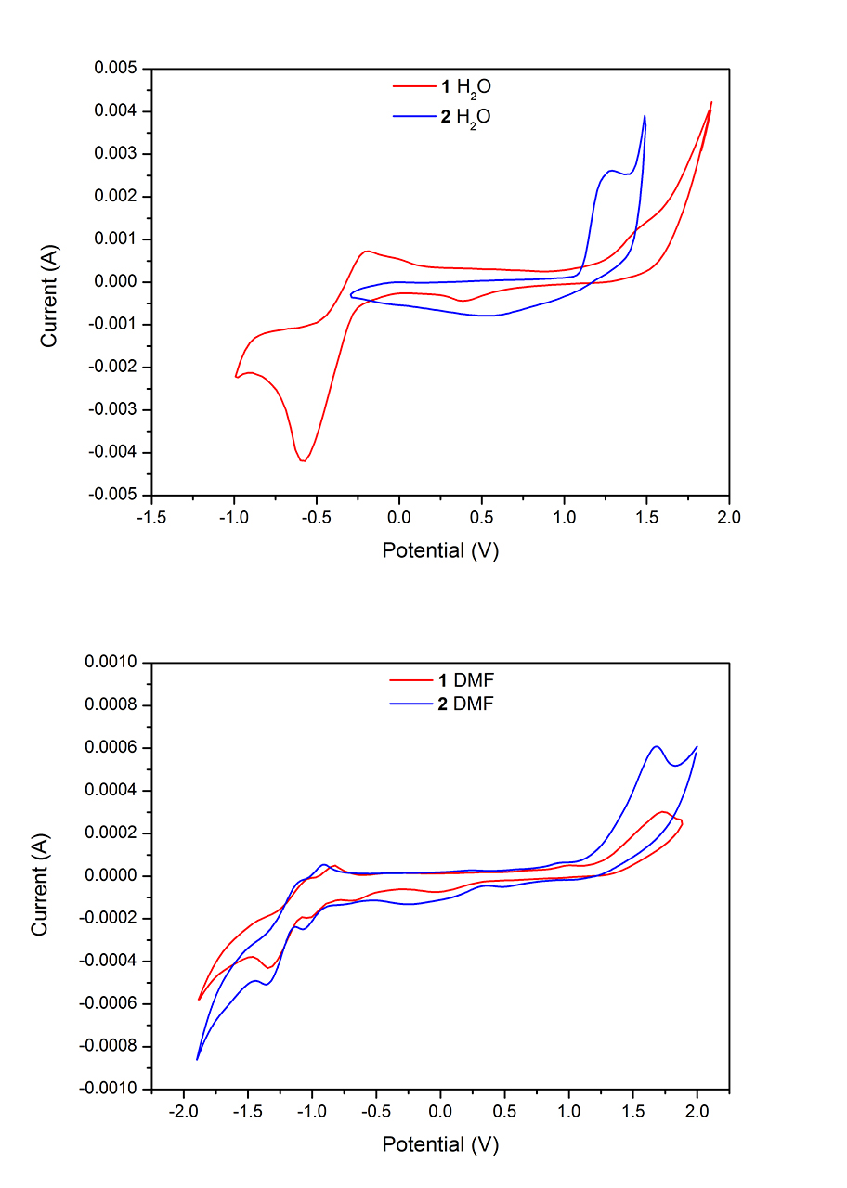
In order to have more evidence to support this basic mechanism for the transformation of 1 and 2 into 4, experiments aimed at determining the active photochemical band and the quantum yield and rate of the reactions were carried out. The results support the proposed mechanism: a) the active band is different for 1 (λ = 360±3 nm) and 2 (λ = 401±3 nm), b) the quantum yields for the photo-transformation of 1 (Ф₃₆₀ _{nm} = 0.0031±0.0003) is double than that for 2 (Ф_{401 nm} = 0.0015±0.0001), c) the rate of the photoreaction from 1 (k(360 nm) = 1.55·10⁻¹⁰ s⁻¹) is notably faster than from 2 (k(401 nm) = 7.50·10⁻¹¹ s⁻¹), d) the H₂O ligand is finally occupying the free coordination position after releasing the PTAH ligand independently of using complex 1 and 2, even when the active band is selectively excited, e) the resulting unsaturated five-coordinated intermediate isomerizes from trans to cis-configuration (which is thermally more stable for steric reasons), and, additionally, the H₂O has a smaller trans influence than PTA. For both complexes the photo-active band involves the p orbitals of the N_{PTA} (lone pairs) and the bpy ligands.
Figure. 6 Cyclic voltammograms (Ag/AgCl; 0.1 V/s) of 1 and 2 in water and DMF.
In previous work, we have proposed a dissociative mechanism for the photo-isomerization and Cl⁻ release in [trans-[RuCl₂(PTA)₄] in water.^{[9b]} A similar process has been observed for the complex [Ru(NH₃)₄(H₂O)(HPTA)]³⁺, which contains a mono-protonated-PTA. This complex is transformed into [Ru(NH₃)₃(H₂O)₂(HPTA)]³⁺ by a water photo-substitution at λ = 330 nm and 370 nm.^{[9c]} The only example of a photo-dissociation of a PTA derivative, its methylate derivative mPTA, has also been reported by our group.^{[9a]} The complex cis-[RuCl₂(mPTA)₄] releases a mPTA by irradiation of λ = 367 nm in water. For these complexes it has also been showed that the most probable process is a photo-dissociation with a further isomerization and the final coordination of the free site by a water molecule. Therefore, the photo-transformation of complexes 1 and 2 into 4 is the first example for a photo-release of a PTA ligand.

Electrochemistry of 1(Cl₂) and 2(CF₃SO₃)₂.
The electrochemical properties of the complexes 1 and 2 were studied by cyclic voltamperometry in water and, for comparison purposes, also in DMF (Fig. 6). The redox data are displayed in Table 1.
The current peaks are somewhat larger than those expected for the Ru(III)/Ru(II) waves, nevertheless the observed events can be assigned to one-electron processes. The observed irreversible anodic oxidation in water corresponding to the Ru(II)/Ru(III) redox process occurs at 1.47 V (E_{ox}) with reduction at 0.39 V (E_{Red}) (ΔE_{p} = 1.08 V) for 1 whereas for 2 the process is quasi-reversible (E = 0.89 V; ΔE_{p} = 0.79 V).
Scheme 4 Proposed process for the transformation of 1(Cl₂) and 2(CF₃SO₃)₂ into 4.
In DMF the redox Ru(II)/Ru(III) waves for both complexes are irreversible and arise at lower potential than in water for both complexes (1: E_{ox} = 1.00 V, ΔE_{p} = 1.70 V; 2: E_{ox} = 0.98 V, ΔE_{p} = 1.22 V). These results are in agreement with the larger stability of 1. It is important to notice that, at high potential, both complexes show an irreversible wave (1: E_{ox} = 1.72 V, ΔE_{p} = 1.78 V; 2: E_{ox} = 1.68 V, ΔE_{p} = 1.20 V) that could only be assigned to a Ru(III)/Ru(IV) process. The hybrid molecular HOMO orbitals for both complexes that include the ligand mixing with metal is responsible for the lack of reversibility that is not observed in systems where oxidation occurs purely from the metal centre, such as in [Ru(bpy)₃]²⁺. As expected, the redox wave of the bpy ligands is found at lower potential that those of Ru atom. In water it was only possible to observe a bpy redox wave for complex 1. In contrast in DMF both complexes display two redox waves, one for each of the two bpy ligands. Those at lower potential are reversible for both complexes and occur in 1 at ca. +0.1 V relative to 2. The second bpy wave is quasi-reversible in both complexes and the potential for 1 is more positive than that for 2. Finally, the cyclic voltamperograms of complexes 1 and 2 in water at different pH were found to be very sensitive to the buffer used and, in most cases, not to show the bpy redox-waves or the metal redox-waves. The obtained potentials are in the range found in parent complexes with diphosphines^{[26]} but a conclusive correlation with the luminescence of these complexes could not be demonstrated.
Table 1. Redox peaks^{[a]} of 1 and 2 in DMF and water.
1(Cl)₂ |  | 2(CF₃SO₃)₂
DMF
red 1 | -1.35 | red 1 | -1.34
red 2 | -1.04 | red 2 | -1.07
red 3 | -0.70 | red 3 | -0.24
red 4 | -0.06 | red 4 | 0.48
ox 1 | -1.01 | ox 1 | -1.1
ox 2 | -0.82 | ox 2 | -0.9
ox 3 | 1.00 | ox 3 | 0.98
ox 4 | 1.72 | ox 4 | 1.68
H₂O
red 1 | -0.57 | red 1 | 0.5
red 2 | 0.39 | ox 2 | 1.29
ox 1 | -0.18
ox 2 | 1.47
[a] Potentials in volts.

Crystal structure of 1(PF₆)₂ and 2(CF₃SO₃)
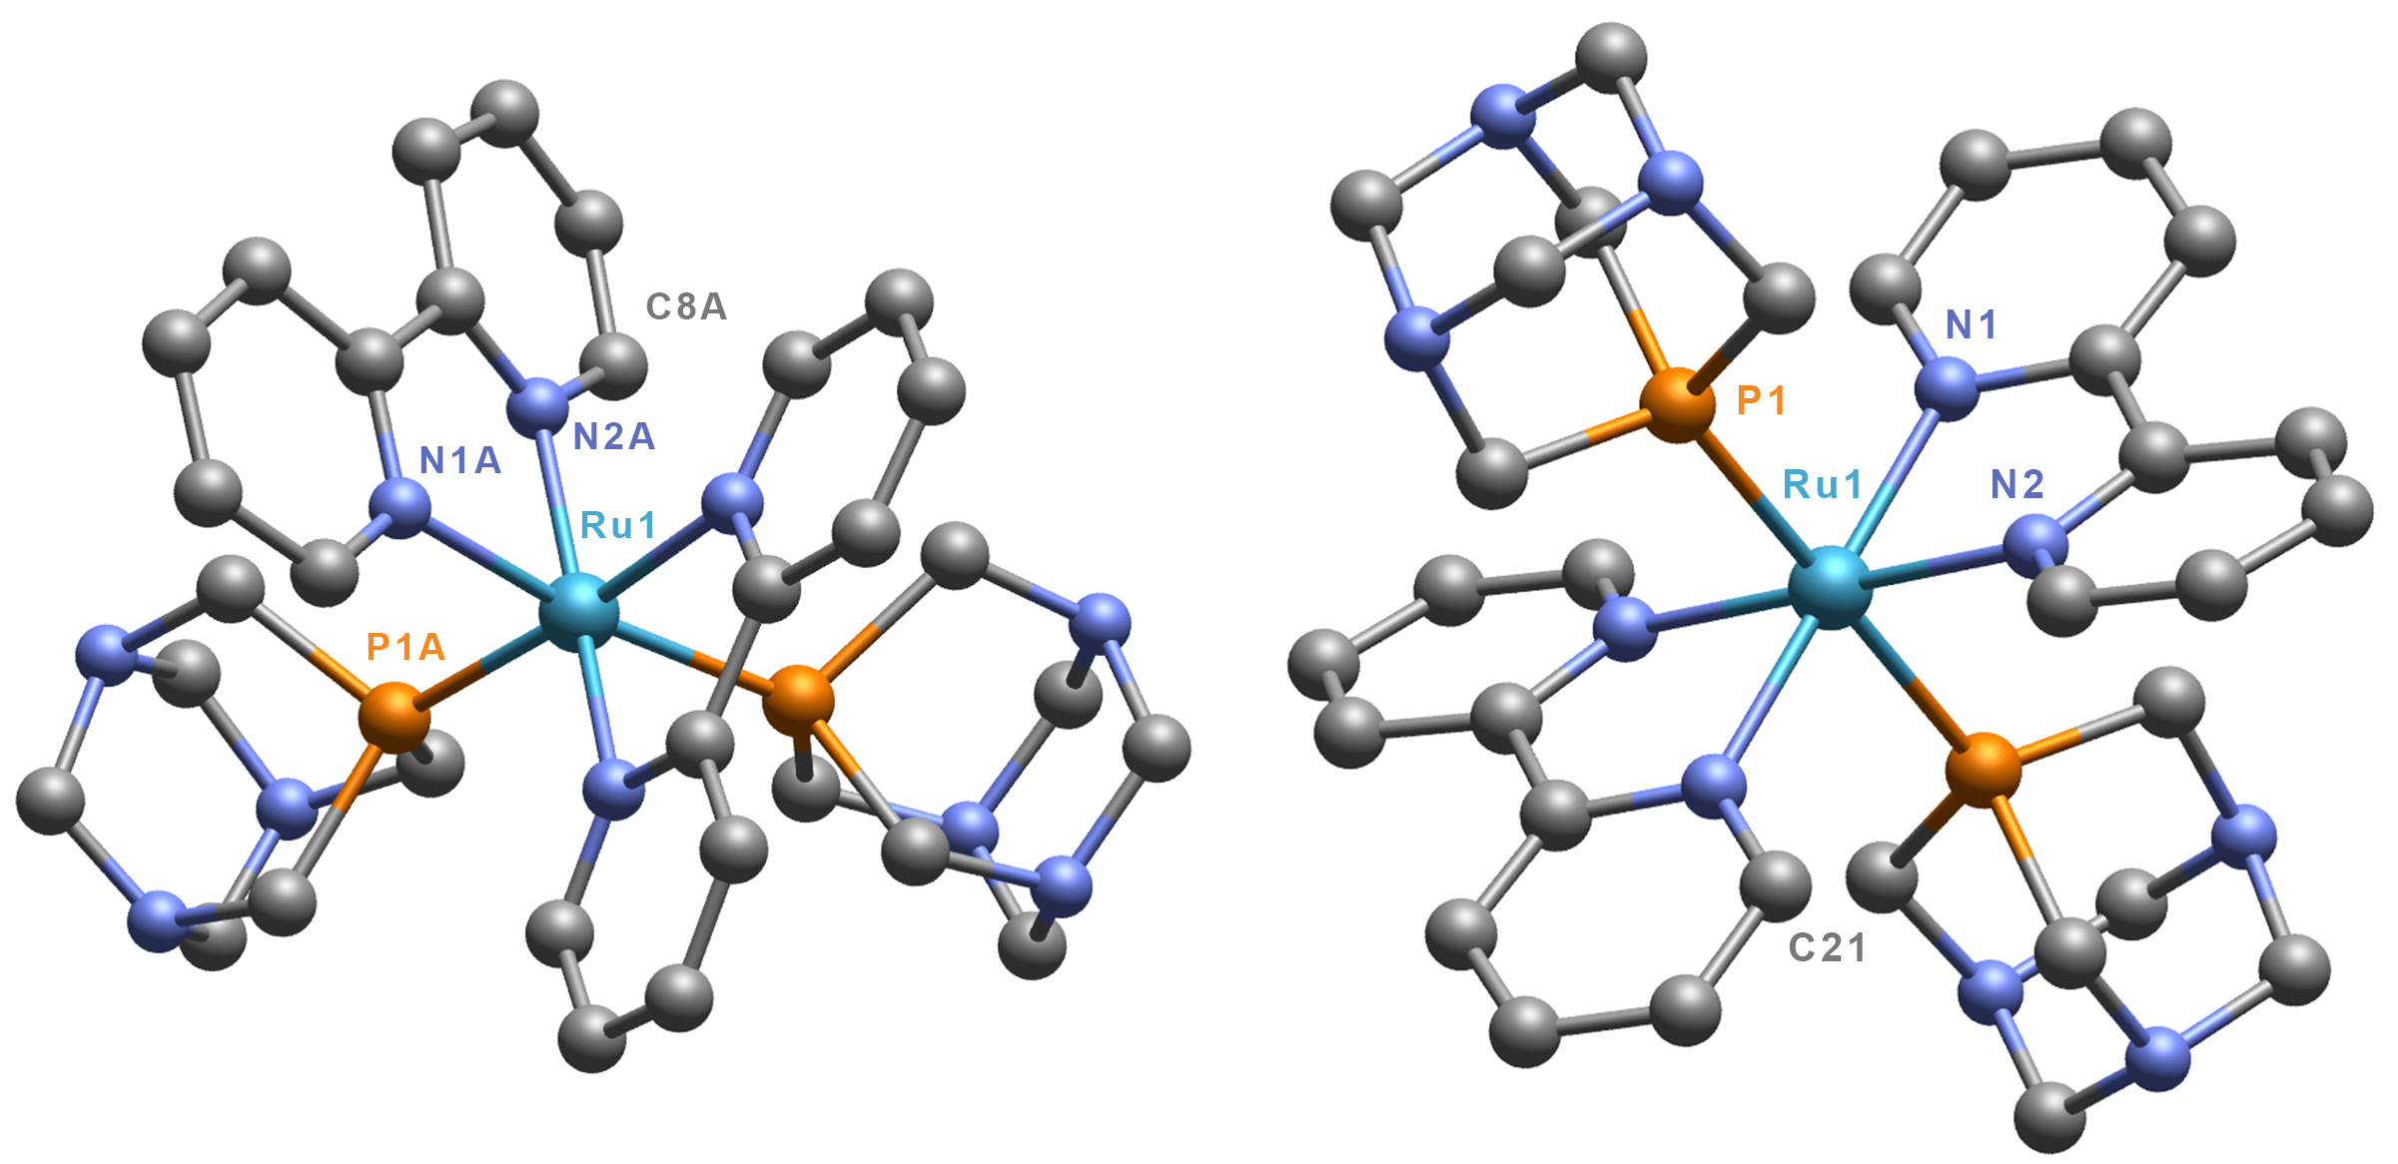
Light-orange crystals suitable for single crystal X-ray diffraction data collection were obtained by cooling slowly a saturated solution of 1(PF₆)₂ from 90ºC to 25ºC in 18 h. The asymmetric unit cell is constituted by three cation molecules of cis-[Ru(bpy)₂(PTA)₂]²⁺ and six PF₆⁻ anion. The octahedrally-distorted ruthenium is coordinated by two bpy and two PTA moieties through their P atom (Fig. 7). Selected interatomic distances and angles are given in Table 2. It is important to stress that 1(PF₆)₂ is the first example of a metal complex bearing two bpy and two monodentate phosphines in cis-disposition characterized by single crystal X-ray diffraction.^{[27]} The bond lengths between metal and ligands are similar, but different, in each of the complex molecules constituting the asymmetric unit cell. The cis-disposition of the bpy ligands leaves one N_{bpy} atom trans to a P_{PTA}, but the other N_{bpy} is trans to an N atom of the other coordinated bpy molecule. Ruthenium-nitrogen bond lengths are in the range 2.090(7) Å - 2.117(7) Å and 2.100(2) Å - 2.139(9) Å for N_{bpy} trans to N_{bpy} and N_{bpy} trans to P_{PTA} while Ru-P_{PTA} distances between 2.308(3) Å - 2.332(3) Å, which is a shorter range than that observed for the for the complex cis-[RuCl₂(PTA)₄] (2.252(2) Å – 2.388(2) Å)^{[28d]} but similar to those found in similar complexes in literature.^{[28]} The angles between PTA ligands are in the range 98.30(1)º (P1B-Ru2-P2B) - 98.59(1)º (P1A-Ru1-P2A), indicating that the coordination geometry of the metal is notably distorted for all the molecules in the asymmetric unit cell. As expected, both bpy ligands display a large deviation from a planar coordination geometry, caused by the repulsion between the H atoms located in the 3 and 3’ position.^{[29]} Finally, distances among molecules are larger than 3 Å, indicating that there are no hydrogen bonds or significant interactions between the ligands.
Figure 7 Cationic complex unit single crystal X-ray structure of 1 (left) and 2 (right) including the atomic labelling scheme. Anions and hydrogen atoms are not included for clarity.
Single crystals of 2 were crystallized by slow evaporation from its saturated solution in water. The crystal asymmetric unit cell contains two cation complexes trans-[Ru(bpy)₂(PTA)₂]²⁺ and two CF₃SO₃⁻ anions. The octahedrally-distorted ruthenium atom is bonded to the P atom of two PTA molecules trans to each other and to two bpy molecules, which are located in the remaining equatorial coordination position (Fig. 7). Selected interatomic distances and angles are given in Table 2. The Ru-N bond lengths are in the range of 2.105(5) Å - 2.110(5) Å, which is similar to that found in 1 for Ru-N bond length trans to N_{bpy}. The two P_{PTA} to metal distances in 1 are somewhat different (Ru1-P1 = 2.342(18) Å; Ru2-P2 = 2.353(18) Å) but the same in the two molecules in the asymmetric unit cell, as imposed by the
Table 2. Selected bond distances and angles of 1(PF₆)₂ and 2(CF₃SO₃)₂
1(PF₆)₂ |  | 2(CF₃SO₃)₂
Ru1-P1A | 2.325(4) Å | Ru1-P1 | 2.342(18) Å
Ru1-P2A | 2.308(3) Å | Ru1-N1 | 2.110(5) Å
Ru1-N1A | 2.139(9) Å | Ru1-N2 | 2.105(5) Å
Ru1-N2A | 2.090(7) Å | P1-Ru1-N1 | 91.30(14)º
P1A-Ru1-N1A | 89.3(3)º | P1-Ru1-N2 | 88.90(14)º
P1A-Ru1-N2A | 85.2(3)º | P1-Ru-P1 | 180.00(6)º
P1A-Ru1-N3A | 175.2(3)º
P1A-Ru1-P2A | 98.6(1)º
Ru2-P1B | 2.311(2) Å | Ru2-P2 | 2.353(18) Å
Ru2-P2B | 2.326(5) Å | Ru2-N3 | 2.110(5) Å
Ru2-N1B | 2.117(7) Å | Ru2-N4 | 2.106(5) Å
Ru2-N2B | 2.110(1) Å | P2-Ru2-N3 | 91.18(15)º
P1B-Ru2-N1B | 87.8(3)º | P2-Ru2-N4 | 89.92(14)º
P1B-Ru2-N2B | 86.1(3)º | P2-Ru2-P2 | 180.00(7)º
P1B-Ru2-N4B | 171.6(3)º
P1B-Ru2-P2B | 98.3(1)º
Ru3-P1C | 2.317(4) Å
Ru3-P2C | 2.332(4) Å
Ru3-N1C | 2.100(2) Å
Ru3-N2C | 2.110(6) Å
P1C-Ru3-N1C | 87.8(3)º
P1C-Ru3-N2C | 85.6(3)º
P1C-Ru3-N4C | 172.4(3)º
P1C-Ru3-P2C | 98.3(1)º
symmetry group. The similarity of the Ru-P_{PTA} distances contrasts with the observed differences in complex trans-[RuCl₂(PTA)₄] (2.317(2) Å – 2.353(2) Å), indicating the lower steric impediment in 2. Both ruthenium-nitrogen and ruthenium-phosphorus bond lengths agree with previously reported bisbipyridine-bisphosphine ruthenium complexes as well as the distortion of the bpy rings.^{[30]} The angles between the metal and the ligands indicate that the distortion of the octahedral-coordination environment is smaller than in the cis-isomer 1, and the largest and smallest angles are P1-Ru1-N1 (91.30(14)º) and P1-Ru1-N2 (88.90(14)º). Finally, the distances between molecules in the crystals are larger than 3 Å, again indicating that there are no significant interactions between the ligands.

Conclusions
The electronic properties and photo-reactivity in water of the ruthenium complexes cis-[Ru(bpy)₂(PTA)₂]Cl₂ (1Cl₂) and trans-[Ru(bpy)₂(PTA)₂](CF₃SO₃)₂ (2(CF₃SO₃)₂) are significantly affected by their protonation. The crystal structures of both complexes show that the only significant structural difference between them is the cis or trans configuration of the ligands around the metal, whereas the distances and angles are similar in the two compounds. Complexes 1 and 2 are examples of metal complexes whose optical properties change significantly with pH variations and in which the protonation sites are not electronically connected to the metal centre. Both complexes show an UV/Visible absorbance sensitive to the pH. The Ligand-to-Metal Charge Transfer (LMCT) and Metal-to-Ligand/Ligand-to-Ligand Charge Transfer (MLCT/LLCT) bands in both complexes show different pH dependences. This has never been observed before in ruthenium complexes containing bpy ligands. Both complexes display a slight but consistent luminescence in water under air. The large solubility of both complexes in water facilities the study of their luminescence, which was found to be sensitive to the pH and which affects both the frequency and the intensity of the bands. This observed behaviour cannot be explained on the basis of the energy gap law alone. Complexes 1 and 2 photo-dissociate one PTA ligand in acid water to give the complex cis-[Ru(bpy)₂(PTAH₃)(H₂O)](CF₃SO₃)₅ (4(CF₃SO₃)₅). The first time observed process is selectively induced in both complexes by irradiation of a MLCT/LLCT band involving the p orbitals of the N_{PTA} (lone pairs) and the bpy ligands. Cyclic voltammetry shows that, in water, an irreversible anodic oxidation corresponding to the Ru(II)/Ru(III) redox process occurs for 1 whereas for 2 the process is quasi-reversible, in agreement with the energy of their calculated molecular orbitals. In DMF the redox Ru(II)/Ru(III) waves for both complexes are irreversible and arise at lower potential than in water.
Experimental Section
General Procedures.
All chemicals were reagent grade and, unless otherwise stated, were used as received from commercial suppliers. Likewise, all reactions were carried out in a pure argon atmosphere by using standard Schlenk-tube techniques with freshly distilled and oxygen-free solvents. The ligand PTA and complexes cis-[Ru(bpy)₂Cl₂]·2H₂O and trans-[Ru(bpy)₂(H₂O)₂](CF₃SO₃)₂ were prepared as described in the literature.^{[31,32] 1}H and ¹³C{¹H} NMR spectra were recorded on a Bruker DRX300 spectrometer operating at 300.13 MHz (¹H) and 75.47 (¹³C), respectively. Peak positions are relative to tetramethylsilane and were calibrated against the residual solvent resonance (¹H) or the deuterated solvent multiplet (¹³C). ³¹P{¹H} NMR was recorded on the same instrument operating at 121.49 MHz and the chemical shift was measured relative to external 85% H₃PO₄ with downfield values taken as positive. All NMR spectra were obtained at 25 ºC. Infrared spectra were recorded on KBr disks using a Bruker Vertex 70 FT-IR spectrometer, and the intensity of the bands is indicated as: s (strong), m (medium) and weak (w). UV-vis spectra were obtained with a Jasco V-650 spectrometer from solutions of 10⁻³-10⁻⁵ M in quartz cuvettes (1 cm optical path). Specific absorption coefficients were obtained by linear regression over 5-7 points (R² ≥ 0.999). The emission and excitation spectra were recorded using a Fluoromax-4 TCSPC Horiba Scientific; quartz cells were used (1 cm optical path). The pH of the solutions was maintained by a phosphate-buffer (0.1 M). Elemental analysis (C, H, N, S) was performed on a Fisons Instrument EA 1108 elemental analyser. Electrochemical experiments were recorded with a VersaSTAT3 apparatus. A standard disposition for the measurement cell was used including three-electrode glass cell consisting of a platinum-disk working electrode, a platinum-wire auxiliary electrode and an Ag/AgCl reference electrode. The supporting electrolyte solution (NaCl, 0.1 M for H₂O; NBu₄PF₆, 0.1 M for DMF) was scanned over the solvent window to verify the absence of electro-active impurities. A similar concentration of the analyte (2.5 10-3 M) was employed in all the measurements for H₂O and DMF as solvent. All measurements were made at 0.1 V/s.
Photochemistry experiments
Irradiation by continuous visible light was initially carried out using a home-made photo-reactor with a built-in standard 150 W halogen lamp (in Almeria),^{[33]} and a 150 and 300 W Xe Arc Lamp provide by LOT Oriel. Irradiation at selected wavelengths was carried out with the 150 W Xe Arc Lamp with a water filter (5 cm) and appropriate band-pass or interference filters (Schott) and with the 300 W Xe Arc Lamp coupled with a McPherson model 272 Monochromator (0.2 meter). A potassium ferrioxalate actinometer was used for quantum yield measurements using the method proposed by Kuhn et al. ^{[34]} Solutions for photolysis and dark reactions were prepared under Ar and transferred to a 1.0 cm path-length quartz cells. During the photolysis, the solution was stirred using a small magnetic bar stirrer inside the cell and thermostated by a water-refrigerated jacket.
Synthesis of cis-[Ru(bpy)₂(PTA)₂]Cl₂ (1Cl₂).
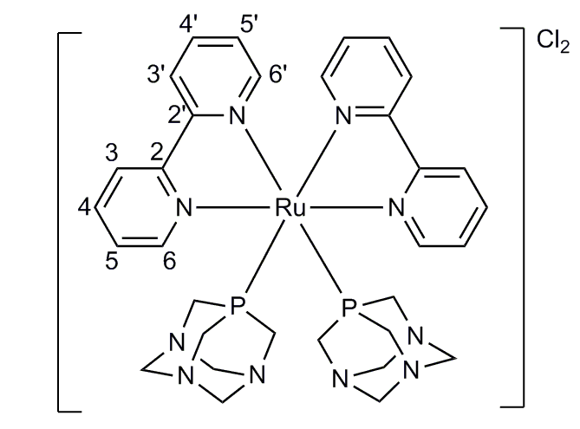
Under a nitrogen atmosphere, PTA (157 mg, 1 mmol) was added into a suspension of cis-[Ru(bpy)₂Cl₂]·2H₂O (108 mg, 0.12 mmol) in 10 mL of degassed water. The mixture was refluxed for 2 hours in the dark at room temperature. The resulting deep yellow-orange solution was filtered and the solved removed to give an orange powder, which was washed with acetone/Et₂O 1:1 (3 x 2 mL) and dried under vacuum. Yield = 134 mg (81%). S_{25ºC} (mg/cm³): 1020. Elemental analysis for C₃₂H₄₀N₁₀P₂Cl₂Ru (798,13): Found C, 47.93; H, 5.15; N, 17.32; calcd. C, 48.12; H, 5.05; N, 17.54. ¹H NMR (300.13 MHz, D₂O, 25ºC): δ 3.77 (m, 12H, PCH₂N_{PTA}); 4.35 (m, 12H, NCH₂N_{PTA}); 7.29 (m, 2H, 5’-bpy + 6-bpy); 7.78 (m, 4H, 5-bpy); 8.03 (m, 2H, 4-bpy); 8.29 (m, 2H, 4'-bpy); 8.40 (m, 2H, 3-bpy); 8.55 (m, 2H, 3'-bpy); 8.73 (m, 2H, 6'-bpy);. ¹³C{¹H} NMR (75.47 MHz, D₂O, 25ºC): 49.65 (t, ²J_{PC} = 15 Hz, ⁴J_{PC} = 4 Hz, NCH₂P_{PTA}); 70.41 (s, NCH₂N_{PTA}); 124.78 (s, 3-bpy); 125.89 (s, 3’-bpy); 128.03 (s, 5'-bpy); 128.78 (s, 5-bpy); 140.05 (s, 4’-bpy); 148.73 (s, 6-bpy); 154.50 (s, 2-bpy + 2’-bpy); δ 156.73 (s, 6'-bpy). ³¹P{¹H} NMR (121.49 MHz, D₂O, 25ºC): δ -38.83 (PTA). FT-IR: cm⁻¹: 421 (w), 452 (m), 469 (m), 579 (s), 732 (m), 749 (m), 771 (m), 811 (m), 891 (w), 950 (s), 974 (s), 1017 (s), 1045 (w), 1106 (m), 1244 (m), 1293 (w), 1366 (vw), 1417 (m), 1444 (m), 1462 (m), 1600 (m), 1641 (m), 2884 (s), 2930 (s), 3076 (s), 3110 (s), 3406 (vs); UV-vis (H₂O): nm [ε (dm³ mol⁻¹ cm⁻¹)]: 191 [74965], 246 [17909], 286 [24356], 385 [4517].
Scheme 5 Numeration of the bpy ligand in 1.

Synthesis of cis-[Ru(bpy)₂(PTA)₂](PF₆)₂ (1(PF₆)₂)
Into a vigorous stirred solution of 1Cl₂ (50 mg, 0.062 mmol) in 5 mL of water a solution of NaPF₆ (21.2 mg, 0.126 mmol) in 5 mL of water was added. After 15 minutes the yellow precipitate was filtered, washed with water (3 x 3 mL), EtOH (3 x 3 mL), Et₂O (2 x 3 mL) and vacuum dried. Crystals of 1(PF₆)₂ were obtained by slow cooling a saturated aqueous solution. Yield: 63 mg (99%). S_{25ºC}(mg/cm³): 0.9. Elemental analysis for C₃₂H₄₀F₁₂N₁₀P₄Ru (1018,12): Found C, 37.63; H, 4.11; N, 13.52; calcd. C, 37.77; H, 3.96; N, 13.76.
Synthesis of trans-[Ru(bpy)₂(PTA)₂](CF₃SO₃)₂ (2(CF₃SO₃)₂)
The trans-[Ru(bpy)₂(H₂O)₂](CF₃SO₃)₂ complex (100 mg, 0.133 mmol) and PTA (210 mg, 1.33 mmol) were dissolved in 10 mL of deoxygenated water and then kept at 80 ºC during 1h. After cooling, the solvent was evaporated and the obtained orange solid washed with acetone (3 x 10 mL) and dried under vacuum. Single crystals suitable for X-ray diffraction were obtained by the slow evaporation of a saturated aqueous solution of the complex. Powder yield: 116 mg (84%). Cristal yield: 39.4 mg (34%). S_{25ºC}(mg/cm³): 110. Elemental analysis for C₃₄H₄₀F₆N₁₀O₆P₂S₂Ru (1026,10): Found C, 39.69; H, 4.19; N, 13.35; S, 5.95; calcd. C, 39.81; H, 3.93; N, 13.65; S, 6.25. ¹H NMR (300.13 MHz, D₂O, 25 ºC): δ 3.16 (s, 24H, PCH₂N_{PTA}); 3.98 (d, ²J_{HH}=13.23 Hz, 12H, NCH₂N_{PTA}); 4.17 (d, ²J_{HH}=13.21 Hz, 6H, NCH₂N_{PTA}); 4.42 (d, ²J_{HH}=13.23 Hz, 6H, NCH₂N_{PTA}); 7.83 (m, 2H, 5-bpy); 8.29 (m, 2H, 4-bpy); 8.58 (m, 2H, 3-bpy); 9.34 (m, 2H, 6-bpy). ¹³C{¹H} NMR (75.47 MHz, D₂O, 25ºC): δ 45.08 (t, ²J_{PC} = 11 Hz, ⁴J_{PC} = 3 Hz, NCH₂P_{PTA}); 70.24 (s, NCH₂N_{PTA}); 124.79 (s, 3-bpy); 127.34 (s, 5-bpy); 139.59 (s, 4-bpy); 153.50 (s, 6-bpy); 157.34 (s, 2-bpy). ³¹P{¹H} NMR (121.49 MHz, D₂O, 25ºC): δ -42.39 (PTA). FT-IR: 461 (vw), 516 (vw), 570 (w), 583 (w), 637 (m), 732 (w), 742 (w), 760 (w), 783 (w), 805 (w), 896 (vw), 944 (m), 973 (m), 1015 (m), 1031 (m), 1100 (w), 1147 (w), 1224 (w), 1241 (m), 1262 (s), 1276 (s), 1417 (vw), 1445 (vw), 1466 (vw), 1600 (vw), 2886 (vw), 2927 (vw). UV-vis (H₂O): nm [ε (dm³ mol⁻¹ cm⁻¹)]: 212 [70533], 245 [24263], 288 [29784], 425 [6450].

Synthesis of cis-[Ru(bpy)₂(PTA)(H₂O)](CF₃SO₃)₂ (3(CF₃SO₃)₂)
HCF₃SO₃ (19 μL, 0.210 mmol) was added to a solution of [Ru(bpy)₂CO₃] (50 mg, 0.105 mmol). After 15 minutes, the ligand PTA (15.7 mg, 0.1 mmol) was added in four portions separated by 15 minutes. After 30 minutes, the solvent was evaporated and the resulting brown solid dissolved in 3 mL ethanol. Et₂O (10 mL) was added to the solution and the resulting precipitate filtered, washed with Et₂O (3 x 5 mL) and vacuum dried. Crystals of sufficient quanlity for single-crystal X-ray experiments were obtained by slow evaporation of a CHCl₃ solution. Yield: 92.3 mg (99%). S_{25ºC}(mg/cm³): 1100. Elemental analysis for C₂₈H₃₀F₆N₇O₇PRuS₂ (887.0): Found C, 37.76; H, 3.55; N, 10.93; calcd C, 37.88; H, 3.40; N, 11.05. ¹H NMR (300.13 MHz, D₂O, 25ºC): δ 3.76 (m, 6H, PCH₂N_{PTA}); 4.37 (m, 6H, NCH₂N_{PTA}); 7.08 (m, 1H, bpy); 7.26 (m, 2H, 5-bpy); 7.69-7.87 (m, 4H, bpy); 7.94 (m, 1H, 4'-bpy); 8.14 (m, 1H, bpy); 8.02-8.32 (m, 2H, bpy); 8.39 (m, 1H, bpy); 8.49 (m, 2H, bpy); 9.02 (m, 1H, bpy); 9.15 (m, 1H, bpy). ¹³C{¹H} NMR (75.47 MHz, D₂O, 25ºC): 47.52 (d, ²J_{PH} = 14 Hz, NCH₂P_{PTA}); 70.58 (d, ³J_{PH} = 6 Hz, NCH₂N_{PTA}); 123.41 -158.62 (m, bpy); ³¹P{¹H} NMR (121.49 MHz, D₂O, 25ºC): δ -31.58 (PTA).
Synthesis of cis-[Ru(bpy)₂(PTAH)(H₂O)](CF₃SO₃)₃·2CF₃SO₃H (4(CF₃SO₃)₃·2CF₃SO₃H)
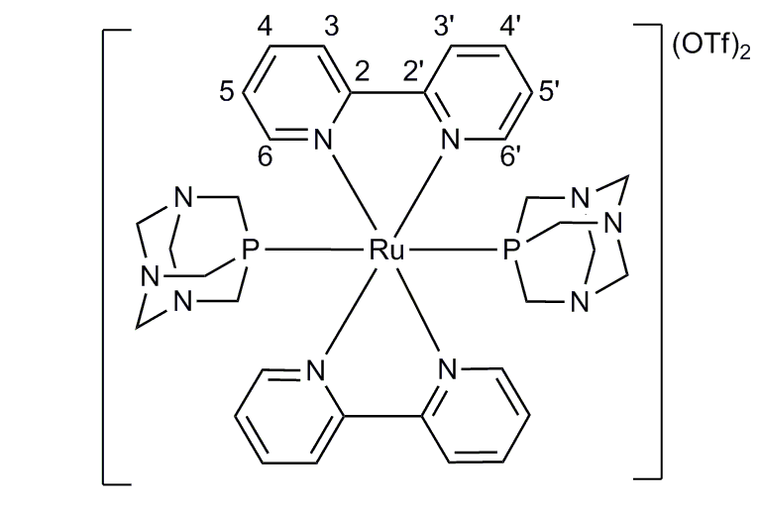
Complex 4(CF₃SO₃)₃·2CF₃SO₃H was synthesised by three different methods: a) Complex 1 (31.9 mg, 0.04 mmol) in 25 mL of a deoxygenated aqueous solution of CF₃SO₃H (1 M) was irradiated with a 300 W Xe Arc Lamp coupled with Monochromator setting the wavelength at λ = 360±3 nm at 20 ºC. After 3 days, the volume reduced to 5 mL under vacuum and then AgCF₃SO₃ (20.5 mg, 0.08 mmol) was added. The precipitated AgCl was filtered through celite. Addition of 50 mL of THF into the resulting clear solution led to a brown precipitate, which was filtered, washed with THF (3 x 10 mL) and Et₂O (3 x 10 mL) and finally dried under vacuum. Yield: 19.9 mg (56%). b) Complex 4 could also be obtained by a similar procedure using complex 2 (41 mg, 0.04 mmoL). The irradiation wavelength was set at λ = 401±3 nm. The reaction time was 9 days. Yield: 18.4 mg (52%). c) Complex 3(CF₃SO₃)₂ (50 mg, 0.05 mmol) was dissolved in 5 mL of aqueous CF₃SO₃H (1 M). After 15 minutes the solvent was removed by evaporation under reduced pressure to 1 mL. Addition of 10 mL of THF gave rise to a brown precipitate, which was filtered, washed with THF (3 x 10 mL) and Et₂O (3 x 10 mL) and finally dried under vacuum. Yield: 64.2 mg (85%).S_{25ºC}(mg/cm³): 1300. Elemental analysis for C₃₁H₃₃F₁₅N₇O₁₆PRuS₅ (1336.9): Found C, 27.65; H, 2.68; N, 7.05; calcd C, 27.83; H, 2.48; N, 7.33.¹H NMR (300.13 MHz, D₂O CF₃SO₃H 1M, 25ºC): δ 3.59 (6H, PCH₂N_{PTA}); 4.21 (s, 6H, NCH₂N_{PTA}); 6.40 (m, 2H, bpy); 7.00 (m, 4H, bpy); 7.32 (m, 2H, bpy); 7.55 (m, 2H, bpy); 7.64 (m, 2H, bpy); 7.87 (m, 2H, bpy); 8.70 (m, 1H, bpy). ¹³C{¹H} NMR (75.47 MHz, D₂O CF₃SO₃H 1M, 25ºC): 45.44 (d, ²J_{PH} = 28 Hz, NCH₂P_{PTA}), 69.80 (s, NCH₂N_{PTA}), 122.67 - 159.90 (m, bpy). ³¹P{¹H} NMR (121.49 MHz, D₂O CF₃SO₃H 1M, 25ºC): δ -19.25 (PTA).
Scheme 6 Numeration of the bpy ligand in 2.
Reactivity of 1 and 2 under visible continuous irradiation
0.5 mL of solutions of 1 and 2 in water at pH = 7, 2 (CF₃SO₃H) and 0 (CF₃SO₃H) were introduced in six 5mm NMR tubes and irradiated with continuous visible light using a home-made photo-reactor with a built-in standard 150 W halogen lamp.^{[29]} The solutions were monitored at intervals of 30 minutes by ³¹P{¹H} NMR and referenced against D₂O+H₃PO₄. For both complexes 1 and 2 at neutral pH no transformation was observed but at acid pH a clear transformation into the same new specie was observed. Reaction at pH = 0 was significantly faster (3 days) than that at pH = 2 (> 5 days).
Reactivity of 1 and 2 under visible selected irradiation
In a typical experiment 3 mL of a degassed solution of 1 and 2 (5∙10⁻⁴ M) in aqueous CF₃SO₃H (1 M) were transferred under nitrogen into a 1 cm path-length quartz cell, kept at 20ºC and irradiated with λ ≥ 320 with stirring. After 18 h (for 1) and 36 h (for 2) the product was spectroscopically characterized as cis-[Ru(bpy)₂(H₂O)₂].^{[38]} Similarly, a degassed 5∙10⁻⁴ M solutions (3 mL) of 1 and 2 in aqueous HCF₃SO₃ (1 M) in 1 cm path-length quartz cells at 20 ºC were irradiated with λ = 318±3 nm and λ = 360±3 nm for 1 solution and λ = 324±3 nm and λ = 401±3 nm for 2 solutions.
In all the experiments, reactions were monitored using UV-vis and ³¹P{¹H} and ¹H NMR spectroscopy at regular intervals. No reaction was observed at λ = 318±3 nm for 1 and λ = 324±3 nm for 2. The photon fluxes (amount basis) at the selected wavelengths of λ = 360±3 nm for 1 and λ = 401±3 nm for 2 were found to be respectively Ф_{360 nm} = 0.0031±0.0003 and Ф _{401 nm} = 0.0015±0.0001 by irradiation of a 3.4∙10⁻⁶ M solution in aqueous 1 M CF₃SO₃H. The reaction rates for 1 and 2 were found to be k(360 nm) = 1.55·10⁻¹⁰ s⁻¹ and k(401 nm) = 7.50·10⁻¹¹ s⁻¹ respectively for the two compounds.
Reactivity of 1 and 2 in D₂O and 1M water solution of CF₃SOH₃ in the dark. Synthesis of cis-[Ru(bpy)₂(PTAH)₂](CF₃SO₃)₄·4CF₃SO₃H (5(CF₃SO₃)₄·4CF₃SO₃H) and trans-[Ru(bpy)₂(PTAH)₂] (CF₃SO₃)₄·4CF₃SO₃H (6(CF₃SO₃)₄·4CF₃SO₃H).
Into a 5 mm NMR tube, 1 (7 mg, 8.7 μmol) and 2 (7 mg, 6.8 μmol) were dissolved in 0.5 mL of D₂O and aqueous 1M HCF₃SO₃ in air and in argon. The tubes were kept in the dark at room temperature and monitored using ³¹P{¹H} and ¹H NMR every 24h. In D₂O the starting complexes were not transformed after 2 weeks. In the HCF₃SO₃ solution the starting complexes were directly protonated when solved and their decomposition was not observed for up to two weeks. The acid solutions were kept at room temperature, providing crystals of the protonated cis-derivatives 5:
cis-[Ru(bpy)₂(PTAH)₂](CF₃SO₃)₄·4CF₃SO₃H (5(CF₃SO₃)₄·4CF₃SO₃H): Yield: 16.5 mg (98%). S_{25ºC}(mg/cm³): 100. Elemental analysis for C₄₀H₄₆F₂₄N₁₀O₂₄P₂RuS₈ (1925.86): Found C, 24.73; H, 2.55; N, 7.02; calcd. C, 24.90; H, 2.40; N, 7.20. ¹H NMR (300.13 MHz, D₂O CF₃SO₃H 1M, 25ºC): δ 3.76 (m, 12H, PCH₂N_{PTA}); 4.50 (s, 12H, NCH₂N_{PTA}); 6.93 (m, 2H, 6-bpy); 7.11 (m, 2H, 5’-bpy); 7.62 (m, 4H, 5-bpy); 7.79 (m, 2H, 4-bpy); 8.10 (m, 2H, 4'-bpy); 8.15 (m, 2H, 3-bpy); 8.32 (m, 2H, 3'-bpy); 8.47 (m, 2H, 6'-bpy). ¹³C{¹H} NMR (75.47 MHz, D₂O, 25ºC): 47.84 (s, PCH₂N_{PTA}), 70.53 (m, NCH₂N_{PTA}), 125.71 - 156.70 (m, bpy). ³¹P{¹H} NMR (121.49 MHz, D₂O CF₃SO₃H 1M, 25ºC): δ -26.59 (PTA).
trans-[Ru(bpy)₂(PTAH)₂](CF₃SO₃)₄·4CF₃SO₃H (6(CF₃SO₃)₄·4CF₃SO₃H): Yield: 12.9 mg (98%). S_{25ºC}(mg/cm³): 100. Elemental analysis for C₄₀H₄₆F₂₄N₁₀O₂₄P₂RuS₈ (1925.86): Found C, 24.83; H, 2.69; N, 6.97; calcd. C, 24.9; H, 2.4; N, 7.2. ¹H NMR (300.13 MHz, D₂O CF₃SO₃H 1M, 25 ºC): δ 3.12 (m, 12H, PCH₂N_{PTA}); 4.13 (d, ²J_{HH}=12.82 Hz, 6H, NCH₂N_{PTA}); 4.27 (d, ²J_{HH}=12.82 Hz, 6H, NCH₂N_{PTA}); 7.64 (m, 2H, bpy); 8.10 (m, 2H, bpy); 8.34 (m, 2H, bpy); 9.02 (m, 2H, bpy). ¹³C{¹H} NMR (75.47 MHz, D₂O CF₃SO₃H 1M, 25ºC): δ 43.66 (s, PCH₂N_{PTA}); 70.39 (s, NCH₂N_{PTA}); 125.34 - 156.90 (s, bpy). ³¹P{¹H} NMR (121.49 MHz, D₂O CF₃SO₃H 1M, 25ºC): δ -38.36 (PTA).
Calculations details.
DFT calculations at B3LYP^{[35, 36]} level of theory were carried out using NWCHEM 6.3 software package.^{[37]} A Gaussian basis set of 6-31g(d,p) was used for the ligands while the effective core potential LAN2DZ set was used for the ruthenium. Structure optimization has been carried out starting from the Cartesian coordinates of the crystal structures. The COSMO model has been adopted to simulate solvent effects.^{[19]} UV absorption spectra were calculated using time dependent density functional theory (TD-DFT) and were obtained by convoluting the 70 lowest singlet excitation energies obtained from the Davidson solutions of the TD-DFT equations with a Gaussian distribution of FWHM=30 nm.
Table 3. Selected Crystallographic Data for 1(PF₆)₂ and 2(CF₃SO₃)₂

 | 1(PF₆)₂ | 2(CF₃SO₃)₂
Empirical formula | C₃₂H₄₀F₁₂N₁₀P₄Ru | C₃₄ H₄₀F₆N₁₀O₆P₂RuS₂
Formula weight | 1017.69 | 1025.89
Crystal system | Monoclinic | triclinic
Space group | Cc | Pī
a [Å] | 22.8893(12) | 9.583 (5)
b [Å] | 32.3394(16) | 10.811 (5)
c [Å] | 19.8282(10) | 20.156(5)
α [⁰] | 90.00 | 78.779(5)
β [⁰] | 125.0020(10) | 77.424(5)
γ [⁰] | 90.00 | 85.183(5)
Volume [Å³] | 12022.7(11) | 1997.2(15)
Z | 12 | 2
Goodness of fit on F² | 1.084 | 1.056
ρ_{calcd.} [mg·m⁻³] | 1.687 | 1.706
μ [mm⁻¹] | 0.647 | 0.665
Data/Restrains/Parameters | 15006 /2/ 1496 | 6383 /0/ 553
R1 [I>2σ(I)] (all) | 0.0596 (0.0740) | 0.0527 (0.1000)
wR2 [I>2σ(I)] (all) | 0.1461 (0.1586) | 0.1396 (0.2253)
Δρ [e·Å³] | 1.035 / -0.650 | 2.803 / -2.886

X-ray structure Determination.
Data of compounds were collected on a Bruker APEX CCD diffractometer (XDIFRACT service of the University of Almeria) using graphite monochromated Mo Kα radiation (λ = 0.7107 Å) at 150 K. The crystal parameters and other experimental details of the data collections are summarized in Table 3. The structures were solved by direct methods SIR92^{[38]} and refined by full-matrix least squares methods with SHEL-XTL^{[39]} and refined by least-squares procedures on F² and final geometrical calculations and graphical manipulations were carried out with the SHELXS-XTL package.^{[39]} The non-hydrogen non-disordered atoms were refined with anisotropic atomic displacement parameters. All hydrogen atoms were included in calculated positions and refined using a riding model. The quality of the resolution of 3(CF₃SO₃)₂ was not good enough for being included in the Table 3. Crystallographic data for all the structures in this paper have been deposited with the Cambridge Crystallographic Data Centre as supplementary publications nos. CCDC 1417357, 1417358, 1434907.
Acknowledgements
Co-financed by the EU FEDER by the projects CTQ2010-20952 and P09-FQM-5402. Thanks are also given to J.A-PAI (FQM-317) and COST Action CM1302 (WG1, WG2). M. S.-R. is grateful to Excellence project P09-FQM-5402 for a postdoctoral contract and F. S. to UAL for a predoctoral grant. Special thanks are given to Dr. Leonardo Bernasconi (Appelton-Rutherford Laboratory, Oxfordshire, U.K.) for checking the paper.
Keywords: water soluble ruthenium complexes, PTA, bipyridine, properties in water, photo-transformation.
- (a) T. Nandhini, K. R. Anju, V. M. Manikandamathavan, V. G. Vaidyanathan, B. U. Nair, Dalton Trans., 2015, 44, 9044-9051; (b) X. J. He, L. F. Tan, Inorg. Chem., 2014, 53, 11152-1159; (c) B. S. Howerton, D. K. Heidary, E. C. Glazer, J. Am. Chem. Soc., 2012, 134, 8324-8327; (d) E. Wachter, D. K. Heidary, B. S. Howerton, S. Parkin, E. C. Glazer, Chem. Commun., 2012, 48, 9649-9651; e) Y.-Q. Zou, J.-R. Chen, X.-P. Liu, L.-Q. Lu, R. L. Davis, K. A. Jørgensen, W.-J. Xiao, Angew. Chem. Int. Ed., 2012, 51: 784–788; P. Wang, S. M. Zakeeruddin, J. E. Moser, M. K. Nazeeruddin, T. Sekiguchi, M. Grätzel, Nat. Mat., 2003, 2, 402–407; f) A. Sarto Polo, M. Kayoko Itokazu, N. Yukie Murakami Iha, Coord. Chem. Rev., 2004,13–14, 1343-1361;
- (a) B. Durham, J. V. Caspar, J. K. Nagle, T. J. Meyer, J. Am. Chem. Soc., 1982, 104, 4803-4810; (b) B. Durham, J. L. Walsh, C. L. Carter, T. J. Meyer, Inorg. Chem., 1980, 19, 860-865; (c) J. Van Houten, R. J. Watts, J. Am. Chem. Soc., 1976, 98, 4853-4858.
- (a) B. G. Hashiguchi, K. J. H. Young, M. Yousufuddin, W. A. Goddard III, R. A. Periana, J. Am.Chem. Soc., 2010, 132, 12542-12545; (b) R. H. Crabtree, Science, 2010, 330, 455-456; (c) I. Nieto, M. S. Livings, J. B. Sacci, L. E. Reuther, M. Zeller, E. T. Papish, Organometallics, 2011, 30, 6339-6342; (d) R. Kawahara, K. I. Fujita, R. Yamaguchi, J. Am. Chem. Soc., 2012, 134, 3643-3646; (e) Y. Himeda, N. Onozawa-Komatsuzaki, H. Sugihara, K. Kasuga, Organometallics, 2007, 26, 702-712; (f) Y. Himeda, Eur. J. Inorg. Chem., 2007, 25, 3927-3941; (g) Y. Himeda, N. Onozawa-Komatsuzaki, S. Miyazawa, H. Sugihara, T. Hirose, K. Kasuga, Chem. Eur. J., 2008, 14, 11076-11081; (h) E. C. Constable, C. E. Housecroft, A. C. Thompson, P. Passaniti, S. Silvi, M. Maestri, A. Credi, Inorg. Chim. Acta., 2007, 360, 1102-1110; (i) F. Gao, X. Chen, Q. Sun, J. N. Cao, J. Q. Lin, Q. Z. Xian, L. N. Ji, Inorg. Chem. Commun., 2012, 16, 25-27; (j) A. C. Thompson, M. C. C. Smailes, J. C. Jeffery, M. D. Ward, Dalton Trans., 1997, 5, 737-744.
- M. J. Fuentes, R. J. Bognanno, W. G. Dougherty, W. J. Boyko, W. S. Kassel, T. J. Dudley, J. J. Paul, Dalton Trans., 2012, 41, 12514-12523.
- M. Brautigam, M. Wachtler, S. Rau, J. Popp, B. Dietzek, J. Phys.Chem. C., 2012, 116, 1274-1281.
- (a) G. Marotta, C. P. v, M. G. Lobello, F. Cavazzini, P. Salvatori, K. Ganesh, M. K. Nazeeruddin, M. Chandrasekharam, F. De Angelis, Dalton Trans., 2015, 44, 5369-5378; (b) K. Peuntinger, T. D. Pilz, R. Staehle, M. Schaub, S. Kaufhold, L. Petermann, M. Wunderlin, H. Görls, F. W. Heinemann, J. Li, T. Drewello, J. G. Vos, D. M. Guldi, S. Rau, Dalton Trans., 2014, 43, 13683-13695; (c) W. B. Swords, G. Li, G. J. Meyer, Inorg. Chem., 2015, 54, 4512-4519.
- (a) A. Gabrielsson, J. R. L. Smith, R. N. Perutz, Dalton Trans., 2008, 32, 4259-4269; (b) A. J. Esswein, D. G. Nocera, Chem. Rev., 2007, 107, 4022-4047; (c) M. V. Campian, J. L. Harris, N. Jasim, R. N. Perutz, T. B. Marder, A. C. Whitwood, Organometallics, 2006, 25, 5093-5104; (d) K. A. M. Ampt, S. Burling, S. M. A. Donald, S. Douglas, S. B. Duckett, S. A. Macgregor, R. N. Perutz, M. K. Whittlesey, J. Am. Chem. Soc., 2006, 128, 7452-7453.
- (a) W. T. Eckenhoff, R. Eisenberg, Dalton Trans., 2012, 41, 13004-13021; (b) H. Clavier, A. Correa, E. C. Escudero-Adan, J. Benet-Buchholz, L. Cavallo, S. P. Nolan, Chem. Eur. J., 2009, 15, 10244-10254; (c) T. Vorfalt, S. Leuthausser, H. Plenio Angew. Chem. Int. Ed., 2009, 48, 5191-5194; (d) R. D. Adams, B. Captain, Angew. Chem. Int. Ed., 2008, 47, 252-257; (e) A. M. Caminade, P. Servin, R. Laurent, J. P. Majoral, Chem. Soc. Rev., 2008, 37, 56-67; (f) P. Barbaro, C. Bianchini, G. Giambastiani, S. L. Parisel, Coord. Chem. Rev., 2004, 248, 2131-2150.
- (a) R. Girotti, A. Romerosa, S. Mañas, M. Serrano-Ruiz, R. N. Perutz, Dalton Trans., 2011, 40, 828-836; (b) R. Girotti, A. Romerosa, S. Mañas, M. Serrano-Ruiz, R. N. Perutz, Inorg. Chem., 2009, 48, 3692-3698; (c) P. M. Frugeri, L. C. G. Vasconcellos, S. E. Mazzetto, D. W. Franco, New J. Chem., 1997, 21, 349-357.
- Recent examples: (a) L. Jaremko, A. M. Kirillov, P. Smolenski, T. Lis, A. J. K. Pombeiro, Inorg. Chem., 2008, 47, 2922-2924; (b) G. W. Wong, W. C. Lee, B. J. Frost, Inorg. Chem., 2008, 47, 612-620; (c) M. Erlandsson, L. Gonsalvi, A. Ienco, M. Peruzzini, Inorg. Chem., 2008, 47, 8-10; (d) S. Bolaño, G. Ciancaleoni, J. Bravo, L. Gonsalvi, A. Macchioni, M. Peruzzini, Organometallics, 2008, 27, 1649-1651.
- Recent examples: (a) S. Miranda, E. Vergara, F. Mohr, D. De Vos, E. Cerrada, A. Mendía, M. Laguna, Inorg. Chem., 2008, 47, 5641-5648; (b) B. Dutta, C. Scolaro, R. Scopelliti, P. J. Dyson, K. Severin, Organometallics, 2008, 27, 1355-1357; (c) A. Dorcier, C. G. Hartinger, R. Scopelliti, R. H. Fish, B. K. Keppler, P. J. J. Dyson, Inorg. Biochem., 2008, 102, 1066-1076; (d) W. H. Ang, E. Daldini, L. Juillerat-Jeanneret,, P. J. Dyson, Inorg. Chem., 2007, 46, 9048-9050. (e) Y. Q. Tan, P. J. Dyson, W. H. Ang, Organometallics, 2011, 30, 5965–5971. (f) E. Guerrero, S. Miranda, S. Lüttenberg, N. Fröhlich, J.-M. Koenen, F. Mohr, E. Cerrada, M. Laguna, A. Mendía Inorg. Chem., 2013, 52, 6635−6647.
- For example see: (a) M. Erlandsson, V. R. Landaeta, L. Gonsalvi, M. Peruzzini, A. D. Phillips, P. J. Dyson, G. Laurenczy, Eur. J. Inorg. Chem., 2008, 4, 620-627; (b) P. Servin, R. Laurent, A. Romerosa, M. Peruzzini, J. P. Majoral, A. M. Caminade, Organometallics, 2008, 27, 2066-2073; (c) T. Campos-Malpartida, M. Fekete, F. Joó, A. Kathó, A. Romerosa, M. Saoud, W. Wojtków, J. Organomet. Chem., 2008, 693, 468-474; (d) G. Laurenczy, S. Jedner, E. Alessio, P. J. Dyson, Inorg. Chem. Comm., 2007, 10, 558-560; (e) S. Bolaño, L. Gonsalvi, F. Zanobini, F. Vizza, V. Bertolasi, A. Romerosa, M. Peruzzini, J. Mol. Cat. A., 2004, 224, 61-70; (f) D. A. Krogstad, A. Guerriero, A. Ienco, G. Manca, M. Peruzzini, G. Reginato, L. Gonsalvi, Organometallics, 2011, 30, 6292−6302; (g) L. M. D. R. S. Martins, E. C. B. A. Alegria, P. Smoleński, M. L. Kuznetsov, A. J. L. Pombeiro, Inorg. Chem. 2013, 52, 4534−4546; (h) W.-C. Lee, J. M. Sears, R. A. Enow, K. Eads, D. A. Krogstad, B. J. Frost, Inorg. Chem., 2013, 52, 1737−1746; (i) P. Crochet, V. Cadierno, Dalton Trans., 2014, 43, 12447–12462.
- (a) M. Serrano-Ruiz, A. Romerosa, B. Sierra-Martín, A. Fernández-Barbero, Angew. Chem. Int. Ed., 2008, 47, 8665-8669; (b) C. Lidrissi, A. Romerosa, M. Saoud, M. Serrano-Ruiz, L. Gonsalvi, M. Peruzzini, Angew. Chem. Int. Ed., 2005, 44, 2568-2572. (c) F. Scalambra, M. Serrano-Ruiz, A. Romerosa, Macromol. Rapid Commun., 2015, 36, 689-693. (d) A. M. Kirillov, M. Filipowicz, M. F. C. Guedes da Silva, J. Kłak, P. Smoleński, A. J. L. Pombeiro, Organometallics, 2012, 31, 7921−7925.
- (a) A. Romerosa, P. Bergamini, V. Bertolasi, A. Canella, M. Cattabriga, R. Gavioli, S. Mañas, N. Mantovani, L. Pellacani, Inorg. Chem., 2004, 43, 905-913; (b) P. Bergamini, V. Bertolasi, L. Marvellli, A. Canella, R. Gavioli, N. Mantovani, S. Mañas, A. Romerosa, Inorg. Chem., 2007, 46, 4267-4276; (c) A. Mena-Cruz, P. Lorenzo-Luis, A. Romerosa, M. Saoud, M. Serrano-Ruiz, Inorg. Chem., 2007, 46, 6120-6128; (d) A. Mena-Cruz, P. Lorenzo-Luis, A. Romerosa, M. Serrano-Ruiz, Inorg. Chem., 2008, 47, 2246-2248; (e) A. Mena-Cruz, P. Lorenzo-Luis, V. Passarelli, A. Romerosa, M. Serrano-Ruiz, Dalton Trans., 2011, 40, 3237-3244; (f) M. Serrano-Ruiz, L. M. Aguilera-Sáez, P. Lorenzo-Luis, J. N. Padrón, A. Romerosa, Dalton Trans., 2013, 42, 11212-11219; (g) L. Hajji, C. Saraiba-Bello, A. Romerosa, G. Segovia-Torrente, M. Serrano-Ruiz, P. Bergamini, A. Canella, Inorg. Chem., 2011, 50, 873-884.
- B. González, P. Lorenzo-Luis, M. Serrano-Ruiz, M. É. Papp, M. Fekete, K. Csépke, K. Osz, A. Kathó, F. Joó, A. Romerosa, J. of Mol. Catal. A: Chem., 2010, 326, 15-20; (b) D. N. Akbayeva, L. Gonsalvi, W. Oberhauser, M. Peruzzini, F. Vizza, P. Brüggeller, A. Romerosa, G. Savad, A. Bergamod, Chem. Commun., 2003, 16, 264-265; (c) P. Lorenzo-Luis, A. Romerosa, M. Serrano-Ruiz, ACS Catal., 2012, 2, 1079-1086; (d) M. Serrano-Ruiz, P. Lorenzo-Luis, A. Romerosa , A. Mena-Cruz, Dalton Trans., 2013, 42, 7622-7630.
- J. Huang, J. Chen, H. Gao, L. Chen, Inorg. Chem., 2014, 53, 9570-9580.
- (a) A. Vogler, H. Kunkely, Comment. Inorg. Chem., 1990, 9, 201-205; (b) Y. Wang, B. T. Hauser, M. M. Rooney, R. D. Burton,, K. S. Schanze, J. Am. Chem. Soc., 1993, 115, 5675-5683; (c) A. Acosta, J. Cheon, J. I. Zink, Inorg. Chem., 2000, 39, 427-432; (d) J. Van Slageren, A. Klein, S. Záliš, Coord. Chem. Rev., 2002, 230, 193-218; (e) A. Vogler, H. Kunkely, Coord. Chem. Rev., 2000, 202, 991-1008.
- (a) M. Sieger, C. Vogler, A. Klein, A. Knodler, M. Wanner, J. Fiedler, S. Zalis, T. L. Snoeck, W. Kaim, Inorg. Chem., 2005, 44, 4637-4643; (b) S. Verma, P. Kar, A. Das, H. N. Ghosh, Chem. Eur. J., 2011, 17, 1561-1568; (c) C. L. Ramírez, C. N. Pegoraro, O. Filevich, A. Bruttomeso, R. Etchenique, A. R. Parise, Inorg. Chem., 2012, 51, 1261-1268.
- A. Klamt, G. Schürmann, J. Chem. Soc. Perkin Trans. 2, 1993, 79, 799-805.
- M. Serrano-Ruiz, S. Imberti, L. Bernasconi, N. Jadagayeva, F. Scalambra, A. Romerosa, Chem. Commun., 2014, 50, 11587-11590.
- J. Michael Hollas, Modern Spectroscopy, John Wiley & Sons, Inc., 111 River Street, Hoboken, NJ 07030, USA, 2004.
- J. Kovács, F. Joó, A. Bényei, G. Laurenzy, Dalton Trans., 2004, 15, 2336-2340.
- J. Bravo, S. Bolaño, L. Gonsalvi, M. Peruzzini, Coord. Chem. Rev. 2010, 254, 555−607.
- C. Gossens, A. Dorcier, P. J. Dyson, U. Rothlisberger, Organometallics, 2007, 26, 3969-3975]
- L. A. Berben, M. C. Faia, N. R. M. Crawford, J. R. Long, Inorg. Chem., 2006, 45, 6378-6386]
- J. V. Caspar, T. J. Meyer, Inorg. Chem., 1983, 22, 2444-2453.
- Cambridge Structural Database (CDS): http://www.ccdc.cam.ac.uk/products/csd/
- (a) D. S. Eggleston, K. A. Goldsby, D. J. Hodgson, T. J. Meyer, Inorg. Chem., 1985, 24, 4573-4580; (b) A. D. Phillips, L. Gonsalvi, A. Romerosa, F. Vizza, M. Peruzzini, Coord. Chem. Rev., 2004, 248, 955-993; (c) A. Romerosa, T. Campos-Malpartida, C. Lidrissi, M. Saoud, M. Serrano-Ruiz, M. Peruzzini, J. A. Garrido-Cardenas, F. Garcia-Maroto, Inorg. Chem., 2006, 45, 1289-1298; (d) C. A. Mebi, B. J. Frost, Inorg. Chem., 2007, 46, 7115-7120; (e) S. Bolaño, J. Bravo, J. Castro, M. M. Rodríguez-Rocha, M. Fátima, C. Guedes da Silva, A. J. L. Pombeiro, L. Gonsalvi, M. Peruzzini, Eur. J. Inorg. Chem., 2007, 35, 5523-5532; (f) A. Romerosa, M. Saoud, T. Campos-Malpartida, C. Lidrissi, M. Serrano-Ruiz, M. Peruzzini, J. A. Garrido, F. García-Maroto, Eur. J. Inorg. Chem., 2007, 18, 2803-2812.
- (a) S. K. Chattopadhyay, K. Mitra, S. Biswas, S. Naskar, D. Mishra, B. Adhikary, R. G. Harrison, J. F. Cannon, Transit. Met. Chem., 2004, 29, 1-6; (b) A. W. Cordes, B. Durham, W. T. Pennington, B. Kuntz, L. Allen, J. Crystallogr. Spectrosc. Res., 1992, 22, 699-704; (c) M. J. Heeg, R. Kroener, E. Deutsch, Acta Cryst. C., 1985, 41, 684-686; (d) F. Xu, W. Huang, Acta Cryst. E., 2007, 63, m2114-m2116.
- (a) A. Hazel, A. Mukhopadhyay, Acta Cryst., 1980, B36, 1647-1649; (b) A. W. Cordes, B. Durham, P. N. Swepston, W. T. Pennington, S. M. Condren, R. Jensen, J. L. Walsh, J. Coord. Chem., 1982, 4, 251-257.
- (a) D. J. Daigle, Inorg. Synth., 1998, 32, 40-45; (b) D. J. Daigle, A. B. Pepperman, S. L. Vail, J. Heterocyclic. Chem., 1974, 11, 407-408.
- (a) G. Sprintschnik, H. W. Sprintschnik, P. P. Kirsch, D. G. Whitten, J. Am. Chem. Soc., 1977, 99, 4947-4954; (b) A. J. Cruz, R. Kirgan, K. Siam, P. Heiland, D. P. Rillema, Inorg. Chim. Acta., 2010, 363, 2496-2505; (c) J. C. Dobson, T. J. Meyer, Inorg. Chem., 1988, 27, 3283-3291.
- Spanish Patent: P200200835 ES 2206017 A1 2004.
- H. J. Kuhn, S. E. Braslavsky1, R. Schmidt, Pure Appl. Chem., 2004, 12, 2105-2146.
- M. G. Sauaia, E. Tfouni, R. H. de Almeida Santos, M. T. do Prado Gambardella, M. P. F.M. Del Lama, L. F. Guimarães, R. Santana da Silva, Inorg. Chem. Comm., 2003, 7, 864-867.
- (a) A. Szabo, N. S. Ostlund, Modern quantum chemistry, Dover Publications Inc., Mineola, New York, 1996; (b) A. D. Becke, J. Chem. Phys., 1993, 98, 1372-1377; (c) C. Lee, W. Yang, R. G. Parr, Phys. Rev. B, 1988, 37, 785-789.
- M. Valiev, E. J. Bylaskaa, N. Govinda, K. Kowalskia, T. P. Straatsmaa, H. J. J. Van Dama, D. Wanga, J. Nieplochaa, E. Aprab, T. L. Windusc, W. A. de Jong, Comput. Phys. Comm., 2010, 181, 1477-1489.
- A. Altomare, G. Cascarano, C. Giacovazzo, A. Guagliardi, M. C. Burla, G. Polidori, M. Camalli, J. Appl. Crystallogr., 1994, 27, 435-436.
- (a) Program for Crystal Structure Solution, (Eds.: G. M. Sheldrick). University of Göttingen: Germany, 1986; (b) Bruker Analytical X-ray Systems. SHELXTL-NT Versions 5.10 and 6.10, 2000.

Entry for the Table of Contents (Please choose one layout)

Layout 1:

FULL PAPER
New water-soluble ruthenium complexes containing PTA and 2,2’-bipyridine were characterized and their optical properties in water studied. |  | 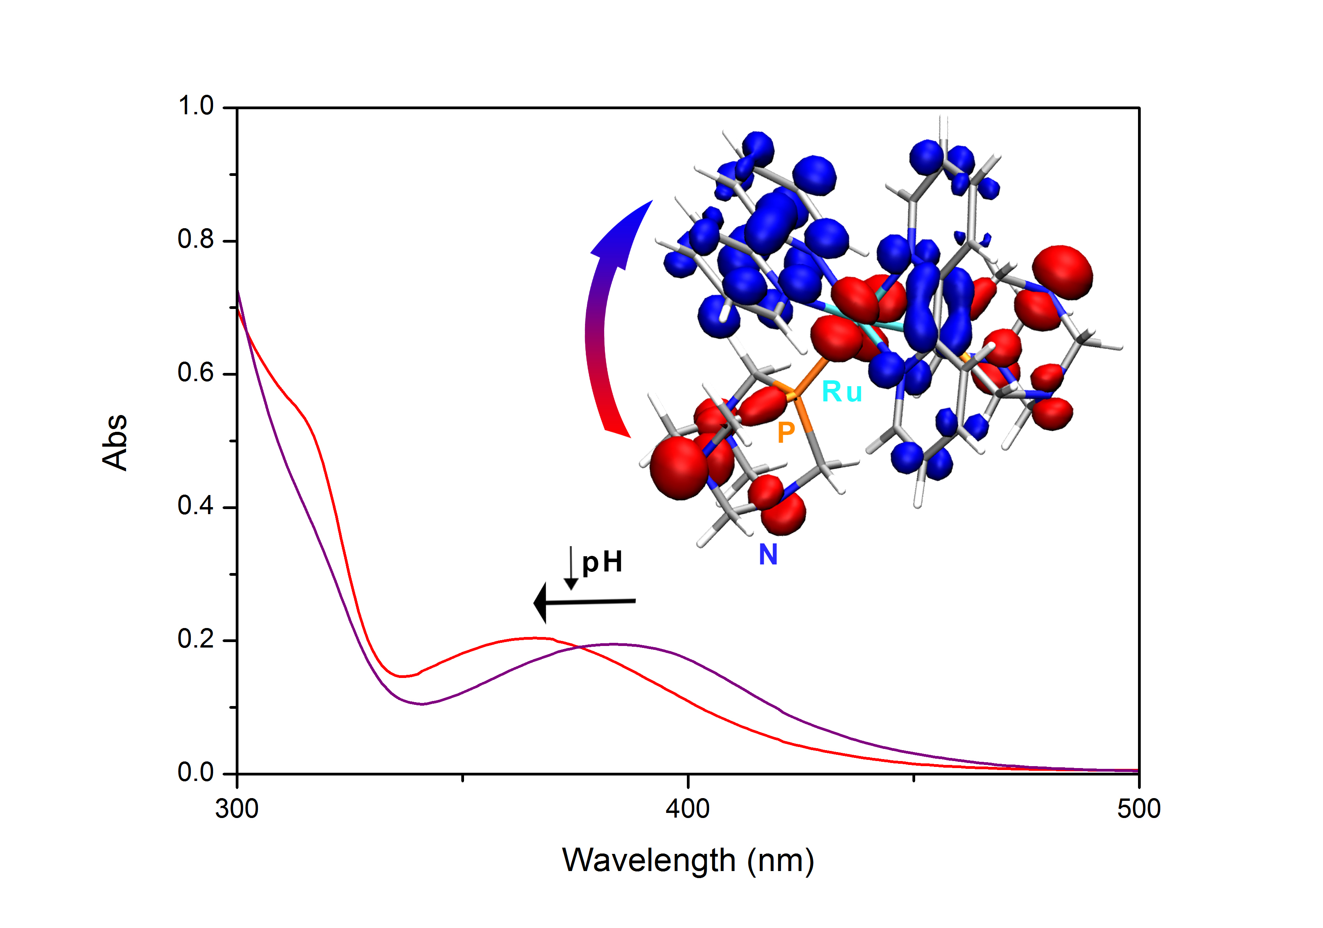 |  | water soluble ruthenium complexes, PTA, bipyridine, properties in water, photo-transformation.  F. Scalambra, M. Serrano-Ruiz, S. Nahim-Granados, A. Romerosa*  Page No. – Page No.  Ruthenium complexes containing 2,2'-bipyridine and PTA (PTA = 1,3,5-triaza-7-phosphaadamantane)

