Outdoor production of microalgae biomass at pilot-scale in seawater using centrate as the nutrient source
Romero Villegas G.I.¹, Fiamengo M.², Acién Fernández F.G.¹, Molina Grima E.¹

¹Department of Chemical Engineering, University of Almería, Ctra. Sacramento, s/n, 04120 La Cañada de San Urbano Almería, Spain
²Dipartimento di Scienze della vita e biotecnologie, Università degli Studi di Ferrara, Via Savonarola, 9, 44121 Ferrara FE, Italia

Keywords: Microalgae, centrate from anaerobic digestion; nitrogen removal; phosphorus removal, carbon removal; tubular photobioreactors
Abstract
In this paper the outdoor production of marine microalgae in tubular photobioreactors was studied, using real centrate from an urban wastewater treatment plant as the nutrient source. Experiments were performed modifying the centrate percentage in the culture medium (20, 30, 40 and 50%) and the dilution rates (0.2 and 0.3 day⁻¹) to study the phenomena taking place. Results confirm that marine microalgae can be produced under outdoor conditions using centrate as the nutrient source; at the same time treating it and recovering the nutrients contained in the centrate. The most efficient conditions for producing biomass were using 20% centrate and dilution rate of 0.3 day⁻¹, the biomass productivity was 15.62 g·m⁻²·day⁻¹ and the photosynthetic performance was 0.54 g·E⁻¹ and 2.6%. Regarding nutrients, centrate does not contain enough carbon to avoid carbon limitation thus the supply of carbon from flue gas is necessary. On the other hand, centrate is rich in nitrogen (N-NH₄), but only under optimal conditions is it efficiently fixed as biomass; otherwise it is stripped out to the atmosphere. Phosphorus is likewise only fixed efficiently as biomass under optimal conditions or it is lost by precipitation. It was observed a maximal nutrient removal capacity of up to 36.9 mg_{N}·L⁻¹·day⁻¹ and 5.38 mg_{P}·L⁻¹·day⁻¹. The population of the cultures was mainly composed of N. gaditana with conditions close to monocultures being achieved when maximizing the centrate percentage or reducing the set dilution rate. At any rate, the biochemical composition of the biomass produced did not show great variation, being rich in carbohydrates and proteins whichever the culture conditions given. The utilization of centrate to produce microalgal biomass allows to reduce the production cost and enhance process sustainability, reducing eutrophication, allowing the production of microalgal biomass for a range of low-cost applications such as feed or biofertilizers in addition to biofuels.
- Introduction
Microalgae biomass is used in high value applications related to human and animal nutrition although they have also been proposed as a raw material for the production of commodities such as chemicals, biofertilizers and biofuels [1]. Producing commodities requires the production of large amounts of biomass, far higher than the present worldwide microalgae production of 20 kt·year⁻¹ [2]. In turn, microalgae biomass production requires huge amounts of nutrients - from the elemental composition of microalgae, it has been concluded that 1.8 kg of CO₂, 0.10 kg nitrogen and 0.02 kg of phosphorous are necessary per kg of biomass. To supply CO_{2,} it is possible to use flue gases whereas nitrogen and phosphorus are usually supplied as fertilizers. However, the utilization of mineral fertilizers imposes a subsequent limitation on capacity, and reduces the sustainability of the biomass produced [3,4]. Using freshwater along with artificial fertilizers also increases the production cost to above 5 €·kg⁻¹ [5,6].
Alternatively, microalgae can be produced using wastewater [7]. When using sewage and flue gases, the production cost is reduced by one order of magnitude (<0.5 €·kg⁻¹) [8]. However, when using wastewater, no pure cultures are obtained, with natural consortia of bacteria and microalgae prevailing under these conditions. The consortia composition largely varies as a function of water quality and operating conditions [9]. Wastewater is rich in carbon, nitrogen, phosphorus and other compounds required for microalgae production; these can contaminate rivers, oceans and underground aquifers [10] if not adequately removed. Therefore, wastewater can be used to replace the culture media prepared for microalgae production that before used fertilizers, increasing the sustainability of the entire process [11,12].
Because wastewater is typically freshwater, its utilization in microalgae production can limit the microalgae used to only freshwater strains. However, the utilization of marine microalgae strains offers advantages such as lower contamination risk, higher lipid content and valuable compounds compared to freshwater strains. For this reason, the coupling of marine microalgae production and wastewater treatment is of great interest. The best option for this coupling is to use centrate from anaerobic digestion as the concentrated nutrient source [13]. Centrate from the anaerobic digestion of activated sludge contains up to 1000 mg_{N}·l⁻¹ and 30 mg_{P}·l⁻¹ hence its depuration in wastewater treatment plants entails high cost and energy consumption. In a previous work, the production of Nannochloropsis gaditana was demonstrated using centrate from the anaerobic digester of a wastewater treatment plant as the nutrient source; although the supply of additional phosphorus helped to improve system performance [13]. Moreover, this concept was further demonstrated at the pilot scale under outdoor conditions [14]. In that work, the feasibility of using centrate as the nutrient source in seawater was demonstrated within the 15-30% range although experiments were only performed at one dilution rate in a narrow percentage of centrate - the influence of the dilution rate and a wider range of centrate percentages was not studied.
In this work, the continuous production of microalgae biomass in seawater using centrate as the nutrient source was studied. Experiments were performed in summer time, at two different dilution rates (0.2 day⁻¹ and 0.3 day⁻¹) (the rate of flow of medium over the volume of culture in the bioreactor), while modifying the percentage of centrate in the culture medium (from 20 to 50%). System performance was evaluated in terms of dry weight biomass production/productivity and nutrient removal capacity. Additionally, An overview of the major strains prevailing inside the cultures as well as the biochemical composition of the produced biomass under study was performed. The objective was to determine the system’s performance and the main factors limiting its efficiency as a prior step to the industrial development of low-cost marine microalgae biomass production for the commodities markets.
- Materials and methods
  - Microorganism and culture media
The marine microalga Nannochloropsis gaditana Lubián CCMP 527 was selected because of its high growth rate and productivity under outdoor conditions [15]. Inoculum for the cultures was grown indoors at a pH of 8.0 controlled by on-demand CO₂ injection, at a controlled temperature (25 °C) in 5 l glass bottles at 200 µE·m⁻²·s⁻¹ under continuous illumination and aeration at 0.2 v·v⁻¹·min⁻¹. The culture medium used for the inoculum growth was Algal medium (Bionova, Santiago de Compostela, Spain) prepared in seawater. After reaching the stationary phase, the cultures were transferred to 100 l outdoor bubble columns, under controlled pH (8.0) regulated by the on-demand injection of flue gas. Algal medium prepared in seawater was also used in these bubble columns. During the linear growth phase the cultures were finally transferred to the outdoor tubular photobioreactors in which mixtures of seawater and centrate at different percentages were used as the culture medium.
Centrate was taken directly from the wastewater treatment plant of Almería (Spain), after passing through the bed filter used to separate solids from the liquid fraction of the digestate leaving the anaerobic digestion of activated sludge produced from wastewater treatment. This centrate thus contained almost no solids yet was rich in ammonium and other compounds. The average centrate composition used during the experiments is shown in Table 1. The culture medium was prepared daily by supplementing natural seawater with centrate according to the centrate percentage set for each experiment. Additionally, potassium phosphate was added to achieve an N/P ratio of 5:1, which was previously demonstrated as allowing optimal culture performance [14]. Seawater was obtained directly from a seawater pumping station. No additional treatment or sterilization of the culture medium was performed prior to entering the reactors so as to minimize the production cost.
  - Photobioreactors and operating conditions
Experiments were conducted outdoors in a set of three fence-type tubular photobioreactors from May to September, with the daily mean irradiance and ambient temperature being 7.5±0.5 kWh·m⁻²·day⁻¹ (26±3 MJ·m⁻²·day⁻¹, 1200+170 µE·m⁻²·day⁻¹) and 25.1±4.5 ºC. The tubular photobioreactors were built as previously described in [16]. Each reactor had a working volume of 340 l. The tubular reactors consisted of a vertically-arranged tubular solar receiver (125 m length and 0.05 m diameter) and a bubble column for heat exchange and O₂ degassing (1.92 m high and 0.25 m in diameter). A centrifugal pump (SE-150-M, Espa, Spain) was used to recirculate the culture through the reactor at 0.5 m s⁻¹. The inner-tube diameter was set at 0.05 m to maximize solar radiation capture. The reactors were oriented east–west and the distance between them was 1.6 m so as to minimize shadowing. The temperature during the day was kept under 30°C by circulating the seawater through a heat exchanger. The flue gas was produced by a diesel-oil boiler connected to a compressor which was used to store the flue-gas for further utilization. At the boiler outlet, the flue-gas was cooled as necessary by passing it through a passive stainless-steel serpentine. Moreover, before being injected into the cultures, the flue gas was filtered through three sequential cartridge filters (1 μm) to reduce the particulate content in the gas stream. The average CO₂ concentration in the flue gas was 10.9±0.5%. The air flow entering each photobioreactor was 0.25 v·v⁻¹·min⁻¹ (FR4L72BVBN flow meters, Key Instruments, USA), while the flue gas was injected as required to maintain the pH at 8.0, at a constant flow rate of 0.05 v·v⁻¹·min⁻¹ (FR4A41BVBN flow meters, Key Instruments, USA). Dissolved oxygen, pH and temperature values were measured online with DO and pH probes (5342 pH electrode and 5120 OD electrode, Crison Instruments S.A., Spain) connected to a MM44 control-transmitter unit (Crison Instruments, Spain). Data were logged in a PC control unit, allowing the monitoring and control of the culture parameters. The solar radiation the facility received was measured with a thermoelectric pyranometer connected to an AC-420 adapter (LP-02, Geónica S.A., Spain). The data logging system and the control software (DaqFactory 5.85, Azeotech Inc., USA) were designed and built by our research group.
The reactors were operated in semi-continuous, chemostat mode by adding daily fresh medium to the reactors for 4 h in the middle of the solar cycle and, at the same time, harvesting an equal volume of culture. Experiments were conducted at two different dilution rates, 0.20 and 0.30 day⁻¹. Culture medium was prepared directly by mixing the centrate with seawater pumped directly from the seawater pump station; four different centrate percentages (20%, 30%, 40% and 50%) were used. Percentage of centrate influences the amount of nutrients daily provided to the reactors whereas the imposed dilution rate also influences the microalgae biomass harvesting thus the final biomass concentration inside the culture at steady state. Figure 1 shows the schematic process applied in these experiments. Experiments were performed in the three reactors concurrently and in triplicate providing the average values from the three reactors.
  - Biomass concentration and productivity
The biomass concentration was determined daily by measuring absorbance at 750 nm with a spectrophotometer (DR/4000 UV/Vis Spectrophotometer, HACH, USA). Spectrophotometric measurements were verified by dry weight determinations twice a week. The dry weight biomass concentration (Cb) was measured by centrifuging 100 ml of culture for 15 min at 9000 ×g (Sigma Sartorius 4-15, Sartorius A.G., Germany) and freeze-drying over 48 h (LYOQUEST-55 Telstar Technologies, S.L. Spain). Volumetric productivity was calculated multiplying biomass concentration (Cb) by the set dilution rate (D) using Equation 1.
$${Pb}_{vol}=Cb·D$$ | Equation 1
Land areal productivity was calculated according to Equation 2 [15], taking into account the working volume of each reactor (340 l) and the land surface occupied by it (13 m²), which includes the free surface between reactors. Thus, the V/S ratio of tubular photobioreactors used was 26.15 l·m⁻².
$${Pb}_{area}=\frac{{Pb}_{vol}}{Area}$$ | Equation 2
  - Light availability and solar energy efficiency
The average irradiance to which cells are exposed inside a culture (Iav) was calculated as a function of irradiance in the absence of cells (Io), the biomass extinction coefficient (Ka), the biomass concentration (Cb) and the light path inside the reactor (p). This can be approximated using Equation 3 [17].
$$I_{av}=\frac{I_{0}}{(K_{a}·p·C_{b})}\left(1-exp\left(-K_{a}·p·C_{b}\right)\right)$$ | Equation 3
The extinction coefficient (Ka) of the biomass was determined spectrophotometrically (DR/4000 UV/Vis Spectrophotometer, HACH, USA) by dividing the average absorption at wavelengths from 400 to 700 nm by the biomass concentration and light path of the cuvette (p_{cuvette}) (Equation 4).
$$K_{a}=\frac{Abs}{C_{b}·p_{cuvette}}$$ | Equation 4
Quantum yield (Ψ_{E}) is defined as the amount of biomass generated from a unit of radiation (usually a mole of photons) absorbed by the culture. Since this represents the ratio of biomass generation to absorb photon flux, it can be calculated using Equation 5 [17]. The photon flux absorbed through the reactor volume (F_{vol}) is calculated using Equation 6 [17] on the basis of the average irradiance on the culture volume.
$$Ψ_{E}=\frac{P_{b}}{F_{vol}}$$ | Equation 5
$$F_{vol}=I_{av}·K_{a}·C_{b}$$ | Equation 6
Photosynthetic efficiency (PE) is the fraction of energy fixed into biomass by photosynthesis; it is calculated according to Equation 7 [17] as a function of the biomass combustion heat that was considered constant (Q_{b}=20 MJ/kg).
$$PE= \frac{P_{b}·Q_{b}}{F_{vol}}$$ | Equation 7
  - Nutrient removal capacity and coefficient yield
The removal of nitrogen and phosphorus was measured. For this, two major variables were calculated: the removal efficiency (Re) and the removal capacity (Rc). The removal efficiency is calculated as the ratio between the concentration outlet (C) and inlet (Co) in the reactor, thus representing the reduction in the nutrient concentration outlet (Equation 8). The removal capacity is calculated as the total amount of nutrient removed per unit volume over time, thus indicating the system’s net capacity for removing whatever nutrient (Equation 9).
$$R_{e}=\frac{C_{0}-C}{C_{0}}·100$$ | Equation 8
$$R_{c}={(C}_{0}-C)·D$$ | Equation 9
  - Analytical methods
To analyze the culture medium and supernatant, the standard official methods approved by the Spanish Ministry of Agriculture was used [18]. Phosphate was measured by visible spectrophotometry through the phospho-vanado-molybdate complex [19]. Nitrates were quantified using a spectrophotometer between 220 and 275 nm [19]. Ammonium was measured by the Nessler reaction method [19]. Total Inorganic Carbon (TIC), Total Organic Carbon (TOC) and Total Carbon (TC) were measured by the direct injection of samples, previously filtered, into a Shimadzu-5050A TOC analyzer provided with an NDIR detector and calibrated with standard solutions of potassium phthalate.
Microalgal population analysis and taxonomic identification were performed according to the Utermöhl method; briefly, the microalgae were fixed with formaldehyde to preserve sample viability, then they were put in a cylindrical sedimentation chamber where they were counted and identified by inverted microscopy [20]. With regard to biochemical composition, freeze-dried biomass from each steady state was analyzed. Lipids were determined gravimetrically from an extract obtained with chloroform:methanol (2:1) (v/v) [21], the protein content was determined using the modified Lowry method [22] and fatty acids were determined by gas chromatography [23].
- Results
To determine the optimal conditions for outdoor production of marine microalgae using centrate as the nutrient source, it was performed semi-continuous culture experiments (by adding daily fresh culture medium to the reactors for 4 h in the middle of the solar cycle and, at the same time, harvesting an equal volume of culture) using mixtures of centrate and seawater as the culture medium at different percentages; additionally, experiments were carried out at two different dilution rates. The different mixtures or culture media compositions used are shown in Table 1. Centrate from the wastewater treatment plant contains up to 1,830 mg·l⁻¹ of bicarbonate and 525 mg·l⁻¹ of chloride, in addition to 700 mg·l⁻¹ of ammonium and 11.5 mg·l⁻¹ of phosphorus. The high concentration of bicarbonate of the centrate is a consequence of the anaerobic conditions at which it is produced, it being in equilibrium with biogas containing up to 50% of CO₂. The nitrate concentration is very low, at 4.4 mg·l⁻¹, therefore ammonium acts as the main nitrogen source for microalgal growth. Centrate also contains relevant concentrations of other required compounds such as calcium, potassium and magnesium etc. as well as other important microelements for microalgal growth (iron, zinc and copper etc.). Data show that as the centrate percentage decreases, the nutrient concentration reduces – this is because seawater is much poorer in nutrients than centrate. Whatever the centrate percentage mixed with seawater, the relative composition of the culture medium remained similar, with a C/N/P ratio of 100/126/19. When compared with the elemental biomass composition, of 100/18/1.7, one can conclude that the culture media obtained by diluting centrate in seawater has an excess of nitrogen and phosphorus versus carbon; hence the cultures might be carbon limited if additional carbon is not supplied by on-demand CO₂ injection. Moreover, nitrogen is in excess with respect to the phosphorus concentration so the supply of additional phosphorus is essential. In previous indoor studies it was demonstrated that using centrate without an additional phosphorus supply meant the cultures were phosphorus limited; it was not possible to produce sufficient biomass to remove all the nitrogen from the culture medium [13]. As a result, additional phosphorus was added to balance the nitrogen: phosphorus ratio (N:P=5:1) (Table 1).
Using these culture media, the experiments at two different dilution rates - 0.2 and 0.3 day⁻¹ was performed. At a centrate percentage below 40%, stable steady states were achieved, whereas above this value, the cultures were not stable and frequently were washed-out. Both the biomass concentration and productivity varied as a function of the dilution rate set and the centrate percentage in the culture medium (Figure 2A). At centrate percentages below 40%, the biomass concentration ranged from 2.0 to 1.3 g_{biomass}·l⁻¹, reducing as the set dilution rate increased. The biomass concentration reduced when the centrate percentage increased from 20 to 40%; but with centrate at 50%, a larger reduction was observed, with values of 0.2 g_{biomass}·l⁻¹ at both dilution rates. These results indicate that centrate percentages above 40% can inhibit the performance of the cultures due to an excess of ammonium. Thus, at a centrate percentage of 40%, the ammonium concentration inlet was 293 mg·l⁻¹, whereas at 50%, the ammonium concentration increased to 366 mg·l⁻¹. Regarding biomass productivity, a similar pattern was observed, with the biomass productivity reducing as the centrate percentage increased; however, this was higher at 0.3 day⁻¹ than at 0.2 day⁻¹ (Figure 2B, 2C). A maximal biomass productivity of 0.60 g_{biomass}·l⁻¹·day⁻¹ (15.62 g_{iomass}·m⁻²·day⁻¹) was measured when using centrate at 20% and a dilution rate of 0.3 day⁻¹, but this reduced to 0.33 g_{biomass}·l⁻¹·day⁻¹ (8.74 g_{iomass}·m⁻²·day⁻¹) when using centrate at 40% and a dilution rate of 0.2 day⁻¹. Using centrate at 50%, the biomass productivity dropped to almost zero, to 0.03 g_{Biomass}·L⁻¹·day⁻¹ (0.89 g_{Biomass}·m⁻²·day⁻¹) whatever the set dilution rate. These results confirm that centrate excess reduces system performance.
To evaluate the decrease in system efficiency, light utilization efficiency can be employed. This is determined by measuring the biomass extinction coefficient and the average irradiance inside the cultures. Data confirm that when the composition of the culture medium or the set dilution rate is manipulated; the optical properties of the biomass is modified (Figure 3A). Thus, the biomass extinction coefficient increased from 0.19 to 0.30 m²·g⁻¹ when the centrate percentage in the culture medium rose from 20 to 50% at an set dilution rate of 0.30 day⁻¹. At 0.2 day⁻¹, the same trend was observed although the net Ka values were even higher, ranging from 0.31 to 0.39. Larger increases took place, at both dilution rates, when using 50% centrate in the culture medium. The extinction coefficient enhancement is usually related to an increase in the cells’ pigment content and this reduces light availability inside the cultures. Data in Figure 3B show that the average irradiance remained constant at both dilution rates when the centrate percentage in the culture medium was lower than 40%; however, above this value, the cultures became stressed and the average irradiance greatly increased indicating the cultures’ low light utilization efficiency.
The production of biomass allows for nutrient removal from the culture medium; consequently, The removal of carbon, nitrogen and phosphorus were measured by analyzing the reactor’s culture medium inlet and culture broth outlet. Results show that, due to the centrate’s high bicarbonate content, the total inorganic carbon concentration in the reactor’s culture medium inlet rose as the centrate percentage used increased (Figure 4A). Total inorganic carbon inlets ranging from 90 to 220 mg·l⁻¹ were measured. In contrast, the total organic carbon concentration in the centrate was much lower - the higher the centrate percentage in the culture medium, the higher the organic carbon concentration at the inlet, yet values ranged from 8 to 18 mg·l⁻¹ (Figure 4B). Inorganic carbon is the main contributor to total carbon at the culture medium inlet, ranging from 95 to 225 mg·l⁻¹ (Figure 4C). Analyzing the carbon outlet, one observes that, in spite of the on-demand CO₂ supply for pH control, inorganic carbon is significantly removed from the culture medium when using a centrate percentage lower than 40% - the inorganic carbon concentration outlet being below 40 mg·l⁻¹ whatever the set dilution rate. Only when using 50% centrate in the culture medium was the inorganic carbon concentration inlet and outlet equal; thus, no inorganic carbon was removed from the culture medium under these conditions. Regarding organic carbon, the inlet values are lower than the outlet values; nevertheless, they were always below 50 mg·l⁻¹. When using centrate percentages from 20% to 40%, the organic carbon concentration ranged from 30 to 35 mg·l⁻¹, with no influence from the centrate percentage being observed; although it was slightly higher at the lower set dilution rate of 0.20 1·day⁻¹. When using a centrate percentage of 50%, the organic carbon concentration outlet was equal to the inlet, indicating low performance of the culture under these conditions. The significant reduction in inorganic carbon concentration indicates that microalgae growth is partially based on dissolved inorganic carbons, in addition to the CO₂ supplied for pH control. The higher organic carbon concentration outlet, compared to the inlet, is explained by the release of organic molecules and remaining biomass after culture clarification by filtration; in any case, the measured values were extremely low. Therefore, the total carbon concentration outlet shows the same pattern as the inorganic carbon concentration, with a large amount of carbon being removed from the culture medium when using centrate percentages lower than 40%; whereas at 50%, the system does not remove a relevant amount of carbon. European Commission Directive 98/15/EEC [24] does not impose limits on inorganic carbon, it only limits the amount of COD in the released effluent to values below 100 mg·l⁻¹; TOC values measured here at the outlet were, by and large, below this limit.
Regarding nitrogen and phosphorus, a similar trend was observed (Figure 5). Nitrogen mainly corresponded to ammonium because the nitrate concentration was much lower; even at the outlet, the nitrate concentration was always lower than 1 mg·l⁻¹ thus no nitrification took place. The total nitrogen concentration inlet increased as the centrate percentage in the culture medium rose, ranging from 113 to 290 mg_{N}·l⁻¹ (Figure 5A). The total nitrogen concentration outlet was lower than 2.0 mg_{N}·l⁻¹, whatever the set dilution rate, when using centrate percentage of 20 and 30%. At 40% centrate, the nitrogen concentration outlet increased to 7.0 mg_{N}·l⁻¹, still lower than the 10 mg_{N}·l⁻¹ required by European Commission Directive 98/15/EEC for the disposal of treated wastewater in sensitive areas [24]. Only when using a centrate percentage of 50% did the nitrogen concentration outlet achieve high values, up to 80 mg_{N}·l⁻¹, thus confirming the system’s inability to remove the nitrogen supplied to the system under these conditions.
Regarding phosphorus, it is important to note that additional phosphorus was supplied to the centrate and seawater mixtures to achieve a N:P ratio of 5:1. Results shows that the phosphorus inlet concentration increased along with the centrate percentage supplied to the culture medium, with values from 16.5 mg_{P}·l⁻¹ to 45.82 mg_{P}·l⁻¹ being measured (Figure 5B). Regarding the outlet, the phosphorus concentration was always below 3 mg_{P}·l⁻¹ when using centrate percentages from 20 to 40%, increasing up to 7.6 mg_{P}·l⁻¹ when using 50% centrate in the culture medium. No marked differences were observed at the two dilution rates assayed. European Commission Directive 98/15/EEC establishes the requirements for urban wastewater discharges in sensitive areas, setting total maximal phosphorus to 2 mg_{P}·l⁻¹ [24]. Consequently, only when using centrate percentages from 20 to 30% can this limit be accomplished; using centrate percentages above 40%, the phosphorus concentration exceeds this limit.
These figures show that centrate can be used as the nutrient source for the outdoor production of marine microalgae. At the same time, large amounts of nutrients are removed from the culture medium to produce this biomass. However, the quality of the produced biomass is also relevant - if it is not sufficiently high, the entire process fails. Two major variables were analyzed: (i) predominant strains, and (ii) overall biochemical composition. Regarding predominant strains, although the initial inoculum used was N. gaditana, no sterilization process was applied to the culture medium thus some contamination occurred. Taxonomic studies showed N. gaditana to be the predominant strain but also other species, such as Geitlerinema sp., Chlorella sp., Limnothrix sp., and Chaetophorales sp., were present in the cultures. Results indicate that both the centrate percentage (Figure 6A) and the set dilution rate (Figure 6B) influence the relative population of microalgae in the cultures. Therefore, the higher the centrate percentage or the lower the dilution rate, the higher the predominance of N. gaditana cells. The main contaminant strains were Geitlerinema sp. and Limnothrix sp., but these strains do not tolerate a high centrate percentage in the culture medium so were washed out when using 40% centrate in the culture medium. Regarding to the influence of the dilution rate, the prevalence of these contaminant strains was higher at the higher dilution rate, indicating that these strains grow faster than N. gaditana; however, they were less efficient at the lower dilution rate where there was a higher biomass concentration of N. gaditana and lower light availability in the culture. Regarding the biochemical composition, whatever the centrate percentage and set dilution rate used, carbohydrates were the main biomass component, followed by proteins and lipids (Figure 7). The carbohydrate content (Figure 7A) rose from 40% to 57% when the centrate percentage in the culture medium increased, while no significant influence was observed from the set dilution rate. In contrast, the biomass protein content (Figure 7B) fell when increasing the centrate percentage in the culture medium, with values ranging from 46% to 23%; at the same time, a large effect was observed from the set dilution rate. A similar trend was observed in the lipid fraction (Figure 7C), which fell when increasing the centrate percentage from 28 to 20%, regardless of the set dilution rate. These figures confirm that changes in the culture’s relative population do not have a major influence on the biochemical composition of the biomass produced. Consequently, although understanding of the system “biology” is a powerful tool in appropriate system management, the most relevant criteria in defining the quality and applicability of the produced biomass is its biochemical composition, which limits the potential products obtained as well as the downstream processes to be applied.
- Discussion
In order to increase the sustainability and profitability of microalgae production, the utilization of seawater and wastewater nutrient recycling is strongly recommended. To do this, microalgae production in open ponds requires up to 2,390 l_{water}·kg_{Protein}⁻¹ produced whereas this value drops to 1.4 l_{water}·kg_{Protein}⁻¹ when using closed, flat-panel reactors [25]. With regard to nutrients, up to 153 g_{N}·kg_{proteins}⁻¹ and 16.5 g_{P}·kg_{proteins}⁻¹ are needed. These values correspond to greenhouse gas emissions of up to 7.03 and 3.83 kg_{CO2eq}·kg_{proteins}⁻¹ in open ponds and flat panels, respectively – this is equivalent to conventional agricultural emissions of 3.73 kg_{CO2eq}·kg_{proteins}⁻¹ [25]. Regarding profitability, the microalgae production cost at large scale can be reduced to 12 €·kg⁻¹ using tubular photobioreactors, and even up to 2.1 €·kg⁻¹ if “optimal” reactors and conditions are achieved; under these conditions, fertilizer consumption represents up to 20% of the overall production cost [5]. The data reported here demonstrate that only seawater and centrate need to be used to produce microalgae biomass of adequate biochemical composition for multiple uses, thus increasing process sustainability and profitability. As centrate contains a high level of compounds such as carbon, nitrogen and phosphorus (Table 1), this can be used as the sole nutrient source to support microalgal growth. Nonetheless, an excess of centrate can also be toxic so it is necessary to determine the optimal percentage in the culture medium for microalgal growth [13,14] to optimize process performance. Centrate contains ammonium, which has been reported as being toxic at high concentrations, exceeding 100 mg_{NH4}·l⁻¹. However, tolerance to ammonium varies greatly as a function of the microalgae strain and the culture conditions [26]. Under indoor conditions, it has been demonstrated that maximal productivities of 0.4 g_{Biomass}·l⁻¹·day⁻¹ can be obtained with N. gaditana using centrate as the sole nutrient source, at a centrate percentage up to 50% in the culture medium [13]. Data reported here show that in tubular photobioreactors under outdoor conditions, a maximal productivity of 0.6 g_{Biomass}·l⁻¹·day⁻¹ (15.6 g·m⁻²·day⁻¹) was achieved with N. gaditana at a 0.30 day⁻¹ dilution rate and a centrate percentage of 20% in the culture medium (Figure 2B). Previously, a maximal productivity of 0.47 g_{Biomass}·l⁻¹·day⁻¹ was obtained for N. gaditana in tubular photobioreactors under outdoor conditions when a centrate percentage of 15% was used; above this centrate percentage, the productivity decreased [14]. In any case, these values are equivalent to the 0.60 g_{Biomass}·l⁻¹·day⁻¹ obtained in outdoor tubular photobioreactors using fertilizers as the nutrient source [15]. Consequently, it can be concluded that a culture media prepared using 15-20% centrate in seawater would be adequate for producing N. gaditana.
Excess centrate in the culture medium reduces the culture performance, increasing the biomass extinction coefficient and barely decreasing the average irradiance inside the cultures (Figure 3). Moreover, quantum yield and photosynthetic efficiency reduces with increasing centrate percentage in the cultures (Figure 8). When using 20% and 30% centrate, both quantum yield (Figure 8A) and photosynthetic efficiency (Figure 8B) remained constant whatever the set dilution rate; however, above this value, the cells’ photosynthetic performance reduced, indicating the adverse effect of the culture medium used. These figures confirm the adverse effect of the high centrate percentage in the culture medium previously observed when analyzing the biomass production capacity. Photosynthetic efficiency was higher when operating at the higher dilution rate of 0.3 day⁻¹, with values up to 0.54 g_{biomass}·E⁻¹ and 2.7% being measured. Values up to 2.2 g_{biomass}·E⁻¹ were reported for P. tricornutum in outdoor tubular photobioreactors [27] whereas for N. gaditana, values up to 1.16 g_{biomass}·E⁻¹ were reported using 50% centrate under indoor conditions [13] and 0.7 g_{biomass}·E⁻¹ with 15% centrate and 0.3 day⁻¹ under outdoor conditions [14]. In terms of photosynthetic efficiency, a maximal value of 10% is theoretically possible so there is still a shortfall to increase the performance of these systems.
The utilization of wastewaters (centrate among others) can stress the cultures as a result of inadequate nutrient proportions or excessive amounts of some nutrients, such as ammonium; what is sure is that using these types of effluents makes the possibility of culture contamination more likely. To avoid this problem, the culture medium can be sterilized but this reduces the sustainability and profitability of the process. Instead, the most suitable strategy is to select robust strains that are tolerant to contamination and to manipulate the operating conditions. The data reported here demonstrate that N. gaditana was the dominant strain when increasing the centrate percentage in the culture medium and when reducing the set dilution rate; under optimal conditions, up to 95% of the monocultures were obtained (Figure 6). The cyanobacteria Geitlerinema and Limnothrix were the most frequent contaminants, their proportion increasing as the centrate percentage in the culture medium reduced or the dilution rate increased. Geitlerinema sp. favors high temperatures whereas N Limnothrix has been reported to maximize its performance under a high nitrogen concentration and low salinity [28]. The presence of contaminants in the cultures was much lower than previously reported by other authors studying wastewater, for which more than ten strains were simultaneously found [9,29]. Moreover, the results reported here agree with previous observations that monocultures can be obtained using centrate even when using open reactors [30]. According to these observations, the utilization of anaerobically-digested effluent such as centrate and imposing high productivity conditions allows one to control the strains prevailing in the cultures; nevertheless, more research on this matter is still required. In any case, the biochemical composition of the biomass obtained has to be considered more important that the strain produced as this determines whether it is finally utilized or not. To produce non-human consumption products such as biofuels, biofertilizers and even animal feed, waste utilization in the production process is allowed as long as the safety of the released biomass is assured. In our study, the produced biomass was rich in carbohydrates and proteins, while the lipid content was lower (Figure 7). Given that the market price of proteins (i.e. 1 €·kg⁻¹) is higher than that for lipids (i.e. 0.6 €·kg⁻¹), and that carbohydrates are the cheapest component (i.e. 0.3 €·kg⁻¹), one can conclude that the maximum biomass value would be 0.67 €·kg⁻¹ – this would be obtained under optimal production conditions in the culture medium of 0.3 day⁻¹ and 20% centrate. According to the biomass’ biochemical composition, the most suitable products obtained would include biofertilizers from the proteins/amino acids. Nonetheless, the entire biomass could be used for products such as feed for aquaculture and animals. A complete, real scenario analysis would be required prior to precisely ascertaining the reliability of any final application [31].
In addition to biomass production, the removal of contaminants from centrate is advantageous because this reduces the energy consumption and therefore the greenhouse gas emissions from conventional wastewater treatment plants. It also lowers the wastewater treatment cost. The flow of centrate in wastewater treatment plants is not a negligible issue, comprising up to 2% of total wastewater flow, which has to be recirculated thus increasing the cost and energy consumption of wastewater treatment processes. For a small conventional plant processing 10,000 m³·day⁻¹ of wastewater, avoiding the necessity of recirculating and treating this centrate could lead to a reduction in power consumption of up to 2,400 kWh·day⁻¹, with an annual reduction in cost of 87.6 k€·year⁻¹. The data reported here demonstrate that, when using centrate percentages in the culture medium below 50%, the remaining water complies to regulations and can be released safely into the environment (Figure 4, Figure 5). However, under these conditions, biomass productivity is lower than when using 20% centrate; therefore, it is recommended using 20% of centrate. Adverse effects from excess centrate relate to the effluent’s ammonium concentration. Several studies showed that a nitrogen concentration above 100 mg_{N-NH4}·l⁻¹ can be toxic to some microalgae strains [32] while various species tolerate values from 22 mg_{N-NH4}·l⁻¹ to 700 mg_{N-NH4}·l⁻¹ [26]. In the case of N. gaditana, optimal performance was reported when operating at a nitrogen concentration in the culture medium inlet of 190 mg_{N-NH4}·l⁻¹ under indoor conditions [13] and 100 mg_{N-NH4}·l⁻ ¹ under outdoor conditions [14]. However, the ammonium concentration in the culture was much lower, at 115 mg_{N-NH4}·l⁻¹ under indoor conditions [13] and 25 mg_{N-NH4}·l⁻¹ under outdoor conditions [14] due to cell consumption. The data reported here show that the ammonium concentration inlet in the reactor under optimal conditions (0.3 day⁻¹, 20% centrate) was 115 mg_{N-NH4}·l⁻¹ but the ammonium concentration at the reactor outlet was close to zero (Figure 5). In any case, the cultures were not limited by this since increasing the centrate percentage reduced the biomass productivity.
In terms of treatment capacity, the results show that total carbon removal efficiency increased with the percentage of centrate in the culture medium up to values of 60%; when using 40% centrate, the total carbon removal capacity reached 40 mg·l⁻¹·day⁻¹ under these conditions (Figure 9A). When using 50% centrate, the performance was so low that no relevant carbon removal was measured. Regarding nitrogen, the removal efficiency was higher than 95% when using less than 40% centrate in the culture medium, reducing to 70% when using 50% centrate despite the low performance of the cells under these conditions (Figure 9B). Moreover, the nitrogen removal capacity was higher, at 0.3 day⁻¹, increasing with the centrate percentage in the culture medium up to values of 75 mg_{N}·l⁻¹·day⁻¹, despite the adverse effect of an excess in centrate. Regarding phosphorus, a similar trend was observed as in total nitrogen. Thus, the removal efficiency was higher than 95% when using less than 50% centrate in the culture medium but reduced to 80% when using 50% centrate (Figure 9C). In terms of removal capacity, values were higher at 0.3 day⁻¹ than at 0.2 day⁻¹, increasing to 12 mg_{P}·l⁻¹·day⁻¹. Previous studies have shown that microalgae can remove up to 69% of total carbon (7.14 mg_{TIC}·m⁻²·day⁻¹, 1400 mg_{TIC}·l⁻¹·day⁻¹) from piggery wastewater [33,34] whereas when using clean water and pure CO₂, all the inorganic carbon is supplied by the gas phase, up to 1800 mg_{TIC}·l⁻¹·day⁻¹ being required to maintain biomass productivity values up to 1.0 g_{Biomass}·l⁻¹·day⁻¹ [35]. In terms of nitrogen removal capacities, using centrate in the culture, values up to 47.5 mg_{N}·l⁻¹·day⁻¹ were reported in indoor cultures of Muriellopsis [30] whereas for Chlorella, values up to 8.5 mg_{N} l⁻¹·day⁻¹ were reported using ten-fold diluted centrate; this value can increase to 22.7mg_{N}·l⁻¹·day⁻¹ under optimal conditions [36]. Similar values were reported for pig manure, for which a nitrogen removal capacity ranging from 0.5 to 12 mg_{N} l⁻¹·day⁻¹ were reported [37]. With regard to phosphorus, previous experiments carried out under indoor and outdoor conditions demonstrated that centrate lacked phosphorus-limiting microalgal growth. It was shown that N. gaditana could remove up to 5.8 mg_{P}·L⁻¹·day⁻¹, depurating up to 75% of the total phosphorus when 60% centrate was used under outdoor conditions [13]. Outdoor conditions provided the maximal removal capability of 2.6 mg_{P}·L⁻¹·day⁻¹ with centrate at 30% [14].
Although the data reported here demonstrate that there was sufficient treatment capacity to depurate clean water that could be released safely into the environment, to maximize system sustainability it is essential to recycle the nutrients contained in the centrate, not only to remove them from the culture medium. Mass balances allow us to identify the major phenomena related to nutrient removal or recycling. Figure 10 shows the data obtained from mass balances applied to each of the experimental conditions tested. The data show that the total carbon supplied in the culture medium was insufficient to satisfy the cultures’ demand for producing biomass; for this reason, approximately 90% of the carbon was supplied by flue gas injection under whichever operating condition was tested. The carbon mass balance allows one to confirm that carbon is mainly assimilated as biomass, more than 80% for a centrate percentage below 40%; whereas this value dropped to less than 20% under adverse culture conditions using 50% centrate in the culture medium. Carbon loss to the air is minimal, lower than 20%, whatever the experimental conditions, the most relevant carbon loss corresponding to the supernatant. In the case of nitrogen, there could be a set of phenomena occurring in the removal of this nutrient concurrent with the nitrogen taken up by the microalgae cells that produce biomass; namely, nitrogen release to the atmosphere and even nitrification-denitrification processes performed by bacteria or cyanobacteria. No nitrification phenomena were observed from the experimental data, but results confirm that only at the minimum centrate percentage used (20%) was the nitrogen mainly assimilated into the biomass, more than 90%, with less than 10% being lost to the atmosphere. When increasing the centrate percentage in the culture medium, nitrogen loss to the atmosphere greatly increased, becoming the main contribution. Because no nitrification-denitrification was observed, the explanation for this phenomenon is an enhancement in ammonium/ammonia stripping when increasing the ammonium concentration in the culture, thus increasing the driving force for mass transfer. Previous works concluded that stripping is a function of the reactor mass transfer capacity comprising three important factors (temperature, pH and airflow). It has been reported that temperature (≥ 22ºC), pH ( ≥ 8) and airflow are determinants for this phenomenon’s occurrence [38,39]. Thus, a mix of these factors coupled to nutrient taken up by the microalgae cells led to almost complete nitrogen depuration. Finally, with regard to phosphorus, a similar trend to that observed for nitrogen was observed. Phosphorus assimilation by the biomass was the main contributor, more than 90%, when using the lower centrate percentage in the culture medium; this reduced to 70% and 20% when increasing the centrate percentage in the culture medium to 30 and 40%, respectively. Phosphorus loss to the supernatant was not relevant, most of the phosphorus was probably lost by precipitation due to an excess in phosphorus supply and alkaline pH during the experiments. Because both ammonium stripping and phosphorus precipitation are pH dependent, reducing the pH during the culture operation would be advantageous despite a greater demand for flue gas to maintain this lower pH.
- Conclusions
The data presented here demonstrate that the seawater strain N. gaditana can be produced outdoors in tubular photobioreactors using centrate as the nutrient source. The presence of contaminant strains can be modulated by modifying the operating conditions (the centrate percentage in the culture medium and the set dilution rate). It has been demonstrated that an excess of centrate reduces the cultures’ performance both in terms of biomass productivity and solar light utilization efficiency. However, at 20-30% centrate and a 0.3 day⁻¹ dilution rate, the system performance is optimal. Under these conditions, not only was the biomass productivity higher, up to 0.6 g·l⁻¹·day⁻¹, but also nutrient removal efficiency and the net assimilation of nutrients by the biomass. Moreover, under these conditions the quality of the released water complied with the strictest regulations, meaning it can be released safely into the environment. This work has identified the main phenomena occurring when using centrate to produce marine microalgae strains, making it a promising strategy for producing sustainable and profitable microalgal biomass for low cost applications.
References
[1] P. Spolaore, C. Joannis-Cassan, E. Duran, A. Isambert, Commercial applications of microalgae, J. Biosci. Bioeng. 101 (2006) 87–96. doi:10.1263/jbb.101.87.
[2] M.H. Huesemann, J.R. Benemann, Biofuels from microalgae: review of products, processes and potential, with special focus on Dunaliella sp., in: A. Ben-Amotz, J.E.W. Polle, V.D. Subba-Rao (Eds.), Allga Dunaliella - Biodiversity, Physiol. Genomics Biotechnol., Science Publishers, New Hampshire, 2009: pp. 445–474.
[3] L. Lardon, A. Hélias, B. Sialve, J.-P. Steyer, O. Bernard, Life-Cycle Assessment of Biodiesel Production from Microalgae, Environ. Sci. Technol. 43 (2009) 6475–6481. doi:10.1021/es900705j.
[4] P. Collet, L. Lardon, A. Hélias, S. Bricout, I. Lombaert-Valot, B. Perrier, O. Lépine, J.P. Steyer, O. Bernard, Biodiesel from microalgae - Life cycle assessment and recommendations for potential improvements, Renew. Energy. 71 (2014) 525–533. doi:10.1016/j.renene.2014.06.009.
[5] F.G. Acién, J.M. Fernández, J.J. Magán, E. Molina, Production cost of a real microalgae production plant and strategies to reduce it, Biotechnol. Adv. 30 (2012) 1344–1353. doi:10.1016/j.biotechadv.2012.02.005.
[6] N.H. Norsker, M.J. Barbosa, M.H. Vermuë, R.H. Wijffels, Microalgal production - A close look at the economics, Biotechnol. Adv. 29 (2011) 24–27. doi:10.1016/j.biotechadv.2010.08.005.
[7] E.J. Olguín, G. Giuliano, D. Porro, R. Tuberosa, F. Salamini, Biotechnology for a more sustainable world, Biotechnol. Adv. 30 (2012) 931–932. doi:10.1016/j.biotechadv.2012.06.001.
[8] F.G. Acién, J.M. Fernández, E. Molina-Grima, Economics of Microalgae Biomass Production, in: Biofuels from Algae, Elsevier, 2014: pp. 313–325. doi:10.1016/B978-0-444-59558-4.00014-0.
[9] E. Posadas, P.A. García-Encina, A. Domínguez, I. Díaz, E. Becares, S. Blanco, R. Muñoz, Enclosed tubular and open algal-bacterial biofilm photobioreactors for carbon and nutrient removal from domestic wastewater, Ecol. Eng. 67 (2014) 156–164. doi:10.1016/j.ecoleng.2014.03.007.
[10] M.P. Caporgno, R. Trobajo, N. Caiola, C. Ibáñez, A. Fabregat, C. Bengoa, Biogas production from sewage sludge and microalgae co-digestion under mesophilic and thermophilic conditions, Renew. Energy. 75 (2015) 374–380. doi:10.1016/j.renene.2014.10.019.
[11] M. Nayak, A. Karemore, R. Sen, Performance evaluation of microalgae for concomitant wastewater bioremediation, CO2 biofixation and lipid biosynthesis for biodiesel application, Algal Res. 16 (2016) 216–223. doi:10.1016/j.algal.2016.03.020.
[12] K. Kumar, C.N. Dasgupta, B. Nayak, P. Lindblad, D. Das, Development of suitable photobioreactors for CO2 sequestration addressing global warming using green algae and cyanobacteria, Bioresour. Technol. 102 (2011) 4945–4953. doi:10.1016/j.biortech.2011.01.054.
[13] C. Sepúlveda, F.G. Acién, C. Gómez, N. Jiménez-Ruíz, C. Riquelme, E. Molina-Grima, Utilization of centrate for the production of the marine microalgae Nannochloropsis gaditana, Algal Res. 9 (2015) 107–116. doi:10.1016/j.algal.2015.03.004.
[14] C. Ledda, G.I. Romero-Villegas, F. Adani, F.G. Acien-Fernández, E. Molina-Grima, Utilization of centrate from wastewater treatment for the outdoor production of Nannochloropsis gaditana biomass at pilot-scale, Algal Res. 12 (2015) 17–25. doi:10.1016/j.algal.2015.08.002.
[15] A. San Pedro, C.V. González-López, F.G. Acién, E. Molina-Grima, Outdoor pilot-scale production of Nannochloropsis gaditana: Influence of culture parameters and lipid production rates in tubular photobioreactors, Bioresour. Technol. 169 (2014) 667–676. doi:10.1016/j.biortech.2014.07.052.
[16] E. Molina, J. Fernández, F.G. Acién, Y. Chisti, Tubular photobioreactor design for algal cultures, J. Biotechnol. 92 (2001) 113–131. doi:10.1016/S0168-1656(01)00353-4.
[17] E. Molina Grima, J.M. Fernández Sevilla, J.A. Sánchez Pérez, F. García Camacho, A study on simultaneous photolimitation and photoinhibition in dense microalgal cultures taking into account incident and averaged irradiances, J. Biotechnol. 45 (1996) 59–69. doi:10.1016/0168-1656(95)00144-1.
[18] M. de Agricultura, Métodos Oficiales de Análisis: Suelos y aguas, (1982).
[19] APAT-IRSA/CNR, IRSA-CNR Metodi analitici per le acque Volume Primo, Roma, 2003.
[20] L. Edler, M. Elbrächter, The Utermöhl method for quantitative phytoplankton analysis, Microsc. Mol. Methods Quant. Phytoplankt. Anal. (2010) 13–20. doi:10.1016/j.resp.2011.02.009.
[21] A. Nowotny, Carbohydrate Determination by Phenol-Sulfuric Acid, in: Basic Exerc. Immunochem., Springer Berlin Heidelberg, Berlin, Heidelberg, 1979: pp. 171–173. doi:10.1007/978-3-642-67356-6_52.
[22] C.V. López González, M. del C. Cerón García, F.G. Acién Fernández, C. Segovia Bustos, Y. Chisti, J.M. Fernández Sevilla, Protein measurements of microalgal and cyanobacterial biomass, Bioresour. Technol. 101 (2010) 7587–7591. doi:10.1016/j.biortech.2010.04.077.
[23] D.L. Alonso, E.H. Belarbi, J.M. Fernández-Sevilla, J. Rodríguez-Ruiz, E.M. Grima, Acyl lipid composition variation related to culture age and nitrogen concentration in continuous culture of the microalga Phaeodactylum tricornutum, Phytochemistry. 54 (2000) 461–471. doi:10.1016/S0031-9422(00)00084-4.
[24] E.C. Directive, 98/15/EC of 27 February, (1998).
[25] R.B. Draaisma, R.H. Wijffels, P.M.E. Slegers, L.B. Brentner, A. Roy, M.J. Barbosa, Food commodities from microalgae, Curr. Opin. Biotechnol. 24 (2013) 169–177. doi:10.1016/j.copbio.2012.09.012.
[26] Y. Collos, A. Vaquer, P. Souchu, Acclimation of nitrate uptake by phytoplankton to high substrate leves s1, J. Phycol. 41 (2005) 466–478. doi:10.1111/j.1529-8817.2005.00067.x.
[27] F.G. Acién-Fernández, F. García-Camacho, J.A. Sánchez-Pérez, J.M. Fernández-Sevilla, E. Molina-Grima, Modeling of biomass productivity in tubular photobioreactors for microalgal cultures: Effects of dilution rate, tube diameter, and solar irradiance, Biotechnol. Bioeng. 58 (1998) 605–616. doi:10.1002/(SICI)1097-0290(19980620)58:6<605::AID-BIT6>3.0.CO;2-M.
[28] M. Yilmaz Cankilic, Analisys of cyanobacterial diversity of some hot springs in Afyonkarahisar, Turkey, Appl. Ecol. Environ. Res. 14 (2016) 463–484. doi:10.15666/aeer/1402_463484.
[29] S. Chinnasamy, A. Bhatnagar, R.W. Hunt, K.C. Das, Microalgae cultivation in a wastewater dominated by carpet mill effluents for biofuel applications, Bioresour. Technol. 101 (2010) 3097–3105. doi:10.1016/j.biortech.2009.12.026.
[30] M. del M. Morales-Amaral, C. Gómez-Serrano, F.G. Acién, J.M. Fernández-Sevilla, E. Molina-Grima, Production of microalgae using centrate from anaerobic digestion as the nutrient source, Algal Res. 9 (2015) 297–305. doi:10.1016/j.algal.2015.03.018.
[31] J. Ruiz, G. Olivieri, J. de Vree, R. Bosma, P. Willems, J.H. Reith, M.H.M. Eppink, D.M.M. Kleinegris, R.H. Wijffels, M.J. Barbosa, Towards industrial products from microalgae, Energy Environ. Sci. 24 (2016) 405–413. doi:10.1039/C6EE01493C.
[32] E.P. Lincoln, A.C. Wilkie, B.T. French, Cyanobacterial process for renovating dairy wastewater, Biomass and Bioenergy. 10 (1996) 63–68. doi:10.1016/0961-9534(95)00055-0.
[33] I. de Godos, S. Blanco, P.A. García-Encina, E. Becares, R. Muñoz, Long-term operation of high rate algal ponds for the bioremediation of piggery wastewaters at high loading rates, Bioresour. Technol. 100 (2009) 4332–4339. doi:10.1016/j.biortech.2009.04.016.
[34] E.M. Ferrero, I. de Godos, E.M. Rodríguez, P.A. García-Encina, R. Muñoz, E. Bécares, Molecular characterization of bacterial communities in algal–bacterial photobioreactors treating piggery wastewaters, Ecol. Eng. 40 (2012) 121–130. doi:10.1016/j.ecoleng.2011.10.001.
[35] I. Fernández, F.G. Acién, J.M. Fernández, J.L. Guzmán, J.J. Magán, M. Berenguel, Dynamic model of microalgal production in tubular photobioreactors, Bioresour. Technol. 126 (2012) 172–181. doi:10.1016/j.biortech.2012.08.087.
[36] C. Marcilhac, B. Sialve, A.-M.M. Pourcher, C. Ziebal, N. Bernet, F. Béline, Digestate color and light intensity affect nutrient removal and competition phenomena in a microalgal-bacterial ecosystem, Water Res. 64 (2014) 278–287. doi:10.1016/j.watres.2014.07.012.
[37] J. Sevrin-Reyssac, Biotreatment of swine manure by production of aquatic valuable biomasses, Agric. Ecosyst. Environ. 68 (1998) 177–186. doi:10.1016/S0167-8809(97)00070-4.
[38] A. Bonmatı́, X. Flotats, Air stripping of ammonia from pig slurry: characterisation and feasibility as a pre- or post-treatment to mesophilic anaerobic digestion, Waste Manag. 23 (2003) 261–272. doi:10.1016/S0956-053X(02)00144-7.
[39] P.H. Liao, A. Chen, K. V. Lo, Removal of nitrogen from swine manure wastewaters by ammonia stripping, Bioresour. Technol. 54 (1995) 17–20. doi:10.1016/0960-8524(95)00105-0.

Table 1.- Composition of culture medium used during the experiments, which was prepared by mixing centrate from a wastewater treatment plant with seawater at different percentages. Concentration expressed as mg·l⁻¹. In parenthesis the final phosphorus concentration when adding phosphorus to achieve an N:P ratio of 5.
 | Centrate  100% | Centrate  50% | Centrate  40% | Centrate  30% | Centrate  20%
pH | 8.19 | 8.05 | 7.35 | 7.65 | 7.40
Bicarbonates | 1830 ± 742 | 8500 ± 371 | 9834 ± 296 | 11168 ± 244 | 12502 ± 148
Chlorides | 525 ± 124 | 10437 ± 62 | 12420 ± 49 | 14402 ± 41 | 16385 ± 25
Carbonates | 70 ± 121 | 742 ± 60 | 877 ± 48 | 1011 ± 40 | 1146 ± 24
Sodium | 252 ± 74 | 5815 ± 37 | 6927 ± 30 | 8040 ± 24 | 9152 ± 15
Ammonium | 732 ± 234 | 366 ± 117 | 293 ± 94 | 219 ± 77 | 146 ± 47
Calcium | 133.0 ± 18 | 284 ± 9 | 315 ± 7 | 345 ± 6 | 375 ± 4
Potassium | 99.6 ± 5.0 | 260.7 ± 2.5 | 292 ± 2 | 325 ± 2 | 357 ± 2
Magnesium | 88.0 ± 1.0 | 728.0 ± 0.5 | 856 ± 2 | 984 ± 2 | 1112 ± 2
Sulphates | 38.5 ± 7.3 | 1453.0 ± 3.6 | 1735 ± 3 | 2018 ± 2 | 2301 ± 2
Phosphorus | 14.1 ± 3.9  (146.1± 4.1) | 7.0 ± 1.9  (73.2± 3.5) | 5.6 ± 1.5  (58.6± 3.1) | 4.36 ± 1.2  (48.2± 2.3) | 4.2 ± 0.8  (43.8± 1.3)
Boron (B) | 0.28 ± 0.21 | 0.14 ± 0.11 | 0.11 ± 0.08 | 0.08 ± 0.07 | 0.06 ± 0.04
Zinc (Zn) | 0.10 ± 0.07 | 0.05 ± 0.04 | 0.04 ± 0.03 | 0.03 ± 0.02 | 0.02 ± 0.01
Iron (Fe) | 0.04 ± 0.01 | 0.02 ± 0.01 | 0.02 ± 0.01 | 0.01 ± 0.01 | 0.01 ± 0.01
Manganese (Mn) | 0.02 ± 0.01 | 0.01 ± 0.01 | 0.01 ± 0.01 | 0.01 ± 0.01 | 0.00 ± 0.01
Nitrates | 6.55 ± 6.55 | 3.28 ± 3.28 | 2.62 ± 2.60 | 2.0 ± 2.2 | 1.3 ± 1.3
Copper (Cu) | 0.08 ± 0.14 | 0.04 ± 0.07 | 0.03 ± 0.06 | 0.02 ± 0.05 | 0.02 ± 0.03

Figure 1.- Schematic process of microalgal biomass production using centrate as culture medium in outdoor tubular photobioreactors used in this experiment.

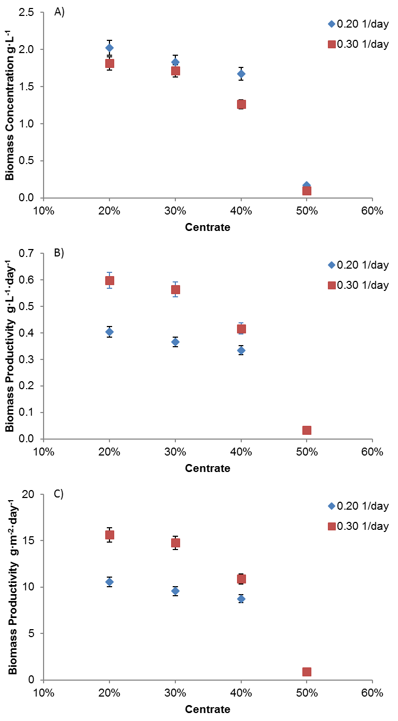
Figure 2.- Influence of the centrate percentage in the culture medium and the imposed dilution rate on biomass concentration and productivity in outdoor tubular photobioreactors. A) Biomass concentration, B) Volumetric biomass productivity, C) Areal biomass productivity. Mean values +S.D. of independent experiments performed in triplicate are shown (P<0.05).

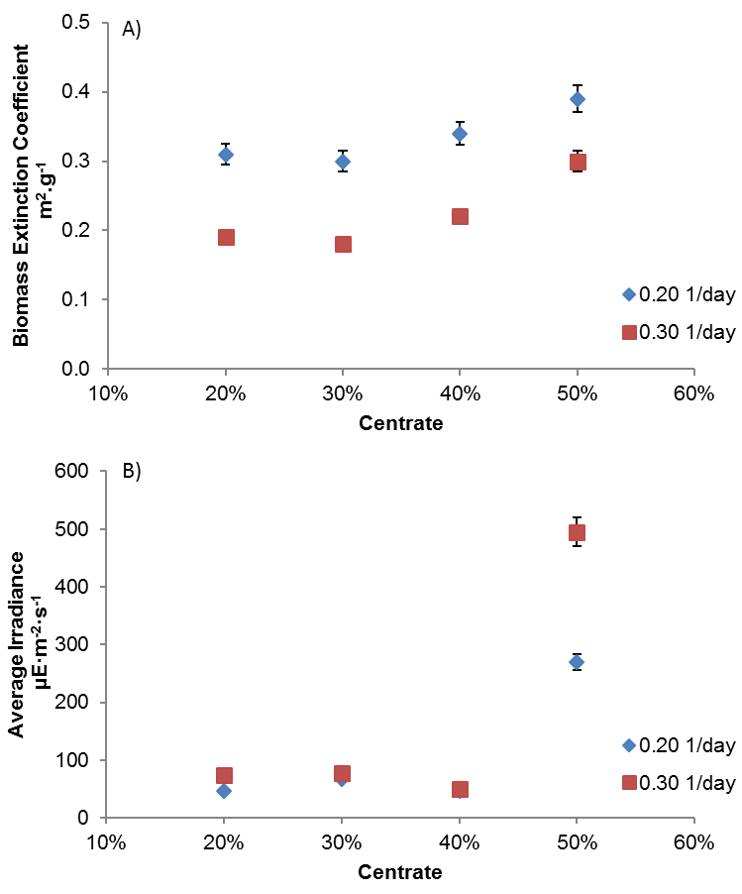
Figure 3.- Influence of the centrate percentage in the culture medium and the imposed dilution rate on the extinction coefficient of the biomass and the average irradiance inside the culture in outdoor tubular photobioreactors. A) Extinction coefficient of the biomass, B) Average irradiance to which the cells are exposed inside the cultures. Mean values +S.D. of independent experiments performed in triplicate are shown (P<0.05).

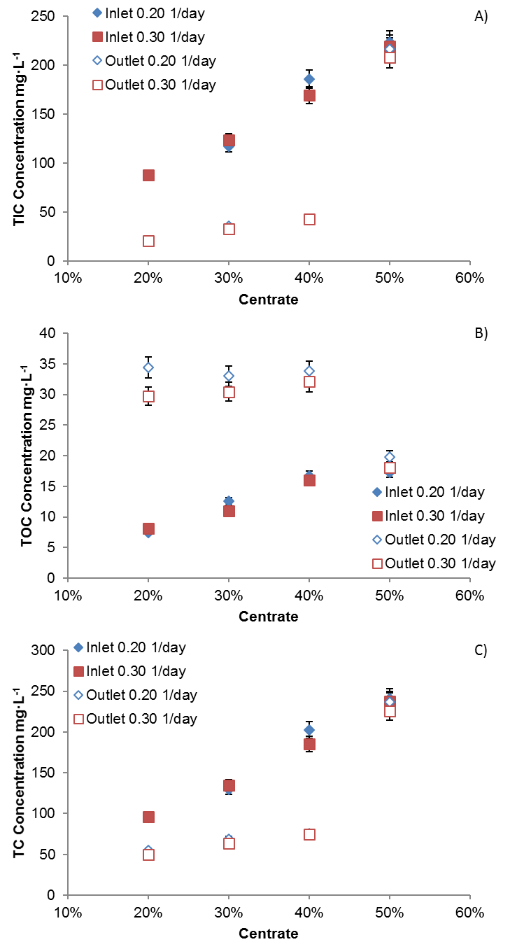
Figure 4.- Influence of the centrate percentage in the culture medium and the imposed dilution rate on the total carbon (organic and inorganic) concentration inlet and outlet in outdoor tubular photobioreactors. A) Total Inorganic Carbon, B) Total Organic Carbon, C) Total Carbon. Mean values +S.D. of independent experiments performed in triplicate are shown (P<0.05).
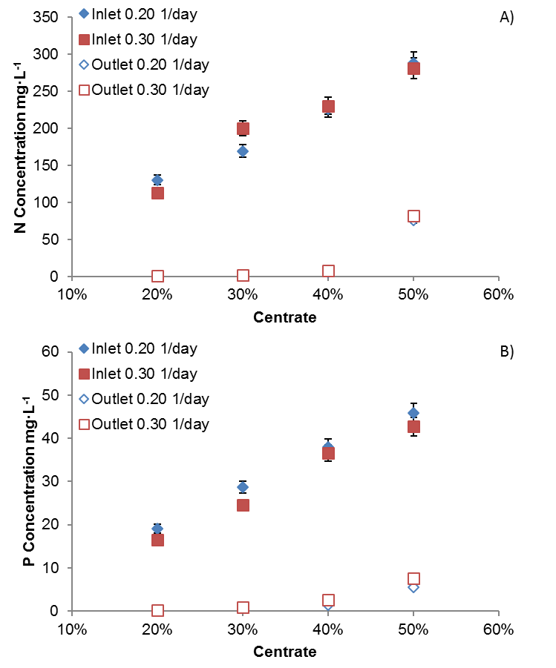
Figure 5.- Influence of the centrate percentage in the culture medium and the imposed dilution rate on the nitrogen inlet and outlet concentration, and phosphorus inlet and outlet concentration in outdoor tubular photobioreactors. A) Total nitrogen, B) Total phosphorous. Mean values +S.D. of independent experiments performed in triplicate are shown (P<0.05).

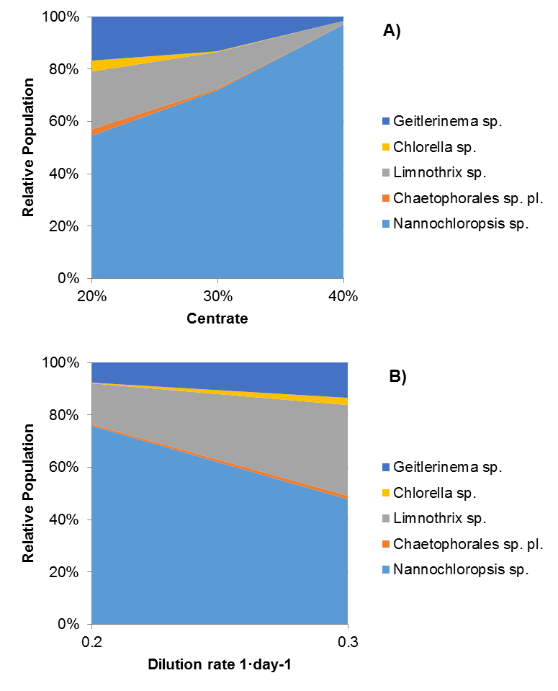
Figure 6.- Variation in the relative population of microalgae strains in the cultures with (A) the centrate percentage in the culture medium and the imposed dilution rate (B) in outdoor tubular photobioreactors. Mean values +S.D. of independent experiments performed in triplicate are shown (P<0.05).

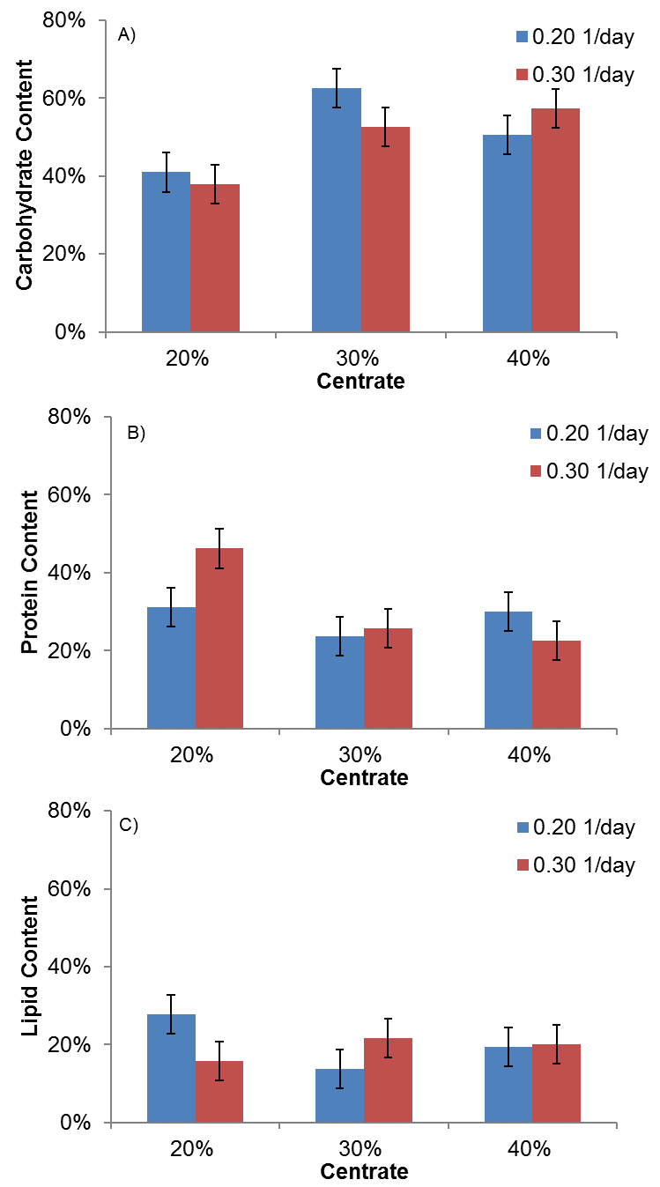
Figure 7.-Variation in the (A) carbohydrate content, (B) protein content and (C) lipid content of the microalgae biomass produced as a function of the centrate percentage in the culture medium and the imposed dilution rate in outdoor tubular photobioreactors. Mean values +S.D. of independent experiments performed in triplicate are shown (P<0.05).

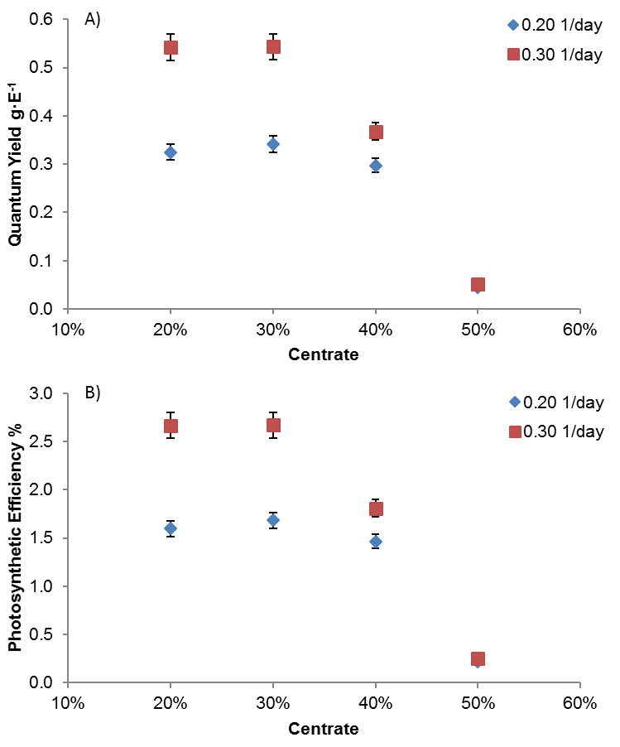
Figure 8.- Influence of the centrate percentage in the culture medium and the imposed dilution rate on the quantum yield and the photosynthetic efficiency in outdoor tubular photobioreactors. A) Quantum yield, B) Photosynthetic efficiency. Mean values +S.D. of independent experiments performed in triplicate are shown (P<0.05).

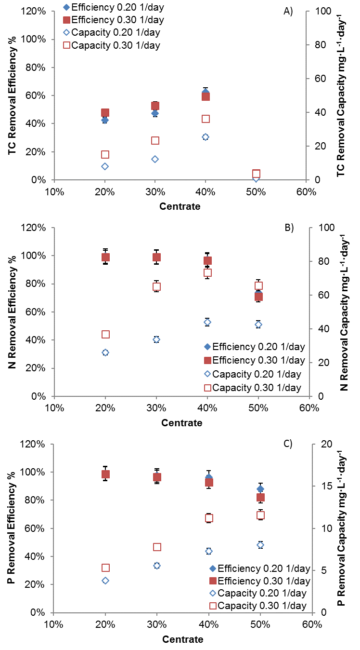
Figure 9.- Influence of the centrate percentage in the culture medium and the imposed dilution rate on the carbon, nitrogen and phosphorus removal efficiency and capacity in outdoor tubular photobioreactors. A) Total carbon, B) Total nitrogen, C) Total phosphorus. Mean values +S.D. of independent experiments performed in triplicate are shown (P<0.05).
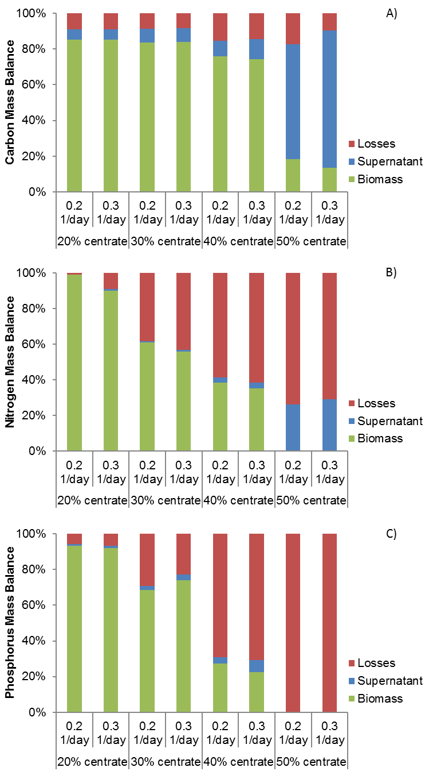
Figure 10.- Influence of the centrate percentage in the culture medium and the imposed dilution rate on the carbon, nitrogen and phosphorus mass balance of the system in outdoor tubular photobioreactors. A) Carbon, B) Nitrogen, C) Phosphorus.

