Effect of pulsed electric field treatment on enzymatic hydrolysis of proteins of Scenedesmus almeriensis
Sahar Akaberi^{1,*}, Christian Gusbeth¹, Aude Silve¹, Divya Senthil Senthilnathan¹, Elvira Navarro-López², Emilio Molina-Grima², Georg Müller¹, Wolfgang Frey¹
¹ Karlsruhe Institute of Technology, Institute for Pulsed Power and Microwave Technology (IHM), Hermann-von-Helmholtz-Platz 1, Geb. 630, 76344 Eggenstein-Leopoldshafen, Germany

² Department of Chemical Engineering, University of Almería, 04120 Almería, Spain

* Correspondence: sahar.akaberi@kit.edu
Abstract
Amino acids concentrates derived from microalgae biomass through enzymatic protein hydrolysis can improve plant growth by saving the energy that is required for amino acid synthesis from conventional mineral fertilizer resources. To obtain high enzymatic hydrolysis yields, pre-treatment of microalgae biomass prior to enzymatic hydrolysis is suggested for facilitating enzyme access to proteins.
Pulsed electric field (PEF) treatment was introduced as a pre-treatment to fresh and concentrated (50 g·kg_{sus}⁻¹ to 80 g·kg_{sus}⁻¹) Scenedesmus almeriensis biomass prior to enzymatic hydrolysis. The concentrated microalgae suspension was treated at an initial conductivity of σ = 1 mS·cm⁻¹ with 1 µs long pulses at an electric field strength of 40 kV·cm⁻¹ and a treatment energy of 75 kJ·kg_{sus}⁻¹ and 150 kJ·kg_{sus}⁻¹. For benchmarking, additional biomass samples were processed by high pressure homogenization (HPH) at 2 kbar and up to 5 passes. Enzymatic hydrolysis was performed by applying the commercial enzymes Alcalase 2.5 L and Falvourzyme 1000 L for 180 min. The amino acids content in supernatant was determined by using the orto-phthaldialdehyde (OPA) assay.
PEF treatment at both energy inputs and HPH treatment at 2 kbar, 5 passes, revealed the same hydrolysis kinetics and the same final value of the degree of hydrolysis (DH) of 50% ± 2%. The energy demand for PEF pre-treatment amounts to 0.75 MJ·kg_{dw}⁻¹ when processing biomass at 100 g_{dw}·l⁻¹. After both pretreatments, incomplete protein hydrolysis could be detected by SDS-PAGE analysis of residual biomass. Most feasible, hydrophobic protein fractions and protein aggregation impede complete protein hydrolysis by the applied enzyme cocktail.
Since PEF treatment preserves cell shape and biomass separability and thus enables cascade processing, it is suggested as alternative downstream processing method for the production of amino acids concentrates from microalgae biomass.
Keywords: pulsed electric field treatment; microalgae biomass; enzymatic hydrolysis; SDS-PAGE; amino acids concentrate
Abbreviations
PEF: pulsed electric field
HPH: high pressure homogenization
DH: degree of hydrolysis
EH: enzymatic hydrolysis
SDS-PAGE: sodium dodecyl sulfate-polyacrylamide gel electrophoresis
Declaration of interest
The authors declare no conflict of interest.

- Introduction
Microalgae have been considered as a promising source of food, feed, and medicine in recent years, because of their high contents of proteins, carbohydrates, lipids, as well as pigments, vitamins and minerals [1,2]. Proteins, for instance, are the major components of various microalgae species if cultivated under nitrogen-sufficient conditions and notably, the amino acid composition of microalgal proteins is comparable to most food proteins [3] promising an alternative source of proteins for human and animal nutrition.
Besides humans and animals, plants can also make use of microalgal proteins as a nitrogen source. However, few plants are able to uptake proteins without the assistance of symbioses microorganisms [4]. For instance, the green microalgae biomass Chlorella vulgaris is applied as soil fertilizer that improves shoot and root growth in wheat Triticum aestivum L., [5]. It has been shown that Acutodesmus dimorphus biomass can be applied to tomato seedlings to enhance branch and flower development [6].
Since proteins even in their primary structure are not as effective as they are in the form of free amino acids, a strategy to make them useful for various purposes is to hydrolyse them into amino acids [8]. Protein hydrolysis can be performed either chemically, or enzymatically by using commercial proteases. Enzymatic hydrolysis (EH) is preferable since, on the one hand, chemically sensitive amino acids remain intact through the hydrolysis and, on the other hand, there is no need for neutralization as it is in the case of acidic hydrolysis which produces higher ash contents [7]. In food or pharma industries, raw protein material from plants, animals, or even from marine organisms is hydrolyzed enzymatically for the production of bioactive peptides [8–10]. This product, known as amino acids concentrate, can also be used for agricultural purposes to supply the plant with a concentrate of free amino acids. Amino acids uptake enables plants to save a considerable amount of energy which would be required for amino acid synthesis [11]. Although few plants make use of this nutritional energy gain by converting proteins into amino acids either by releasing proteolytic enzymes via roots or with the enzymatic help of soil microbes [4].
Comparable strategies can also be pursued on proteins originated from microalgae. In fact, EH of proteins from microalgae biomass has already been investigated to produce food additives [12], pharmaceuticals [13], or plant fertilizers [11].
Specifically for plants, it has been shown that the amino acids concentrate obtained through EH from microalgae biomass Scenedemsus almeriensis significantly improved root growth and flower development of Petunia plants [14]. So far, EH of microalgae biomass has been performed using freeze-dried biomass [11,12]. However, freeze-drying of biomass is not applicable at an industrial level since energy consumption generates prohibitive costs. Furthermore, it appears that cell disruption prior to EH is required, hypothetically because a pre-treatment might facilitate protein release, and in consequence the enzymatic hydrolysis process [11]. It is well known that the conventional cell disruption methods such as high pressure homogenization (HPH), or bead milling (BM) are energy demanding. Considering robust microalgae species, the best reported values at laboratory-scale are 3.4 and 3.6 MJ·kg_{dw}, for HPH and BM, respectively [15,16]. In addition, the debris generated by those methods can also be an issue, especially when further fractionation of the biomass is intended.
Despite the potentials that this product could offer as an environmentally friendly fertilizer, there are still difficulties toward achieving an economic product due to the technical difficulties mentioned above and to the costs of the pre-treatment, or of the enzymes required for hydrolysis. Pulsed electric field (PEF) application has been suggested as a promising technology with the potential to tackle the technical issues while maintaining costs reasonably low. Introducing biological cells to an external electric field causes an increase of transmembrane voltage, which leads to the permeabilization of the cell membrane. With respect to the applied energy, the electric field strength, and pulse duration, permeabilization can be either reversible or irreversible i.e. leading to cell death [17]. Electroporation ensures cell membrane permeabilization which on the one side, leads to the release of intracellular compounds, and on the other side, also enables the transfer of compounds from extracellular matrix into the cells. During the last decades, PEF treatment has been successfully utilized for the extraction of intracellular valuables even at an industrial scale [18]. Hence, in the present work, PEF treatment has been chosen as a pre-treatment method prior to enzymatic hydrolysis since it is expected to facilitate enzyme access into the cells in order to cleave intracellular proteins. In addition, released proteins are expected to be cleaved easier by enzymes. The influence of PEF treatment on the yield of the EH has been studied in order to assess its potential benefit. The whole study was performed on Scenedesmus almeriensis. This protein-rich strain (50-55% of dry weight) exhibits high temperature and irradiance tolerance, which makes it an attractive candidate for outdoor cultivation and large-scale microalgae production [19, 20].
- Material and Methods
  - Microalgae biomass
The microalga S. almeriensis was isolated in fresh water from a greenhouse located in Almeria, Spain. This strain is deposited in the Culture Collection of Algae and Protozoa of the Centre for Hydrology and Ecology, Ambleside, U.K., code CCAP 276/24. Cultivation of this microalgae was carried out in round flasks using Arnon medium 1X [21], and pH 9-10 at 25°C. The flasks were bubbled with air at the rate of 5000 cm³·min⁻¹ to prevent cell sedimentation, and illuminated 24 h at 50-80 μmol·m⁻ ²·s⁻¹. It should be mentioned that this cultivation was limited by CO_{2.} In order to have a high amount of proteins for the EH, the biomass was harvested after 7 days of cultivation, while cells were still in the exponential phase of growth. When higher amount of biomass was required, cultivation was carried out in the Arnon medium 2X, pH 8 in a 25 l bubble column annular photobioreactor, illuminated 24 h at 250 μmol·m⁻ ²·s⁻¹ with a temperature maintained at 25°C. The cultivation was aerated with 5000 cm³·min⁻¹ of air supplemented with 25 cm³·min⁻¹ of CO₂. In both cases, microalgae suspension was concentrated after the harvest using a centrifuge (swinging-bucket rotor, 3200×g). In order to reduce the energy requirement of PEF treatment it is suggested to reduce the conductivity of the microalgae suspension [22]. Since the initial conductivity of our microalgae suspension was at 4.2 mS·cm⁻¹, a washing step was performed in order to adjust the conductivity value of the microalgae suspension at 1.5 mS·cm⁻¹. A follow-up of the conductivity value over time confirmed that the washing step did not damage the cells by inducing an osmotic shock.
  - Pre-treatment of the biomass
Fresh microalgae biomass was processed by PEF and for comparison by high pressure homogenization (HPH) as a benchmark. PEF treatment of microalgae suspension was carried out using a continuous flow treatment chamber and a transmission line based pulse generator developed at the Institute of Pulsed Power and Microwave Technology (Karlsruhe Institute of Technology, Germany) and described in [1]. More details about our PEF treatment chamber for the continuous flow processing of the biomass can be found in [22]. To study the effect of PEF treatment on S. almeriensis, the pulse parameters from Eing et al [23] were chosen since they were shown to be efficient on Auxenochlorella protothecoides. As a starting point a specific treatment energy of 150 kJ·kg_{sus}⁻¹ has been applied, since Goettel et al [1] have shown on Auxenochlorella protothecoides that PEF treatment with higher energies has no further advantages. In addition, PEF treatment at lower energy of 75 kJ·kg_{sus}⁻¹ has been tested to assess the possibility to further reduce the energy demand for PEF-treatment of wet S. almeriensis biomass in particular. PEF treatment was applied using pulses of 1 µs duration, an electric field strength of 40 kV·cm⁻¹ and a treatment energy of either 75 kJ·kg_{sus}⁻¹ or 150 kJ·kg_{sus}⁻¹. The energy input of PEF treatment was selected by solely adjusting the pulse repetition frequency at 3 Hz for 150 kJ·kg_{sus}⁻¹ or at 1.5 Hz for 75 kJ·kg_{sus}⁻¹ at a constant suspension massflow through the treatment chamber of 6 ml·min⁻¹ (For details see [22,23]). HPH treatment was performed by using an EmulsiFlex-C3 homogenizer (Avestin, Canada). To ensure maximum cell disruption, HPH samples were processed at 2 kbar and 5 passes. PEF treated, HPH treated, along with untreated biomass were further processed by EH.
  - Cell dry weight
To determine the cell dry weight, the conventional drying method using a circulating air oven (U LP 500, Memmert, Germany) was followed. 5 ml of cell suspension were weighed in an aluminium plate using a fine balance (Mettler AE 163) (mass of wet algae). The same volume was also centrifuged at 5000×g for 5 min. The supernatant was weighed and termed as the mass of wet medium. Both plates were dried in an oven at 85°C for 2 h. After drying, the weight of dry algae and dry medium were determined. The cell dry weight (CDW, [g·kg_{sus}⁻¹]) is calculated using the equation (1).
$CDW=\left(\frac{mass of dry algae}{mass of wet algae}-\frac{mass of dry medium}{mass of wet medium}\right)×1000$ (1)
Conductivity measurements after PEF treatment
The conductivity σ (mS·cm⁻¹) of the microalgae suspension was measured using a conductivity meter (WTW, cond 3310), without automatic temperature compensation. The temperature T [°C] was recorded simultaneously with the conductivity according to [20]. The equivalent conductivity at 20°C, σ₂₀ [mS·cm⁻¹], was calculated for the microalgae suspension using equation (2), where α₂₀ is the temperature coefficient of variation at 20°C according to [24]. The coefficient α₂₀ was obtained experimentally by measuring the conductivity of the microalgae suspension within a temperature range from 22°C to 35°C (data not shown). The coefficient α₂₀ had a value of 2.38 % per degree of centigrade.
$σ20 =σT\frac{1}{1 + α20(T-20) }$
(2)
2.4. Total protein content
In order to evaluate the total protein content of the microalgae biomass a chemical extraction was performed at a high temperature using sodium hydroxide [25]. From the fresh microalgae suspension concentrated to at least 50 g·kg_{sus}⁻¹, a volume containing 5 mg of microalgae biomass was resuspended in 2 ml sodium hydroxide (1M) and incubated at 95°C for 1 h [26]. After this incubation, samples were cooled to ambient temperature. This suspension was centrifuged at 10000×g for 10 min, and the supernatant was processed for protein determination applying a modified Lowry method (DC™ Protein Assay, BioRad), using bovine serum albumin as standard [25]. Total protein content determined from all treated biomasses was 50.8% ± 2.9 (SE) of dry weight.
2.5. Enzymatic hydrolysis and degree of hydrolysis
EH was carried out according to [11]. Hydrolysis reactors consisted of 50 ml wide-necked jars with the screw cap (Roth, Germany) provided with two ports that were drilled for pH-electrode and pipette access. Temperature and agitation were adjusted using a water bath and a magnetic stirrer with heating function (neoLab, Germany). After transferring the biomass into the reactor, the temperature was adjusted to 50°C. Sodium hydroxide (1M) was used to adjust the pH at 8.
For hydrolysis, two commercial proteases, Alcalase (subtilisin) 2.5 L (Novozyme, Denmark), and Flavourzyme 1000 L (Novozyme, Denmark) were added at 3% (v·w) each with regard to cell dry weight of the biomass, i.e. enzyme to substrate (E/S) ratio of ~6%, since total protein content determined from all treated biomasses was 50.8% ± 2.9 (SE) of dry weight. . According to McDonald [27], Alcalase is classified as an endopeptidase. Whereas, Merz et al [28] showed that Flavourzyme is a mixture of seven different proteases with exo- and endopeptidase activity along with one amylase.
Hydrolysis reaction was performed for 180 min. The rate of hydrolysis was monitored by taking samples every 60 min in which enzymes were immediately thermally deactivated at 80°C for 10 min. The supernatant, containing free amino acids, was separated from the residual biomass by centrifugation at 10000×g for 10 min. The amino acid content was measured using orto-phthaldialdehyde (OPA) assay using serine as standard [29]. Degree of hydrolysis (DH) is a definition used to show the rate of the hydrolysis reaction (equation 3). It is defined as the number of cleaved peptide bonds over the total number of peptide bonds presented in the sample.
$Degree of Hydrolysis \left(\%\right)=\frac{number of cleaved peptide bonds (Amino Acids content)}{Total number of peptide bonds (Protein content )}×100$ (3)
2.6. Determination of the non-hydrolysed proteins after EH
To determine the proteins that remain unaffected after 180 min of the hydrolysis, 1 ml of the hydrolysate was collected. After removing the supernatant (containing amino acids concentrate) by centrifugation for 10 min at 10000×g, the residual biomass was collected. The remaining non-hydrolysed proteins were extracted and subsequently analysed by SDS-PAGE (sodium dodecyl sulfate-polyacrylamide gel electrophoresis). The protein extraction was performed by homogenizing the residual biomass in 1 ml of Tris-Triton buffer containing 20 mM Tris, 200 mM NaCl, 2% Triton X- 100, 2 mM EGTA, 2 mM EDTA, 20% Glycerol, 0.2% SDS, and 1% sodium deoxycholate, pH 7.4 for 30 min at 95°C. Cell lysates were first spun down at 10000󠆾×g for 10 min to remove debris. Then, the supernatant was mixed with 4X Laemmli buffer (200 mM Tris-HCl, 8% (w/v) SDS, 40% (v/v) Glycerol, 4% (v/v) β- mercaptoethanol, 0.8% (w/v) bromphenol blue), and subsequently heated at 95°C for 15 min [30]. After loading 25 µl of sample onto the SDS-PAGE gel (12%) submerged in running buffer (25 mM Glycine, 192 mM Tris, 0.1% SDS), the gel was run for 2 h at 100 V. Finally, the gel was stained with coomassie blue colloidal [31] overnight and washed with distilled water on the next day.
2.7. Microscopy analysis
Images were recorded with a Zeiss Axioplan 2 microscope using a Plan-Apochromat ×63/1.44 DIC objective operated via the Zen 2012 (Blue edition) software platform.
- Results
3.1. Effect of PEF treatment on microalgae biomass
One of the expected changes following PEF treatment is the increase of conductivity of the microalgae suspension, which happens due to the leakage of ions or small charged molecules. Therefore, conductivity changes over time were followed in order to evaluate whether the PEF treatment at both energy inputs were efficient on S. almeriensis. The recorded conductivity changes of the microalgae suspension were corrected for the temperature increase caused by Joule heating, and normalised to the reference temperature of 20°C using equation (2). As expected, PEF treated microalgae biomass at both energy inputs showed an increase in conductivity in comparison to the untreated biomass (Fig. 1). Immediately after submitting the microalgae cells to the PEF treatment, the conductivity increased by a factor of 2 over the conductivity of the untreated biomass for energy input at 150 kJ·kg_{sus}⁻¹, as well as the energy input at 75 kJ·kg_{sus}⁻¹. Within 24h, the conductivity of the control slightly reduced due to prolonged nutrient uptake, whereas the conductivity of the PEF-treated samples continuously increased and finally reached 3.5 times the value of conductivity of the untreated control biomass (Fig. 1). In other words, the increase of the conductivity of the PEF-treated sample for the energy input at 150 kJ·kg_{sus}⁻¹ and at 75 kJ·kg_{sus}⁻¹ was identical.
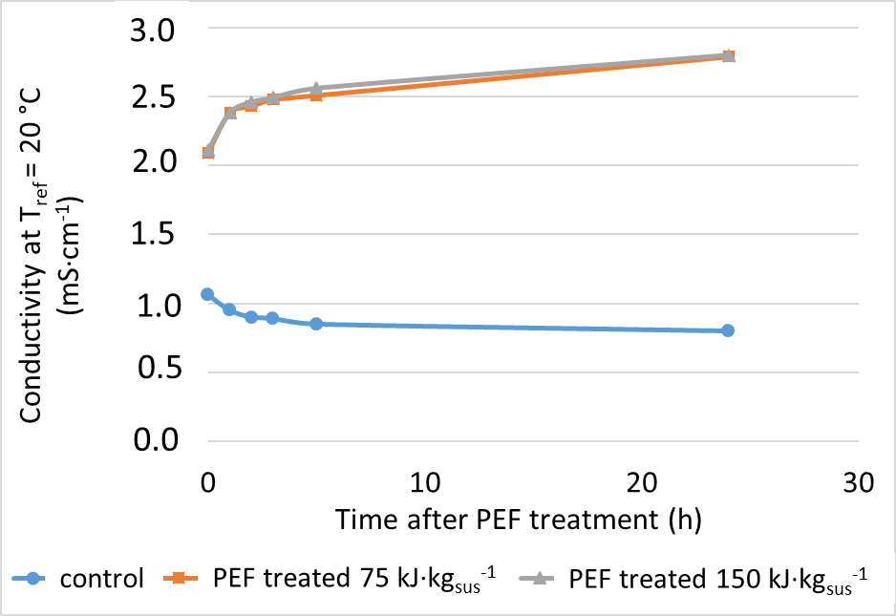
Fig. 1. Conductivity of S. almeriensis suspension after PEF treatment. Biomass obtained from annular PBR and concentrated to 97 g·kg_{sus}⁻¹. PEF treated at an energy input of 75 kJ·kg_{sus}⁻¹ and 150 kJ·kg_{sus}⁻¹, as well as untreated S. almeriensis biomass were incubated for 24 h, and conductivity values were plotted over time.
3.2. Effect of pre-treatment on protein release in suspension
To study the effect of pre-treatment on the release of intracellular proteins in the suspension, fresh S. almeriensis biomass was treated with PEF or HPH. In order to maximize protein release after PEF treatment the biomass was incubated for 2 h. Regarding HPH treatment, the amount of released proteins was determined after different number of passes (Fig. 2). Although the highest amount of proteins could already be obtained after 3 passes, the number of passes through the homogenizer was selected to be n = 5, to ascertain a maximum amount of proteins to be released into the suspension. For HPH treatment, the maximum release of proteins into the suspension was 54% of dry weight. However, after PEF treatment and 2 h of incubation only 1.15% of dry weight of released proteins could be detected.
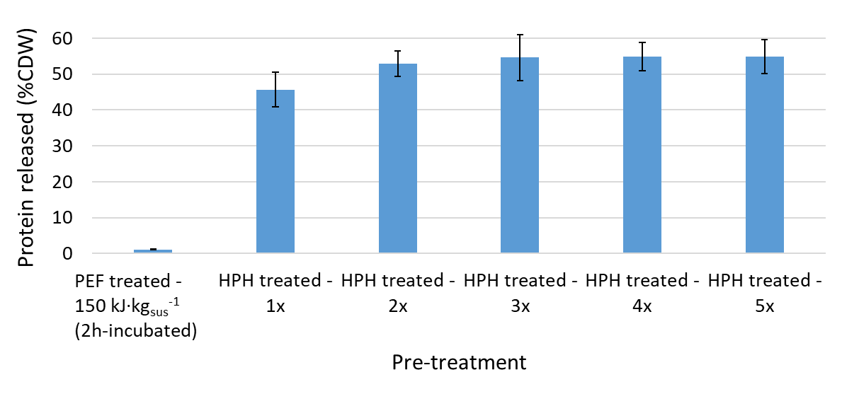
Fig. 2. Effect of pre-treatment on the release of proteins from S. almeriensis after PEF-treatment and HPH-treatment. Large bars on HPH-treatment show the influence of repeated HPH-treatments 1 up to 5 successive passes from the left to the right. PEF treatment was done at 150 kJ·kg_{sus}⁻¹, followed by an incubation period of 2 h, HPH treatment at 2 kbar. The experiment was repeated 3 times, and performed in duplicate. Error bars represent standard errors.
3.3. EH using PEF treated S. almeriensis biomass
In order to investigate the effect of PEF treatment on the yield of hydrolysis, in the first step of this study, the EH has been performed using freshly harvested S. almeriensis biomass obtained from flasks and concentrated to 50 g·kg_{sus}⁻¹. Experiments included some biomass treated with HPH, which acted as a positive control. Untreated microalgae biomass and PEF or HPH treated biomass were submitted to EH using commercial proteases. Both proteases (Alcalase and Flavourzyme) were added at the beginning of the reaction. Free amino acids that are released during hydrolysis, acidify the hydrolysis suspension, thus reducing the pH. However, EH was performed for 180 min at a constant pH of 8 adjusted by adding sodium hydroxide on demand. As the results show, PEF and HPH treatments could significantly increase the degree of hydrolysis just after 60 min of hydrolysis with 39% and 40% degree of hydrolysis, respectively (Fig. 3A and Supplementary file 1). Although both pre-treatment methods initially showed a faster increase of the degree of hydrolysis, the untreated biomass also reached a relatively high DH (40.8%) after 180 min of the EH, in comparison to DH of 50.6% and 48.5% obtained by PEF-treatment and HPH-treatment, respectively. It can be seen that the DH of untreated biomass increased steadily over the time and partially compensated for the initial slower efficiency (Fig. 3A and Supplementary file 1).
The same procedure was performed on microalgae cultivated in the annular PBR without any growth limitation. In addition, increasing the concentration of the treated biomass suspension enables further reduction of PEF energy demand [1]. Thus, in that case, the concentration of the treated biomass suspension was increased to 80 g·kg_{sus}⁻¹. In order to study the influence of PEF treatment energy on the degree of hydrolysis, samples were treated at 150 kJ·kg_{sus}⁻¹ and 75 kJ·kg_{sus}⁻¹.
The hydrolysis degrees obtained after 180 min for the two PEF-treatment energies of 75 kJ·kg_{sus}⁻¹ and 150 kJ·kg_{sus}⁻¹ were 46.5% and 47.7%, respectively. It can be ascertained that the lower energy input achieved a comparable DH as obtained with the higher energy input (Fig. 3B and Supplementary file 2). Regarding HPH treatment, the highest degree of hydrolysis was achieved at the end of the hydrolysis time with 48.5%. As already observed for biomass from flask cultivation (Fig. 3A and Supplementary file 1), the effect of PEF treatment and HPH treatment on the DH after 180 min was identical when the biomass was cultivated in the annular PBR.

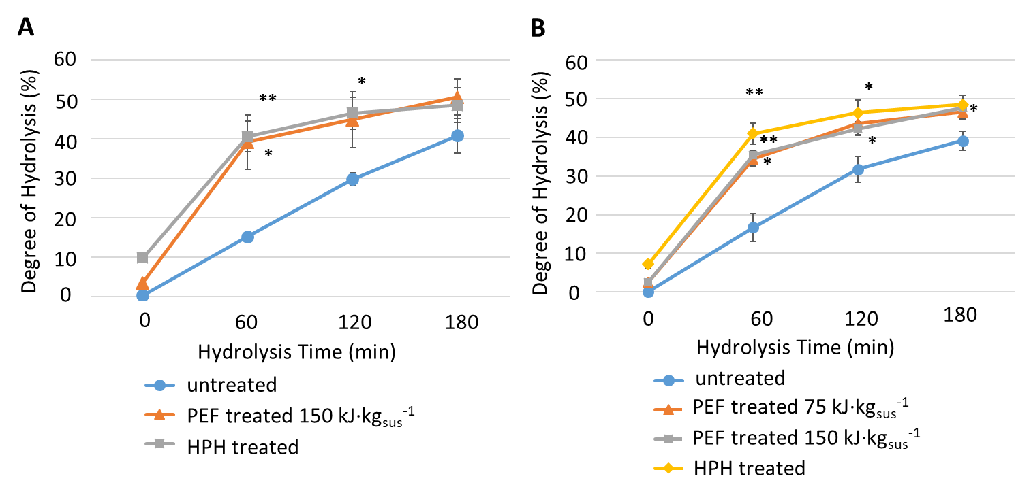
Fig. 3. Kinetics of the hydrolysis of S. almeriensis fresh biomass after PEF treatment, or HPH treatment using 3% (v·w) enzymes. (A) Kinetics of the hydrolysis of biomass at 50 g·kg_{sus}⁻¹ obtained from flasks. (B) Kinetics of the enzymatic hydrolysis of biomass at 80 g·kg_{sus}⁻¹ obtained from PBR. The experiment was performed in triplicate. Error bars represent standard errors. Asterisks indicate differences that are significant at P = 0.05 (*) or P = 0.01 (**), using a Student’s t-test.
3.4. The effect of the type of protease on the hydrolysis reaction
To get insight into the effect of each protease on the hydrolysis degree, the kinetics of hydrolysis was evaluated using untreated S. almeriensis biomass by Alcalase or Flavourzyme (Fig. 4 and Supplementary file 3). The degree of hydrolysis increased with the hydrolysis time for both proteases. However, the higher reaction rate was observed using Alcalase. Whereas Flavourzyme achieved 6,88% of the degree of hydrolysis after 180 min of hydrolysis, Alcalase obtained 46,75% of the degree of hydrolysis. This result indicated that the Alcalase is hydrolysing the majority of the peptide bonds.
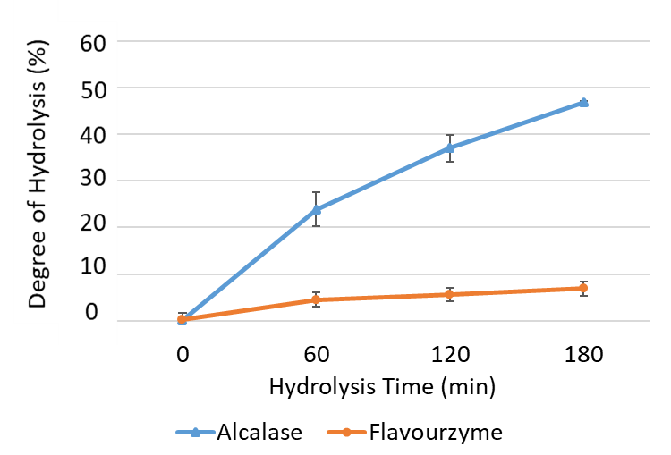
Fig. 4. Kinetics of the hydrolysis of S. almeriensis fresh biomass at 77 g·kg_{sus}⁻¹ by 3% (v·w) Alcalase or Flavourzyme. The experiment was performed in duplicate, error bars represent standard errors.
3.5. Incomplete hydrolysis caused by hydrophobic membrane proteins
The reasons for the limited yield of EH were investigated by determining hydrophobic membrane proteins that were not hydrolysed at the end of the hydrolysis time using SDS-PAGE. Fig. 5A presents lanes of the supernatant after HPH treatment and before EH, where the total protein inventory of S. almeriensis could be detected (lane 1), along with lanes of supernatant at the end of the hydrolysis time from untreated, PEF treated, and HPH treated samples. As can be seen in Fig. 5A, all supernatants from hydrolysed samples (lane 2-4) contain no protein. Also no protein bands could be detected when higher concentrations of supernatant were loaded. Thus, it can be concluded that a 3% (v/w) concentration of proteases is high enough for hydrolysing hydrophilic proteins. Furthermore, the residual biomass that has been separated from the supernatant after the EH, was extracted using lysis buffer and analysed by 12% gel electrophoresis. The results are shown in Fig. 5B. Regardless of pre-treatment, all residual biomass samples contain considerable amounts of small proteins at the size of 15-20 kDa, and a protein at the size of 25 kDa. The HPH treated sample shows the absence of two bands at approximate size of 50 and 150 kDa. There are also bands at 250 kDa and higher with a weaker signal in the untreated sample, which can be interpreted as a result of aggregation.
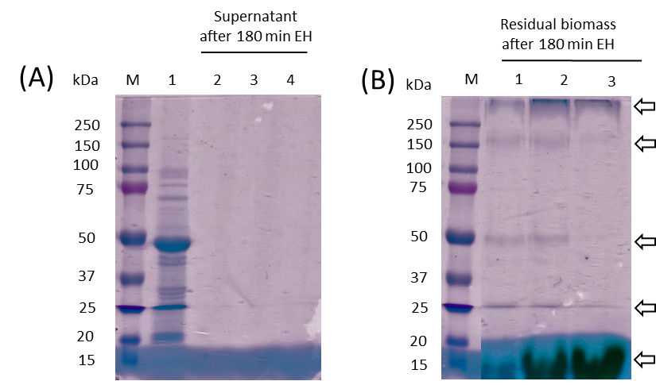
Fig. 5. SDS-PAGE Protein quality after the EH using untreated, PEF treated, and HPH treated S. almeriensis. 12% SDS-PAGE, loading volume 25 µl of sample + 5 µl of Precision Plus Protein standards ladder (M) on the left. Loaded samples include: (A) supernatant from HPH treated before the EH (1), supernatant after 180 min of EH from untreated (2), PEF treated (3), and HPH treated (4), and (B) residual biomass after 180 min of the EH from untreated (1), PEF treated (2), and HPH treated (3). The gel is representative for n = 2 independent repetitions of the experiment.
3.6. Using the residual biomass after the enzymatic hydrolysis of PEF-treated microalgae biomass
For a sustainable microalgae biorefinery, it is necessary to use all valuable compounds (proteins, carbohydrates, lipids). However, conventional cell disruption methods produce a mixture of compounds that make the fractionation of different products quite difficult [32]. Fig. 6, Fig. 7 clearly indicate that PEF treatment maintains the overall structure of the cells as oppose to HPH treatment. The mixture of aggregates, cell wall fragments, and cell debris which are produced during HPH [15], cannot be separated by centrifugation under relevant industrial parameters (2000×g) (Fig. 6). On the contrary, PEF treatment is not an obstacle for a further separation of the residual biomass.
Fig. 6. PEF treatment versus conventional cell disruption by HPH. Demonstration of separability of the biomass by centrifugation under relevant industrial parameters (2000×g).
In this context, PEF treatment as a mild cell disruption method is suggested as a promising technology for cascade processing of microalgae biomass. Even after the EH the supernatant that contains the free amino acids could be separated/collected from the residual biomass by centrifugation. The residual biomass with lower nitrogen content could still be utilized for other energetic purposes such as lipid extraction.
Fig. 7. Microscopic image of microalgae biomass S. almeriensis. (A) Representative images of control untreated S. almeriensis, (B) PEF treated biomass, and (C) HPH treated biomass. Scale bar represents 20 µm.
- Discussion
Since proteins, like most other valuable microalgae compounds, are enclosed within a rigid cell wall, it is commonly recommended to apply a cell-wall-disrupting pre-treatment [11] prior to enzymatic hydrolysis. Efforts have been made to find methods which are not only energy efficient, but also free of chemical contamination [1]. In the current study, we investigated an alternative technique, i.e. PEF treatment, which targets on membrane permeabilization and does not disrupt the cell wall. The objective was to identify relevant processing parameters in order to increase the yield of the EH from microalgae proteins. In order to avoid energy-intensive drying processes, fresh biomass was utilized throughout this study.
4.1. Conductivity increase after PEF treatment
When applying PEF treatment to the biological cells, one of the first indications is an increase of cell suspension conductivity [1]. As shown in (Fig. 1), S. almeriensis causes an increase in the conductivity by a factor of 2 following PEF treatment in comparison to the untreated biomass at the biomass concentration of 97 g·kg_{sus}⁻¹ and the treatment energy of 150 kJ·kg_{sus}⁻¹. Goettel et al [1], and Silve et al [22] showed an increase in conductivity by a factor of 1.5 and 2.5 after PEF treatment of Auxenochlorella protothecoides, respectively. A comparison of the obtained conductivity increase after PEF treatment of S. almeriensis with values obtained from the above mentioned studies confirms a high degree of membrane permeabilization of S. almeriensis by PEF-treatment with 1 µs long pulses at E = 40 kV·cm⁻¹ and an energy input of 150 kJ·kg_{sus}⁻¹. Furthermore, identical DH-values at 75 kJ·kg_{sus}⁻¹ (Fig. 3B) allow to conclude that a maximum degree of membrane permeabilization was achieved at 150 kJ·kg_{sus}⁻¹.
4.2. Effect of pre-treatment and biomass condition on hydrolysis kinetics
Progression of the DH over time was monitored for untreated, PEF treated and HPH treated biomass. DH at 0 min denotes the release of free amino acids after PEF or HPH treatment without impact of admixed enzymes. PEF treated biomass showed DH-values of about 3%, whereas the highest DH was observed after HPH treatment which ranges between 8-10% indicating that externalization of intracellular amino acids is highest with HPH treatment in comparison to PEF treatment. However, without pre-treatment at 0 min, no free amino acid was detected in external medium indicated by a DH of 0%.
For both cultivation conditions (flasks and PBR) and pre-treatments (PEF/HPH) performed in this study, the rate of increase of DH during the first 60 min is the same (Fig. 3B), or well comparable (Fig. 3A). The higher values obtained from HPH after 60 min are referred to the initial ΔDH originated from the initially externalized amount of amino acids. Values of DH converge with increasing the time of hydrolysis and end at a value of close to 50% of DH, although the amount of released proteins after PEF or HPH treatment were significantly different (Fig. 2). In other words, the maximum amount of intracellular proteins released into the suspension after HPH treatment, whereas following PEF treatment and 2 h of incubation only 1.15% of intracellular proteins were detected in the suspension. Thus, the amount of intracellular proteins released into the suspension after either pre-treatment does not affect the DH values. From the similar time course of DH values of PEF and HPH-treated samples, it can be concluded that for the case of PEF treatment, enzymes can penetrate into the cell and hydrolyse intracellular proteins as efficient as free accessible proteins after HPH can be hydrolysed. Maximum release of proteins by HPH does not provide a processing advantage in terms of a higher DH.
Time course and DH-values are the same for flask (CO₂ limited) and PBR cultivation indicating that the different cultivation conditions do not influence the EH process. Although PEF and HPH treatment provide well comparable values after 180 min of EH, 80% of final value can already be obtained after 60 min, suggesting an advantage in terms of processing time after pre-treatment.
In contrast to pre-treated samples, DH of untreated biomass increases slower over time, and obtains only 15% DH after 60 min. Surprisingly, the final value is only 20% lower than the final value obtained from PEF or HPH treated biomass.
Romero Garcia et al [11] reported about EH of freeze-dried S. almeriensis biomass at high concentrations (200-350 g·kg_{sus}⁻¹) by adding 4% (v/v) enzymes consecutively. They obtained the higher degree of hydrolysis (50%) using mechanical treatment by bead milling and adding the enzyme Viscozyme prior to hydrolysis while using biomass at high concentration (>200 g·l⁻ ¹) for reducing the viscosity of the suspension. However, regarding untreated biomass, they obtained a degree of hydrolysis of only 13%, which was significantly lower than the DH of their pre-treated biomass. The study therefore concluded for the necessity of a pre-treatment method for obtaining a higher degree of hydrolysis. With regard to the high DH-values obtained in our study on wet and untreated biomass, it can be suggested that the reduced content of cytosolic water after freeze-drying impedes enzyme transport from the extracellular medium to intracellular proteins. This explains the low values of DH when freeze-dried and untreated biomass is utilized.
4.3. Limiting factors of the enzymatic hydrolysis process
It could be demonstrated that pre-treatment (either PEF or HPH) of wet Scenedesmus biomass considerably accelerates the hydrolysis reaction. Enzyme access to substrate is well comparable in yield and kinetics for membrane permeabilization (PEF) and cell disintegration by HPH as well (Fig. 3). Despite having achieved optimum pre-treatment conditions with both methods, a DH of only 50% could be obtained.
SDS-PAGE analysis of the residual biomass confirmed the presence of significant amounts of proteins at a size of 25 kDa, 50 kDa and 150 kDa after hydrolysis (Fig. 4). Most probable this unaffected protein fraction can be associated with membrane proteins, which are not accessible for enzymes. Intact membrane fragments, which enclose proteins, remain after HPH and PEF as well. Results from literature confirm that restricted enzyme-substrate reaction can be caused by the presence of the lipid compounds. Tchorbanov and Bozhkova [12] investigated the EH of proteins from Chlorella sp. and Scenedesmus incrassatulus biomass using solvent extraction as pre-treatment. They obtained an increased DH after ethanol extraction and concluded that removing the lipophilic compounds by ethanol prior to EH can improve the enzyme- substrate interactions. To increase DH, Morris et al [33] also suggested an ethanolic extraction of microalgae biomass before EH of proteins. Thus lipid extraction prior to EH can be suggested as a measure to improve DH for our application.

EH of untreated wet biomass exhibits a slower kinetics of DH. Nevertheless, with regard to untreated and fresh biomass a comparatively high DH of 40% could be obtained. Regarding the mechanism, the most reasonable explanation is that the catalytic activity of the proteases permeabilizes the cells, thus acting as a pre-treatment [2] by its own. Besides cellulose, pectin, agar, alginate, algaenen, fucans, and hemicellulose, glycoproteins also exist in the cell wall. Burczyk et al [34] have determined the amino acids profile of cell wall proteins obtained from various strains of Chlorella and Scenedesmus. Voigt et al [35] have investigated the polypeptide composition of the cell wall fractions from Scenedesmus obliquus. Their findings also confirm the presence of glycoproteins in the outer cell wall layers as well as in the inner cell wall layers.
From other work in literature, it is evident that proteases are utilized to hydrolyse the proteins of the cell membrane and cause subsequent cell degradation [2] (for review see [36]). Liang et al [37] also reported that the treatment of sonicated microalgae with alkaline proteases and neutral proteases improved the lipid recovery. The latter was attributed to the hydrolysis of membrane proteins, which led to additional cell disruption. Based on these facts it can be concluded, that in the case of wet and untreated biomass cell wall and membrane proteins are hydrolysed which leads to increased permeability of the cell boundary, enabling enzyme access to intracellular protein substrates. This process of cell boundary degradation may also apply for freeze-dried and untreated biomass, but here, the lack of intracellular water hinders efficient enzyme transport to intracellular proteins.
A possible contribution of endogenous proteolytic activity for amino acid production, e.g. by activation of intracellular proteases, can be excluded since incubation of untreated S. almeriensis biomass at 50°C and pH 8 for 180 min without enzyme admixture lead to a maximum DH of only 2% (data not shown) at the end of the incubation time. Adding external proteases is mandatory to achieve reasonable degrees of hydrolysis.
Based on above discussions, regardless of feasibility, approaches for increasing DH in further studies are liberation of proteins from lipophilic environments, e.g. by preceding solvent based lipid extraction. Solubilization agents and aggregation suppressors such as SDS might also improve DH. Unfortunately, such additives are not only toxic, but also incompatible with protease activity.
4.4. PEF pre-treatment is effective even at low treatment energy
Efficiency of PEF treatment is known to depend on the specific energy input [1,22]. Further reduction of the PEF treatment energy to 75 kJ·kg_{sus}⁻¹ has been investigated in this study. Hydrolysis kinetics and the final value of DH were identical for PEF treatments at an energy input of 75 kJ·kg_{sus}⁻¹ and 150 kJ·kg_{sus}⁻¹ (see Fig. 3). In consequence, at a biomass density of 100 g·kg_{sus}⁻¹ a PEF treatment energy of 150 kJ·kg_{sus}⁻¹ and 75 kJ·kg_{sus}⁻¹ correspond to 1.5 MJ·kg_{dw} and 0.75 MJ·kg_{dw}. Thus, it can be concluded that using the lower energy input at 75 kJ·l⁻ ¹ also leads to adequate permeabilization prior to EH. Our results revealed the advantage of performing PEF at lower energy input along with a higher concentration of cells that together reduce the energy demand of PEF treatment per kg of dry biomass.
- Conclusion
PEF treatment of S. almeriensis biomass accelerates enzymatic hydrolysis. PEF treatments at an energy input of 75 kJ·kg_{sus}⁻¹ and 150 kJ·kg_{sus}⁻¹ reveal the same hydrolysis kinetics and the same final value of DH of 48% ± 2%. Consequently, the required PEF treatment energy at a biomass density of 80 g·kg_{sus}⁻¹ amounts to less than 0.93 MJ·kg_{dw}, which is lower than the energy consumed for HPH in this study. HPH pre-treatment did not exhibit processing advantages over PEF-treatment in terms of DH and hydrolysis kinetics. Both pre-treatment methods allow shortening of EH processing time, since 80% of the maximum DH can already be achieved after 60 min of hydrolysis time, whereas 180 min of hydrolysis time were needed for untreated biomass to reach 80% of maximum DH. Moreover, if efficiency losses to 80% of the maximum DH can be tolerated in an industrial process, EH can be performed with pre-treatment for only 60 min or without pre-treatment for 180 min at comparable yields.
Based on identical time courses of DH for PEF and HPH pre-treatment as well, it can be concluded that membrane permeabilisation by PEF enables enzyme entry into the cells and, furthermore, that protein hydrolysis after PEF is as efficient as in the case of free accessible proteins after HPH.
Incomplete protein hydrolysis was confirmed by SDS-PAGE monitoring of the residual protein content after EH. In conclusion, optimization of the utilized enzyme cocktail or removal of lipids prior to EH is required if higher DHs are targeted.
In contrast to HPH, PEF-pretreatment allows cascade processing of Scenedesmus biomass for additional component recovery, since residual biomass is not disrupted after PEF and can be separated efficiently by low-g-centrifugation (Fig. 6, Fig. 7). Future work will focus on exploitation of this unique characteristic of PEF treatment, e.g. for additional recovery of valuable substances.
Acknowledgements
This work was conducted in the framework and ﬁnanced by the Helmholtz Research Program on Renewable Energies [Topic 3: Bioenergy] and by SABANA-project of the European Union’s Horizon 2020 Research and Innovation program [Grant Agreement No. 727874]. We thank Rüdiger Wüstner, Klaus Leber, and Natalja Nazarova for technical support. Additionally, the authors thank Ralf Strässner for considerable advices and deep involvement. Professor F.G. Acien Fernandez, University of Almeria, Spain, kindly provided the S. almeriensis inoculum.
Author contributions
Conception and design of the experiments: SA, CG, AS, GM, WF. Experiments: SA, DSS, EN-L, WF. Draft of this article: SA. Revision of this article: CG, AS, GM, EM, WF.
SA takes responsibility for the integrity of this work.

References

[1] M. Goettel, C. Eing, C. Gusbeth, R. Straessner, W. Frey, Pulsed electric field assisted extraction of intracellular valuables from microalgae, Algal Research 2 (2013) 401–408. https://doi.org/10.1016/j.algal.2013.07.004.
[2] E. Günerken, E. D'Hondt, M.H.M. Eppink, L. Garcia-Gonzalez, K. Elst, R.H. Wijffels, Cell disruption for microalgae biorefineries, Biotechnol. Adv. 33 (2015) 243–260. https://doi.org/10.1016/j.biotechadv.2015.01.008.
[3] E.W. Becker, Micro-algae as a source of protein, Biotechnol. Adv. 25 (2007) 207–210. https://doi.org/10.1016/j.biotechadv.2006.11.002.
[4] C. Paungfoo-Lonhienne, T.G.A. Lonhienne, D. Rentsch, N. Robinson, M. Christie, R.I. Webb, H.K. Gamage, B.J. Carroll, P.M. Schenk, S. Schmidt, Plants can use protein as a nitrogen source without assistance from other organisms, Proc. Natl. Acad. Sci. U. S. A. 105 (2008) 4524–4529. https://doi.org/10.1073/pnas.0712078105.
[5] C. Schreiber, H. Schiedung, L. Harrison, C. Briese, B. Ackermann, J. Kant, S.D. Schrey, D. Hofmann, D. Singh, O. Ebenhöh, W. Amelung, U. Schurr, T. Mettler-Altmann, G. Huber, N.D. Jablonowski, L. Nedbal, Evaluating potential of green alga Chlorella vulgaris to accumulate phosphorus and to fertilize nutrient-poor soil substrates for crop plants, J Appl Phycol 19 (2018) 529. https://doi.org/10.1007/s10811-018-1390-9.
[6] J. Garcia-Gonzalez, M. Sommerfeld, Biofertilizer and biostimulant properties of the microalga Acutodesmus dimorphus, Journal of Applied Phycology 28 (2016) 1051–1061. https://doi.org/10.1007/s10811-015-0625-2.
[7] M. Fountoulakis, H.-W. Lahm, Hydrolysis and amino acid composition analysis of proteins, Journal of Chromatography A 826 (1998) 109–134. https://doi.org/10.1016/S0021-9673(98)00721-3.
[8] R.E. Aluko, Antihypertensive peptides from food proteins, Annu. Rev. Food Sci. Technol. 6 (2015) 235–262. https://doi.org/10.1146/annurev-food-022814-015520.
[9] A. Sila, A. Bougatef, Antioxidant peptides from marine by-products: Isolation, identification and application in food systems. A review, Journal of Functional Foods 21 (2016) 10–26. https://doi.org/10.1016/j.jff.2015.11.007.
[10] S.Y. Lee, S.J. Hur, Antihypertensive peptides from animal products, marine organisms, and plants, Food Chem. 228 (2017) 506–517. https://doi.org/10.1016/j.foodchem.2017.02.039.
[11] J.M. Romero García, F.G. Acién Fernández, J.M. Fernández Sevilla, Development of a process for the production of L-amino-acids concentrates from microalgae by enzymatic hydrolysis, Bioresour. Technol. 112 (2012) 164–170. https://doi.org/10.1016/j.biortech.2012.02.094.
[12] B. Tchorbanov, M. Bozhkova, Enzymatic hydrolysis of cell proteins in green algae Chlorella and Scenedesmus after extraction with organic solvents, Enzyme and Microbial Technology 10 (1988) 233–238. https://doi.org/10.1016/0141-0229(88)90072-5.
[13] H.J. Morris, O. Carrillo, A. Almarales, R.C. Bermúdez, Y. Lebeque, R. Fontaine, G. Llauradó, Y. Beltrán, Immunostimulant activity of an enzymatic protein hydrolysate from green microalga Chlorella vulgaris on undernourished mice, Enzyme and Microbial Technology 40 (2007) 456–460. https://doi.org/10.1016/j.enzmictec.2006.07.021.
[14] B.M. Plaza, C. Gómez-Serrano, F.G. Acién-Fernández, S. Jimenez-Becker, Effect of microalgae hydrolysate foliar application (Arthrospira platensis and Scenedesmus sp.) on Petunia x hybrida growth, J Appl Phycol 25 (2018) 154. https://doi.org/10.1007/s10811-018-1427-0.
[15] B.H.J. Yap, S.A. Crawford, G.J. Dumsday, P.J. Scales, G.J.O. Martin, A mechanistic study of algal cell disruption and its effect on lipid recovery by solvent extraction, Algal Research 5 (2014) 112–120. https://doi.org/10.1016/j.algal.2014.07.001.
[16] P.R. Postma, T.L. Miron, G. Olivieri, M.J. Barbosa, R.H. Wijffels, M.H.M. Eppink, Mild disintegration of the green microalgae Chlorella vulgaris using bead milling, Bioresour. Technol. 184 (2015) 297–304. https://doi.org/10.1016/j.biortech.2014.09.033.
[17] T. Kotnik, W. Frey, M. Sack, S. Haberl Meglič, M. Peterka, D. Miklavčič, Electroporation-based applications in biotechnology, Trends Biotechnol. 33 (2015) 480–488. https://doi.org/10.1016/j.tibtech.2015.06.002.
[18] W. Frey, C. Gusbeth, T. Sakugawa, M. Sack, G. Mueller, J. Sigler, E. Vorobiev, N. Lebovka, I. Álvarez, J. Raso, L.C. Heller, M.A. Malik, C. Eing, J. Teissie, Environmental Applications, Food and Biomass Processing by Pulsed Electric Fields, in: H. Akiyama, R. Heller (Eds.), Bioelectrics, Springer Japan, Tokyo, 2017, pp. 389–476.
[19] J.F. Sánchez, J.M. Fernández-Sevilla, F.G. Acién, M.C. Cerón, J. Pérez-Parra, E. Molina-Grima, Biomass and lutein productivity of Scenedesmus almeriensis: influence of irradiance, dilution rate and temperature, Appl. Microbiol. Biotechnol. 79 (2008) 719–729. https://doi.org/10.1007/s00253-008-1494-2.
[20] I. Fernández, J.L. Guzmán, M. Berenguel, F.G. Acién, Dynamic Modeling of Microalgal Production in Photobioreactors, in: B.N. Tripathi, D. Kumar (Eds.), Prospects and Challenges in Algal Biotechnology, Springer Singapore, Singapore, 2017, pp. 49–87.
[21] D.I. Arnon, B.D. McSwain, H.Y. Tsujimoto, K. Wada, Photochemical activity and components of membrane preparations from blue-green algae. I. Coexistence of two photosystems in relation to chlorophyll a and removal of phycocyanin, Biochimica et Biophysica Acta (BBA) - Bioenergetics 357 (1974) 231–245. https://doi.org/10.1016/0005-2728(74)90063-2.
[22] A. Silve, C.B. Kian, I. Papachristou, C. Kubisch, N. Nazarova, R. Wüstner, K. Leber, R. Strässner, W. Frey, Incubation time after pulsed electric field treatment of microalgae enhances the efficiency of extraction processes and enables the reduction of specific treatment energy, Bioresour. Technol. 269 (2018) 179–187. https://doi.org/10.1016/j.biortech.2018.08.060.
[23] C. Eing, M. Goettel, R. Straessner, C. Gusbeth, W. Frey, Pulsed Electric Field Treatment of Microalgae—Benefits for Microalgae Biomass Processing, IEEE Trans. Plasma Sci. 41 (2013) 2901–2907. https://doi.org/10.1109/TPS.2013.2274805.
[24] S. Grimnes, Ø.G. Martinsen, Bioimpedance and bioelectricity basics, Academic press, London, England, 2015.
[25] O.H. LOWRY, N.J. ROSEBROUGH, A.L. FARR, R.J. RANDALL, Protein measurement with the Folin phenol reagent, J. Biol. Chem. 193 (1951) 265–275.
[26] T. Rausch, The estimation of micro-algal protein content and its meaning to the evaluation of algal biomass I. Comparison of methods for extracting protein, Hydrobiologia 78 (1981) 237–251. https://doi.org/10.1007/BF00008520.
[27] J.K. McDonald, An overview of protease specificity and catalytic mechanisms: Aspects related to nomenclature and classification, Histochem. J. 17 (1985) 773–785.
[28] M. Merz, T. Eisele, P. Berends, D. Appel, S. Rabe, I. Blank, T. Stressler, L. Fischer, Flavourzyme, an Enzyme Preparation with Industrial Relevance: Automated Nine-Step Purification and Partial Characterization of Eight Enzymes, J. Agric. Food Chem. 63 (2015) 5682–5693. https://doi.org/10.1021/acs.jafc.5b01665.
[29] P.M. Nielsen, D. Petersen, C. Dambmann, Improved Method for Determining Food Protein Degree of Hydrolysis, J Food Science 66 (2001) 642–646. https://doi.org/10.1111/j.1365-2621.2001.tb04614.x.
[30] U.K. LAEMMLI, Cleavage of Structural Proteins during the Assembly of the Head of Bacteriophage T4, Nature 227 (1970) 680 EP -. https://doi.org/10.1038/227680a0.
[31] G. Candiano, M. Bruschi, L. Musante, L. Santucci, G.M. Ghiggeri, B. Carnemolla, P. Orecchia, L. Zardi, P.G. Righetti, Blue silver: a very sensitive colloidal Coomassie G-250 staining for proteome analysis, Electrophoresis 25 (2004) 1327–1333. https://doi.org/10.1002/elps.200305844.
[32] C. Posten, C. Walter, Microalgal Biotechnology: Integration and Economy, 1st ed., Walter de Gruyter GmbH Co.KG, s.l., 2012.
[33] H.J. Morris, A. Almarales, O. Carrillo, R.C. Bermúdez, Utilisation of Chlorella vulgaris cell biomass for the production of enzymatic protein hydrolysates, Bioresour. Technol. 99 (2008) 7723–7729. https://doi.org/10.1016/j.biortech.2008.01.080.
[34] J. Burczyk, B. Śmietana, K. Termińska-Pabis, M. Zych, P. Kowalowski, Comparison of nitrogen content amino acid composition and glucosamine content of cell walls of various chlorococcalean algae, Phytochemistry 51 (1999) 491–497. https://doi.org/10.1016/S0031-9422(99)00063-1.
[35] J. Voigt, A. Stolarczyk, M. Zych, P. Malec, J. Burczyk, The cell-wall glycoproteins of the green alga Scenedesmus obliquus. The predominant cell-wall polypeptide of Scenedesmus obliquus is related to the cell-wall glycoprotein gp3 of Chlamydomonas reinhardtii, Plant Sci. 215-216 (2014) 39–47. https://doi.org/10.1016/j.plantsci.2013.10.011.
[36] J. Velazquez-Lucio, R.M. Rodríguez-Jasso, L.M. Colla, A. Sáenz-Galindo, D.E. Cervantes-Cisneros, C.N. Aguilar, B.D. Fernandes, H.A. Ruiz, Microalgal biomass pretreatment for bioethanol production: A review, Biofuel Res. J. 5 (2018) 780–791. https://doi.org/10.18331/BRJ2018.5.1.5.
[37] K. Liang, Q. Zhang, W. Cong, Enzyme-assisted aqueous extraction of lipid from microalgae, J. Agric. Food Chem. 60 (2012) 11771–11776. https://doi.org/10.1021/jf302836v.

